# Moving people from institutions into the community

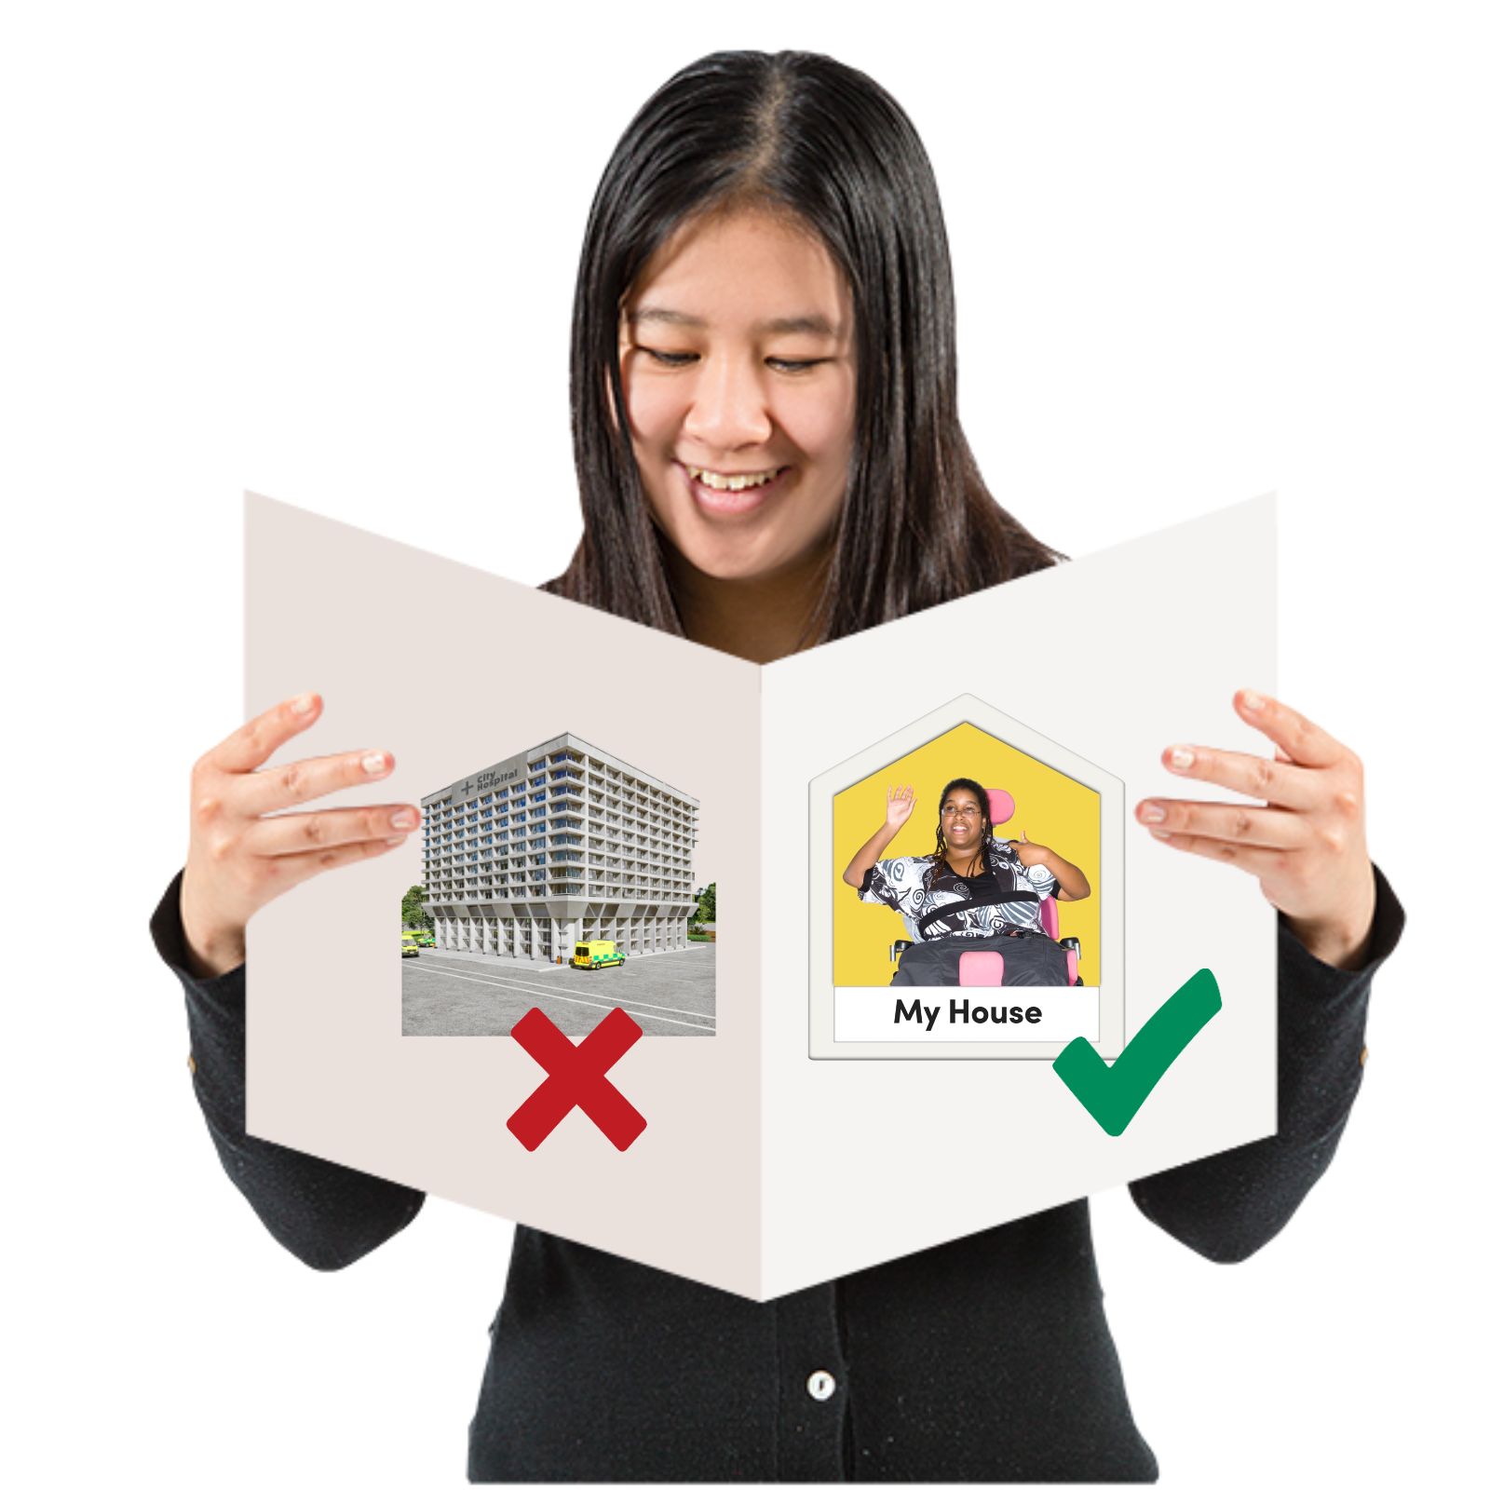

# Easy Read

Easy Read logo of woman smiling and reading an Easy Read


|  |  |
| --- | --- |
| Report by the Scottish Human Rights Commission (SHRC) |  |

## Contents page

|  |  |
| --- | --- |
| Who we are | Page 3 |
| What this report is about | Page 4 |
| How we did the report | Page 8 |
| What the report says | Page 10 |
| Our recommendations | Page11 |

## Who we are

|  |  |
| --- | --- |
| Scottish Human Rights Commission logo | We are the Scottish Human Rights Commission. We are called SHRC for short. |
| People in a circle around a woman protecting her underneath a Scotland flag. | Our job is to protect people’s **human rights** in Scotland. |
| Woman pointing to herself | Human rights are rights that every person has.  For example, the right to be alive and the right to go to school. |

## What this report is about

|  |  |
| --- | --- |
| Woman smiling in her own house. Man smiling in his own house. Another man is in his own house with two thumbs up. | The report is about people with learning disabilities and/or autism and **the right to independent living**. |
| A man in his own house smiling and a care plan booklet. | The right to independent living is a human right which says that people should be able to live at home in their own community.  It also says people should get help to live at home if they need it. |
| Inside of a hospital hallway with 4 doors. On the doors are patient's names to show that they live there. | Some people with learning disabilities and some autistic people are made to live in **institutions** instead of in their own homes. |
| Lots of people in 1 house | An institution is:   * A place where you have to live. * Somewhere you do not get to make choices about your life. For example, you might have to live with other people. |
| A hospital behind a chain-link fence. An NHS sign says "secure hospital". | 1 example of an institution is a hospital for people with learning disabilities. |
| Three disabled people standing next to paper that says "United Nations Disability Rights" | Human rights law says that putting people with learning disabilities and autism in institutions is wrong.  It says that everybody should get to live at home in the community. |
| Booklet that says "plan" and has a picture of the Scottish Parliament building on the front. | The Scottish Government had a plan to move people out of institutions and back into the community.  The Scottish Government’s plan is called the Coming Home Plan. |
| Check | This report measures how well the Coming Home Plan worked. |

## How we did the report

|  |  |
| --- | --- |
| Hands using measuring tape | We used **indicators** to measure what happened with the Coming Home Plan. |
| Hands using measuring tape | Indicators are things you can measure to check what is happening with human rights. |
| Frowning man with thumbs down holding paper with a cross on it. Then the man is smiling with a thumbs up and a tick on the paper. | Indicators can tell you if things are getting better or if they are getting worse. |
| Checklist with a tick | Indicators can also tell you how to make things better. |

## What the report says

|  |  |
| --- | --- |
| Woman holding paper with a cross on it with a thumbs down. | The report says that the Scottish Government did not do enough to make sure people with learning disabilities and people who are autistic can live independently. |
| Man holding paper with a question mark on it. | It was hard to measure progress because a lot of information we needed is missing. |
| Inside of a hospital hallway with 4 doors. On the doors are patient's names to show that they live there. | The report says that people with learning disabilities and people who are autistic are still living in institutions. Not much has changed. |
| Speech bubble with money in it | The report says that the Scottish Government needs to tell us more about how the money for getting people out of institutions was spent. |

## Our recommendations

|  |  |
| --- | --- |
| Woman smiling and pointing to a list | We have made 9 **recommendations** about what needs to be done next. Recommendations means ideas for changes we want to see. |
| A plan next to a clock with an urgent sign | We want the Scottish Government to make a new plan quickly. |
| Man looking through a magnifying glass and smiling. | We want somebody to have the job of checking that the Scottish Government is doing enough to make sure people can live independently. |
| Hands using measuring tape | We want the Scottish Government to use our indicators to measure what is happening. |
| Speech bubble with money in it | We want the Scottish Government to tell us how the money for getting people out of institutions was spent. |
| Plan with a secure hospital on the front | We want the Scottish Government to make a plan for people who are in the most secure hospitals. |
| New law and a police man | We want the Scottish Government to say when they will change the law to protect people with learning disabilities and people who are autistic. |
| Woman reading a report. On 1 page is a hospital with cross. On the other page is a person at home with a tick. | We want the Scottish Government to make a plan to move all people living in institutions into the community. |
| Woman holding a checklist next to the United Nations logo | We want the Scottish Government to tell us it will follow what the United Nations says it has to do to make sure people can live independently. |
| Frowning man with thumbs down holding paper with a cross on it. Then the man is smiling with a thumbs up and a tick on the paper. | We want the Scottish Government to say sorry and make things better for people who have had to live in institutions. |
| Man looking through a magnifying glass | We will keep checking what is happening. |
| Clipboard with a picture of hands holding measuring tape | We have also made a toolkit to help people measure change themselves. |