# State of the Nation: Civil and Political Rights in Scotland 2023-24

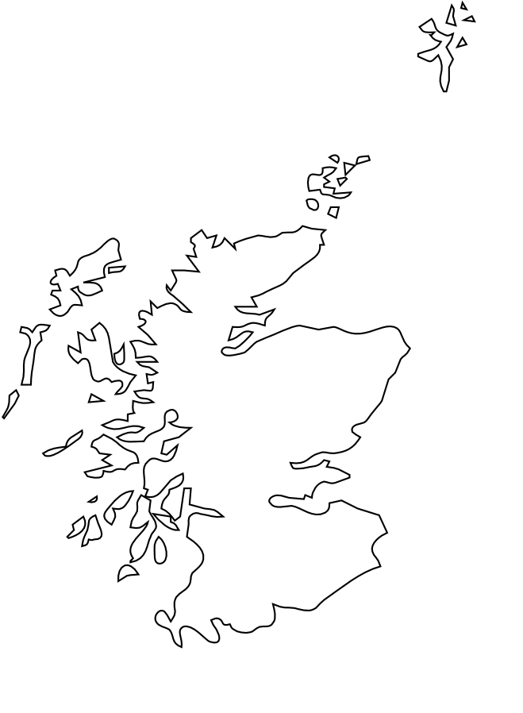

**Easy Read**

|  |  |
| --- | --- |
| Report by the Scottish Human Rights Commission (SHRC) |  |

Easy Read logo of woman smiling and reading an Easy Read
 

## Contents page

| **Heading** | **Page number** |
| --- | --- |
| Who we are | Page 3 |
| What this report is about | Page 5 |
| Why we did the report | Page 8 |
| What other work we are doing | Page 9 |
| What the report says | Page 11 |
| What needs to be done | Page 13 |

## Who we are

|  |  |
| --- | --- |
| Scottish Human Rights Commission logo | We are the Scottish Human Rights Commission. We are called SHRC for short. |
| People in a circle around a woman protecting her underneath a Scotland flag. | Our job is to protect people’s human rights in Scotland. |
| Woman pointing to herself | Human rights are rights that every person has. For example, the right to be alive and the right to go to school. |

## What this report is about

|  |  |
| --- | --- |
| A report with outward-pointing arrows symbolizing distribution. | This is a new type of report called the State of the Nation. |
| Checklist of years from 2020 to 2024 with a pen. | The State of the Nation will come out every year on Human Rights Day. |
| Illustration of the Human Rights Act document with an emblem and three smiling individuals in a circular inset. | This year the report looks at 14 **civil and political rights** which are mostly protected by the Human Rights Act.  Civil and political rights are the rights that stop the Government from hurting people and the rights for everyone to be involved in decisions fairly. |
| A scared young person with an aggressive silhouette behind, crossed out with a red line, promoting the right to be safe from serious harm. Man in orange shirt running out of double doors with 'The right to liberty' text and Human Rights logo. | Civil and political rights include   * The right to be alive * The right to be safe from serious harm * The right to vote in elections |
| Woman checking her watch while sitting between two empty chairs. | Some problems with these rights have been around for a long time. |
| Person gripping metal prison bars with both hands, suggesting confinementA scared young person with an aggressive silhouette behind, crossed out with a red line, promoting the right to be safe from serious harm. | For example, the conditions in prisons have been a problem for many years. |
| A metallic balance scale with two empty pans, level and symmetrical. | Sometimes people's needs have to be balanced to protect human rights.  We don't think the people in charge always understand why people have different needs. |

## Why we did this report

|  |  |
| --- | --- |
| Person in a burgundy beanie pointing at a bar chart with a red line graph.Illustration of the Human Rights Act document with an emblem and three smiling individuals in a circular inset. | We want people to know what their human rights are. |
| Logo for the Scottish Government in English and Gaelic. | We want the Scottish Government to know that we are worried that things are not getting better. |
| Two people shaking hands with a checklist labeled 'Plan' in the background. | We want the Scottish Parliament and the Scottish Government to fix the problems. |

## What other work are we doing

|  |  |
| --- | --- |
| A diverse group of people within a magnifying glass. | We have also been working on Spotlight Projects which look closely at some human rights issues in people's daily lives. |
| Person gripping metal prison bars with both hands, suggesting confinement. | Our first Spotlight found that most ideas to protect human rights in prisons have not been done. |
| A simplified outline of Scotland with the Highlands and Islands region highlighted in blue. | Our second Spotlight found that there are big challenges for some human rights in the Highlands and Islands. |
| Three individuals, one in a wheelchair, stand beside a 'UN Disability Rights' sign, expressing solidarity and empowerment. | Our third Spotlight project will come out next year. This is looking at disabled people's human rights to live independently in their communities. |

## What the report says

|  |  |
| --- | --- |
| Man giving a thumbs-down gesture beside a whiteboard with red 'X' marks. | Our work this year has shown lots of different problems in making the laws that protect human rights work properly. |
| A metallic balance scale symbolising justice and fairness. | We have another Spotlight Project that is looking at is this problem called 'Access to Justice.' |
| A grand courthouse with tall columns, stone facade, and wide stairs leading to the entrance. Stack of twenty British pound notes. | It is confusing and costs a lot of money to go to court when you think your human rights have not been met. |
| Three people discussing a document in a professional office setting. | It is hard to find a lawyer or other person who can give you advice about human rights.  We cannot give people advice or help them go to court. |

## What needs to be done

|  |  |
| --- | --- |
| Two men holding signs with thumbs up and thumbs down gestures. Exterior of a modern government building with Scottish, UK, and EU flags. | We have told the Scottish Parliament our ideas to help improve human rights in Scotland. |
| Three women having a discussion at a wooden desk in an office setting. | We think the Scottish Parliament should make it easier for people to get help from lawyers and make it cost less money. |
| Exterior of a modern government building with Scottish, UK, and EU flags.A white comic-style speech bubble on a black background. | We think the Scottish Parliament should promise to talk about our State of the Nation Report in the Scottish Parliament every year. |
| Man behind prison barsMan looking through a magnifying glass while wearing a blue checkered shirt. | We think the Scottish Parliament should make time to look at our Spotlight report on prisons. |
| A silver laptop with a light blue screen and black keyboard.Person holding a clipboard with a completed checklist. | We think the Scottish Parliament should build a tool to keep track of what the Scottish Government is doing to make human rights better. |