# Economic, Social, and Cultural Rights in the Highlands and Islands

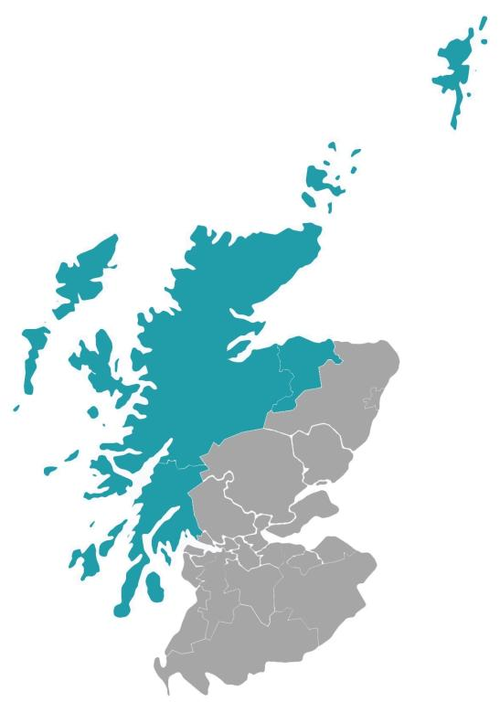

**Easy Read**

Easy Read logo of woman smiling and reading an Easy Read
 

|  |  |
| --- | --- |
| Report by the Scottish Human Rights Commission (SHRC) |  |

Contents

| **Heading** | **Page number** |
| --- | --- |
| Background | Page 3 |
| Our approach | Page 5 |
| Our findings | Page 6 |
| Our recommendations | Page 7 |
| Conclusions | Page 11 |

## Background

|  |  |
| --- | --- |
| Scottish Human Rights Commission logo | We are the Scottish Human Rights Commission. |
| 2024 calendarUnited Nations logo | In 2023 we sent a report to the United Nations. |
| A row of houses | We said there was not enough housing in the Highlands and Islands and that it was expensive. |
| A hospital building with ambulances parked in front of it | We also said there were problems with accessing health care and school. |
| 2023 calendarA woman writing on a clipboard | In April 2023 we decided to do more work in the Highlands and Islands. |
| Report booklet | We have now published a report to tell people what we found. |

## Our approach

|  |  |
| --- | --- |
| A white cruise ship in waterA group of people sitting around a table | We did this work by going to the Highlands and Islands. We met with lots of people there. |
| A person holding a clipboard with a green check mark on itA person holding a clipboard with a red x on it | Our report says what is happening to the human rights in the Highlands and Islands. |

## Our findings

|  |  |
| --- | --- |
| A person holding a clipboard with red cross marks | Our report says that there are big challenges for some human rights in the Highlands and Islands. |
| Man wheeling a patient in a hosptial bedAn older woman standing with a pallet of food. Behind her is a sign for a foodbank | We say there are serious issues with things like food, housing, and healthcare. |
| A person in a red shirt pointing her thumb down | We also say that things seem to be getting worse for human rights. |
| A person standing next to a white board with red crosses | We say that many public services are having problems. For example, healthcare services. |

## Our recommendations

|  |  |
| --- | --- |
| A blue square with a white number 8 on it | We have made 8 recommendations. Recommendations means ideas for what needs to change. |
| The scales of justice | The Scottish Government should make stronger human rights laws. |
| A clock and a red triangle sign with an ! on it to show that it's an emergency. | Some things are urgent and the Scottish Government and other organisations who are responsible should act now. |
| A man holds up a sign with a red cross and then he holds up a sign with a green tick | All public services need to be made better.  Thinking about human rights when planning public services would help with this. |
| A woman holding her hand to her ear | The organisations responsible for human rights in Scotland need to listen to people more often. |
| A farmer standing with a sheep dog and a group of sheep | Plans for delivering things like   * Healthcare * education * housing   need to be flexible, so they work well everywhere, including rural areas. |
| Two people talking, one is writing down what the other is saying | When planning, organisations must do impact assessments.  This means to look at how their plans impact human rights. |
| A black arrow on a target pointing to the middle | The Scottish Government must have a set of goals to make human rights better. |
| Bags of money with pound signs | People who are deciding how much money is available to spend on public services need to think about human rights. |

## Conclusions

|  |  |
| --- | --- |
| Scottish Government logoScottish Parliament building | We are asking the Scottish Government and Parliament to consider our report. |
| Woman writing on a clipboardA group of people sitting around a table | We plan to do more work like this report in other parts of Scotland. |
| A young man holding a sign with a red cross and then later he is holding up a sign with a green tick. | We hope our report can help make things better. |
| A computer with a blue screen | You can read the full report on our website at [www.scottishhumanrights.com](https://www.scottishhumanrights.com/projects-and-programmes/spotlight-projects/economic-social-and-cultural-rights-in-the-highlands-and-islands/) |