# Annual Report 2023 to 2024

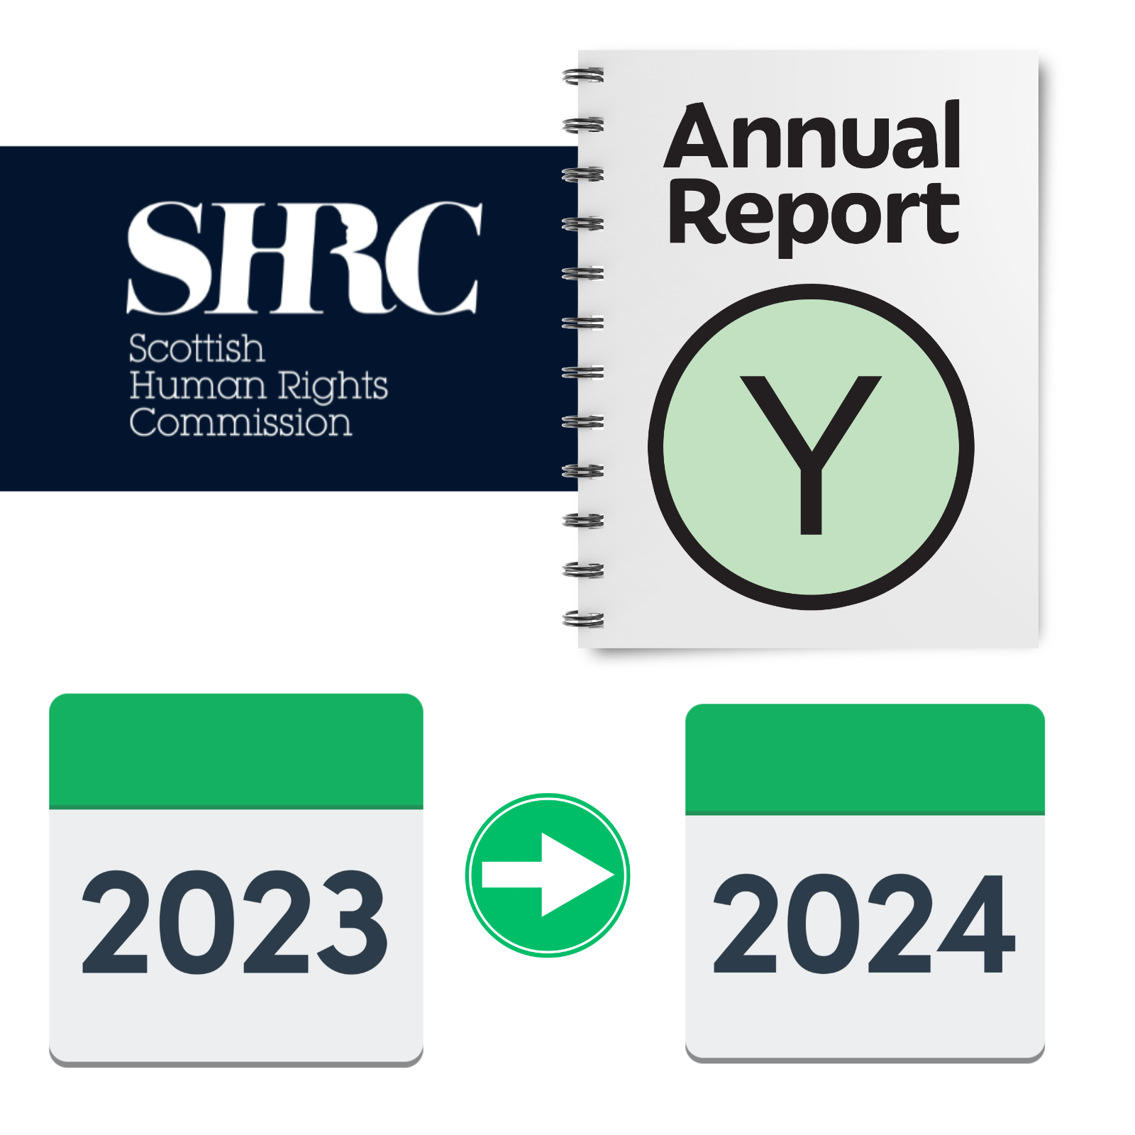

**Easy Read** Easy Read logo of woman smiling and reading an Easy Read
 

|  |  |
| --- | --- |
| Report by the Scottish Human Rights Commission (SHRC) |  |

## Contents page

| **Heading** | **Page number** |
| --- | --- |
| Who we are | Page 2 |
| The work we do | Page 4 |
| Spotlight Projects | Page 6 |
| Our other work | Page 8 |
| Find out more | Page 11 |

## Who we are

|  |  |
| --- | --- |
| Scottish Human Rights Commission logo | We are the Scottish Human Rights Commission. We are called SHRC for short. |
| People in a circle around a woman protecting her underneath a Scotland flag. | Our job is to protect people’s human rights in Scotland. |
| Woman pointing to herself | Human rights are rights that every person has. For example, the right to be alive and the right to a safe place to live. |

## The work we do

|  |  |
| --- | --- |
| Man looking through a magnifying glass | We **monitor** human rights in Scotland. Monitor means to look closely and see if anything changes. |
| Report with arrows going in lots of directions | We write reports about how to make human rights stronger so that people have better lives.  We send the reports to   * the Scottish Parliament * the United Nations * the Council of Europe |
| Law and policy | We can suggest changes to laws and **policies**. Policies are written documents that say the rules about how we do things. |
| Report and a person thinking about human rights | Our reports also help people to learn more about human rights. |
| Calendar showing April 2023 and an arrow pointing to March 2024 | This report is a summary of our work from April 2023 to March 2024. |

## Spotlight Projects

|  |  |
| --- | --- |
| Man with a magnifying glass looking closely at a map of Scotland. | We started working on 4 Spotlight Projects. Spotlight Projects take a close look at some of the human rights issues that we are most worried about. |
| Report next to a woman giving advice on the phone. In her speech bubble is signposts pointing to support,  help and advice. | 1 Spotlight Project is about how to get help when you have a human rights problem in Scotland.  [You can find out more about this project on our website.](https://www.scottishhumanrights.com/projects-and-programmes/spotlight-projects/access-to-justice-for-potential-human-rights-breaches/) |
| A report next to a person behind bars in prison | 1 Spotlight Project is about human rights in prisons.  You can find out more about this project and an [Easy Read](https://www.scottishhumanrights.com/projects-and-programmes/spotlight-projects/absolute-rights-in-places-of-detention/) of the report on our website. |
| A group of disabled people next to the document on UN Disability Rights | 1 Spotlight Project is about human rights of people with learning disabilities and autistic people in Scotland.  [You can out more about this project on our website](https://www.scottishhumanrights.com/projects-and-programmes/spotlight-projects/moving-from-institutions-to-independent-living/). |
| Report next to a map of the UK with Scotland highlighted. A hand is pointing to the top of the map where the Highlands and Islands are | 1 Spotlight Project is about human rights in the Highlands and Islands.  [You can out more about this project on our website.](https://www.scottishhumanrights.com/projects-and-programmes/spotlight-projects/economic-social-and-cultural-rights-in-the-highlands-and-islands/) |

## Our other work

|  |  |
| --- | --- |
| Woman looking up and thinking. In a thought bubble above her head is a photo of the Human Rights Act. | We did research on what people think about human rights and published a report about it.  [You can find an Easy Read of the research here.](https://view.officeapps.live.com/op/view.aspx?src=https%3A%2F%2Fwww.scottishhumanrights.com%2Fmedia%2F2570%2Feasy-read-attitudes-to-human-rights-in-scotland.docx&wdOrigin=BROWSELINK) |
| 3 reports next to each other | We worked on the **Human Rights Bill**. The Human Rights Bill is a plan to make a law which protects more human rights under Scottish law.  We published 3 reports to help the Scottish Government make the Bill better. |
| Front of the Scottish Parliament building | We gave evidence to the Scottish Parliament on lots of human rights issues. |
| A group of disabled people next to the document on UN Disability Rights | We sent a report to the United Nations about disabled people's human rights being impacted by poverty.  [You can find an Easy Read for this report on our website.](https://www.scottishhumanrights.com/media/2471/easy-read-silc-report-for-shrc.pdf) |
| Man touching a woman's body without her permission and a report. | We sent a report to the Council of Europe about violence against women.  To help us write the report, we spoke to women who had experienced violence, including women with learning disabilities.  [You can find out what they said in the Easy Read report here.](https://view.officeapps.live.com/op/view.aspx?src=https%3A%2F%2Fwww.scottishhumanrights.com%2Fmedia%2F2609%2Feasy-read-istanbul-convention-report-summary.docx&wdOrigin=BROWSELINK) |
| A spiralbound plan document showing a team working together. | We also made a new **Strategic Plan**.  A Strategic Plan sets out what we are going to focus on. |
| Calendar pages showing 2024 to 2028. | The new plan covers our work 2024 to 2028.  [Read an Easy Read of our Strategic Plan here.](https://view.officeapps.live.com/op/view.aspx?src=https%3A%2F%2Fwww.scottishhumanrights.com%2Fmedia%2F2624%2Fstrategic-plan-2024-28-easy-read.docx&wdOrigin=BROWSELINK) |

## How to find out more

|  |  |
| --- | --- |
| Email on a laptop | If you want more information about our work, you can email us at [hello@scottishhumanrights.com](mailto:hello@scottishhumanrights.com) |
| A computer with a screen showing the SHRC logo | [You can find the full Annual Report on our website here.](https://www.scottishhumanrights.com/search?query=annual+report&topic=&year=) |
| Woman signing "rights" in British Sign Language. | This report is also available in British Sign Language ([BSL) on our website](https://www.scottishhumanrights.com/british-sign-language-bsl/) and our [YouTube channel](https://www.youtube.com/@ScottishHumanRights). |