Report on human rights and racism in Scotland
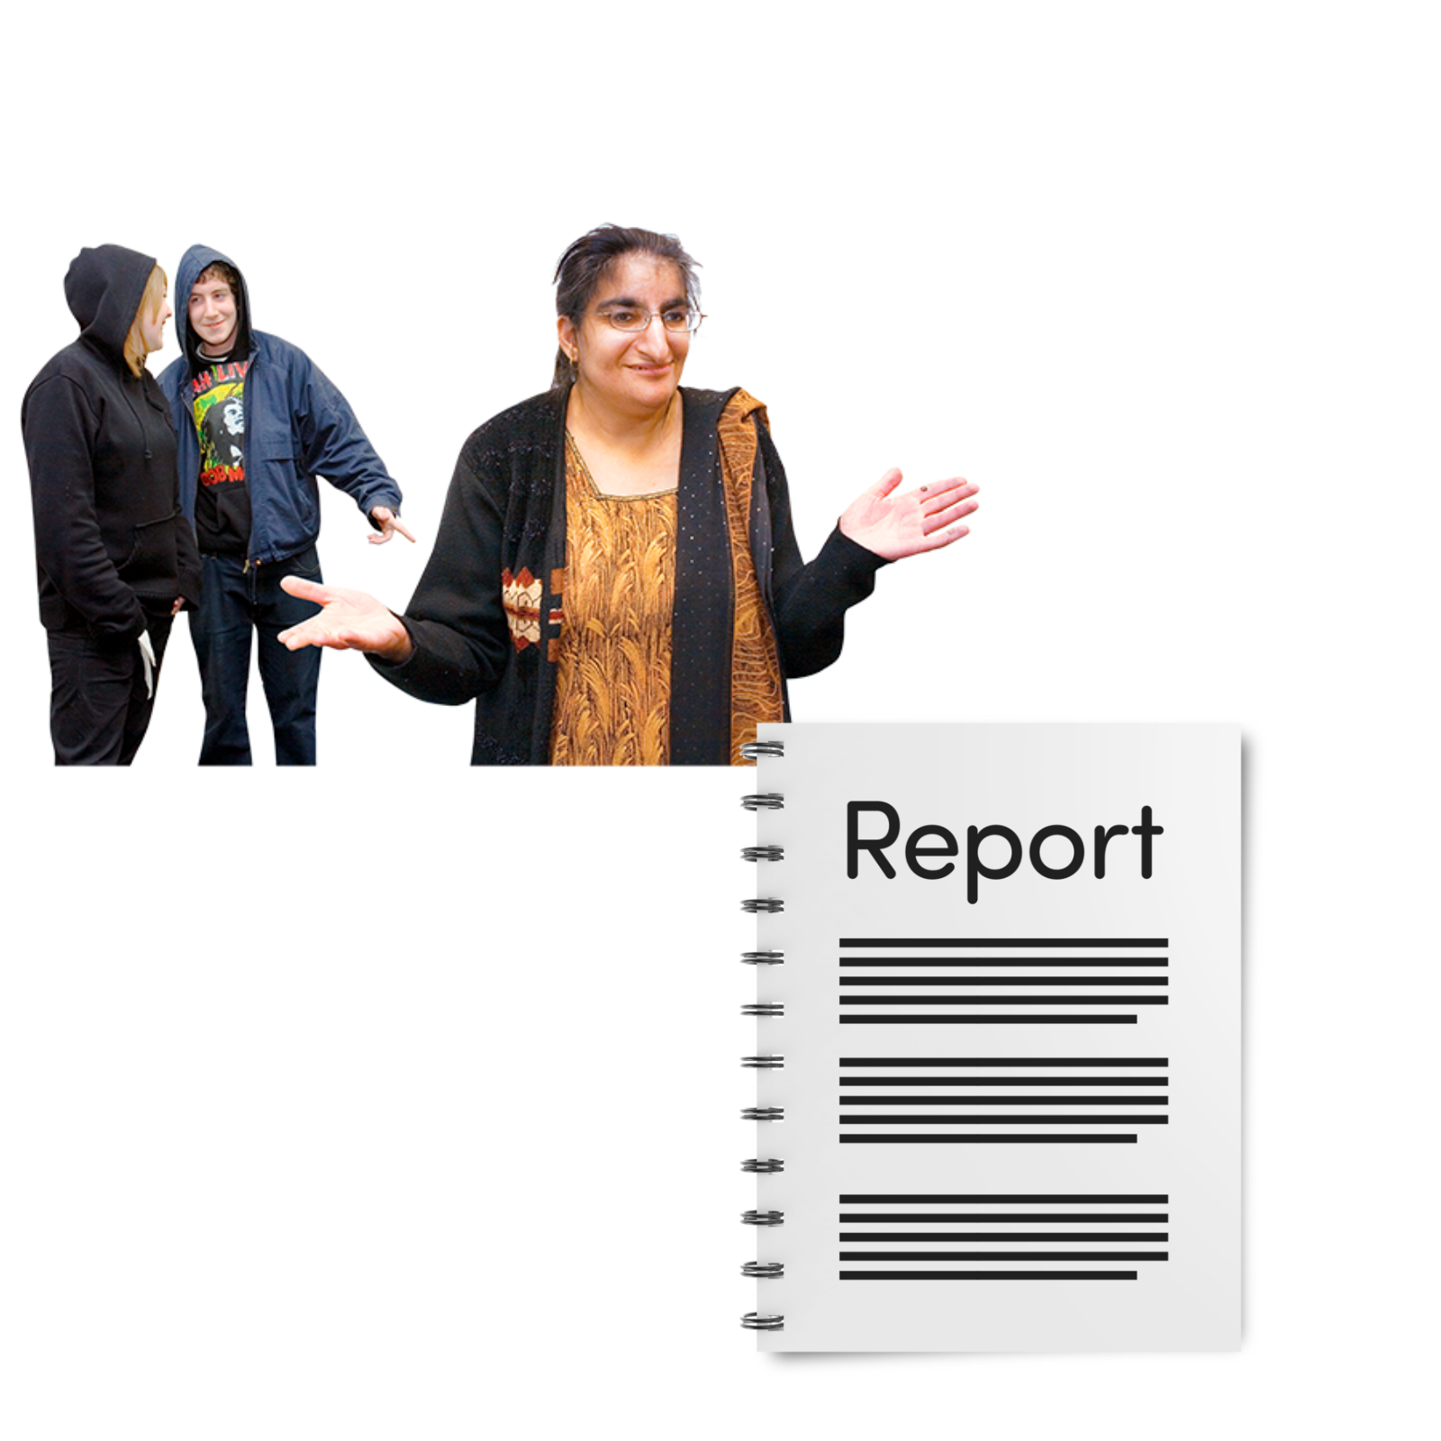

Easy Read

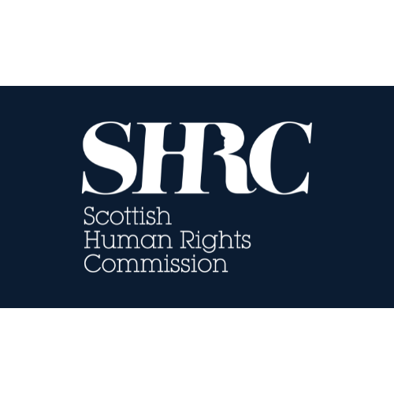 | Report by the Scottish Human Rights Commission

Contents page

Who we are | Page 2
What this report is about | Page 3
What the report says | Page 5
Some of the big problems | Page 6

Who we are
 | We are the Scottish Human Rights Commission. We are called SHRC for short.
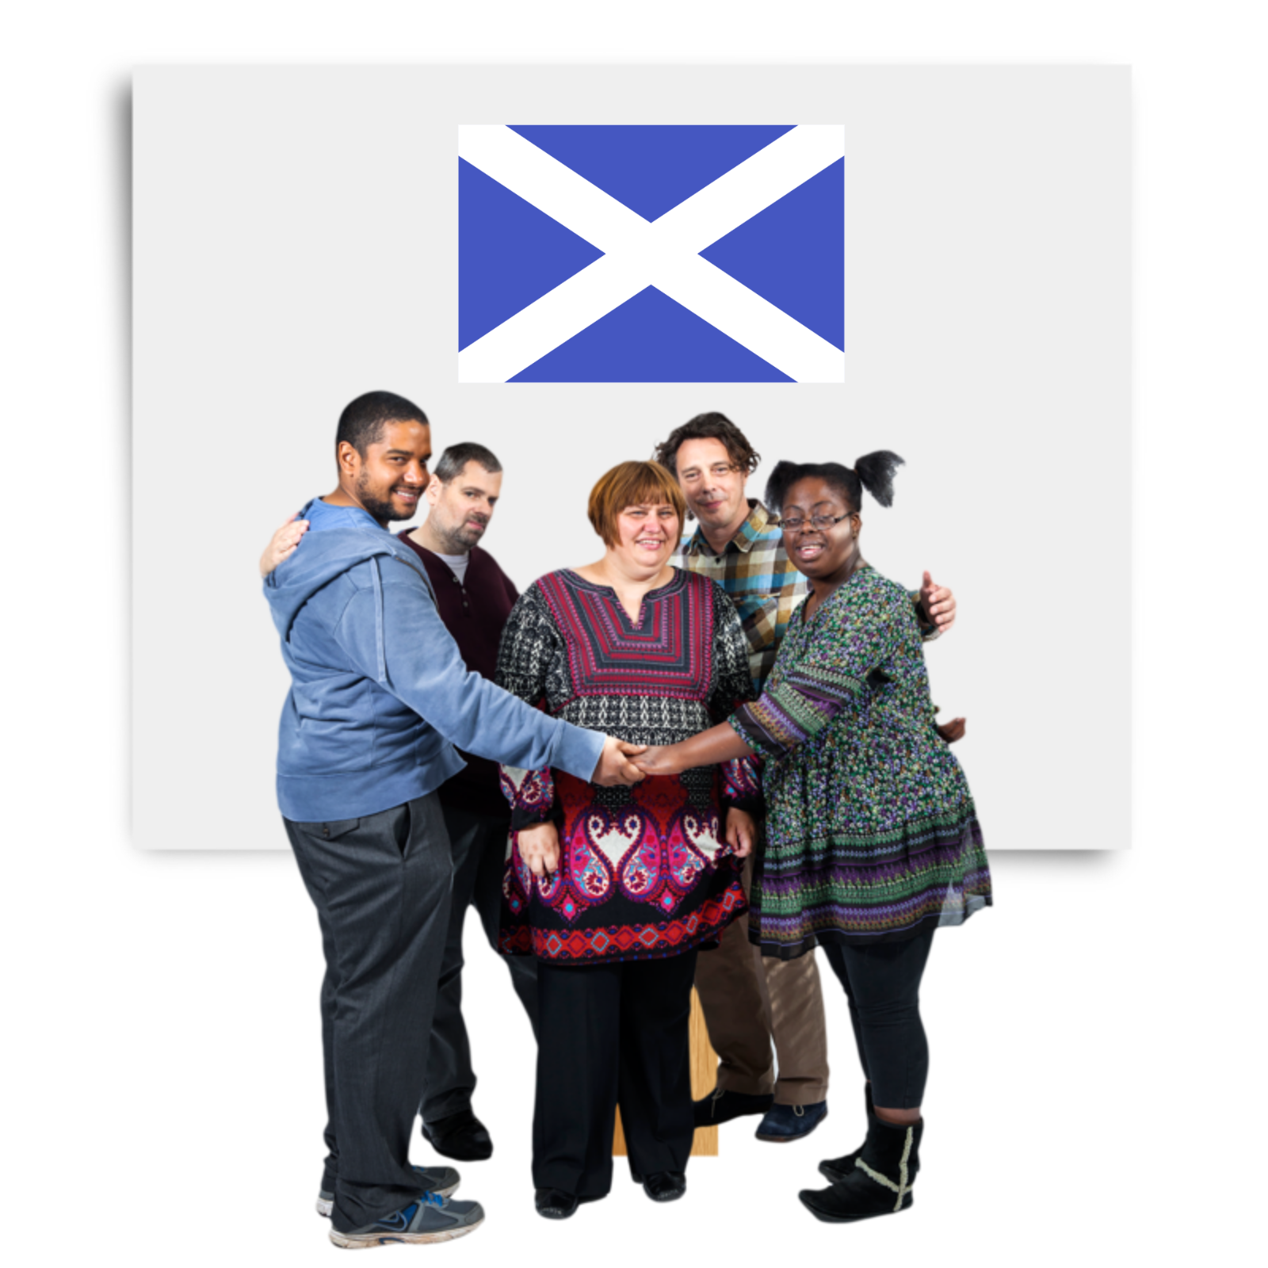 | Our job is to protect people’s human rights in Scotland.
 | Human rights are rights that every person has. For example, the right to be alive and the right to go to school.
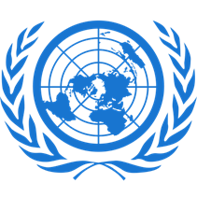 | The United Nations or UN for short, is where countries together to keep people safe and peace between countries.
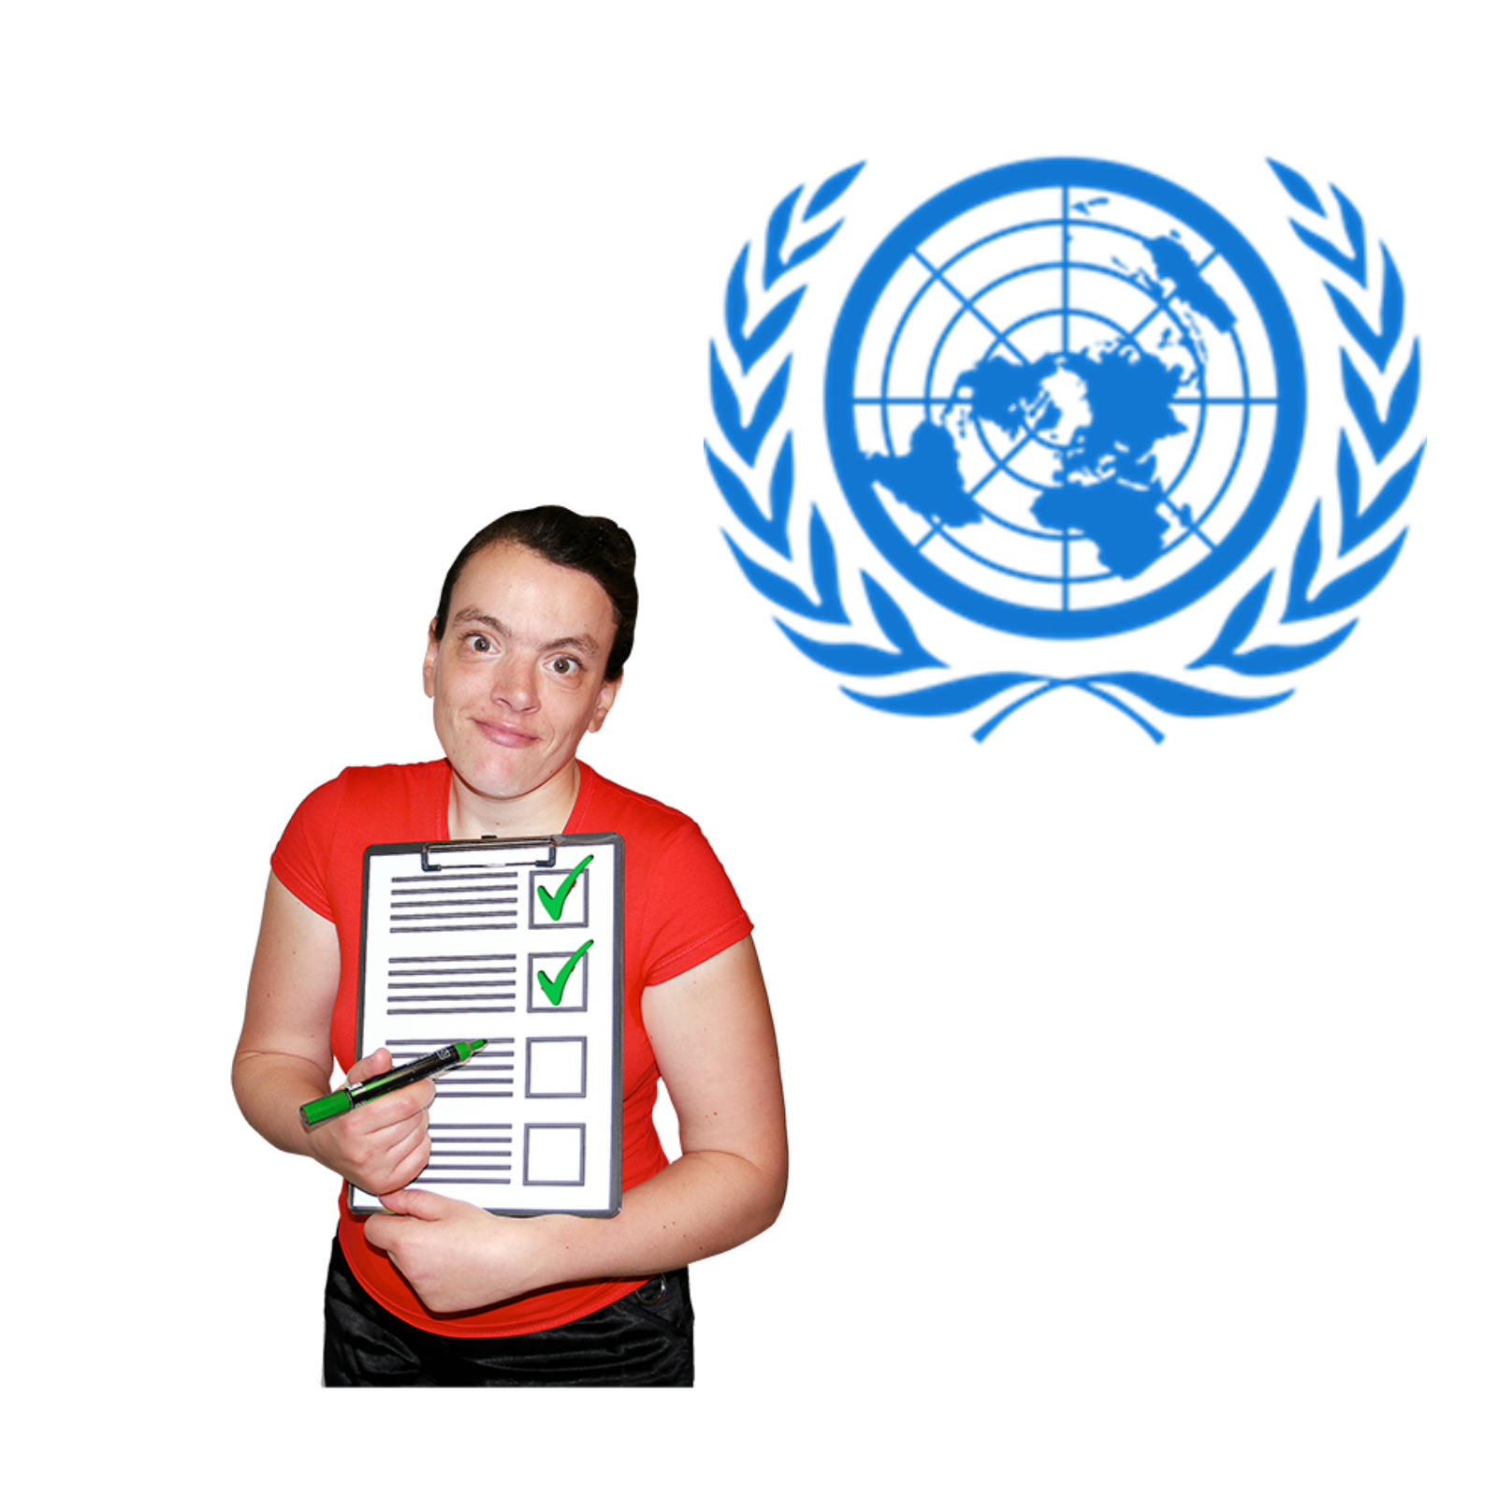 | Part of our job is to watch human rights in Scotland and tell the UN what is happening.

What this report is about
This report is about racism in Scotland, and we made it for the UN.

Racism is when people are treated differently because of the colour of their skin or where they are from.

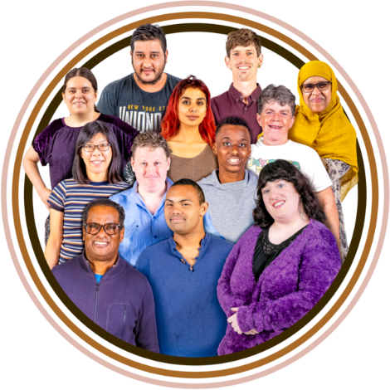 | People have different ways they like to describe themselves.  We say ‘people from a minority ethnic community’ to mean people who might look or talk differently or believe in different things than most people in Scotland.  This might be because they  - were born in a different country  - are from a different culture  - have a different religion  - or have a different skin colour
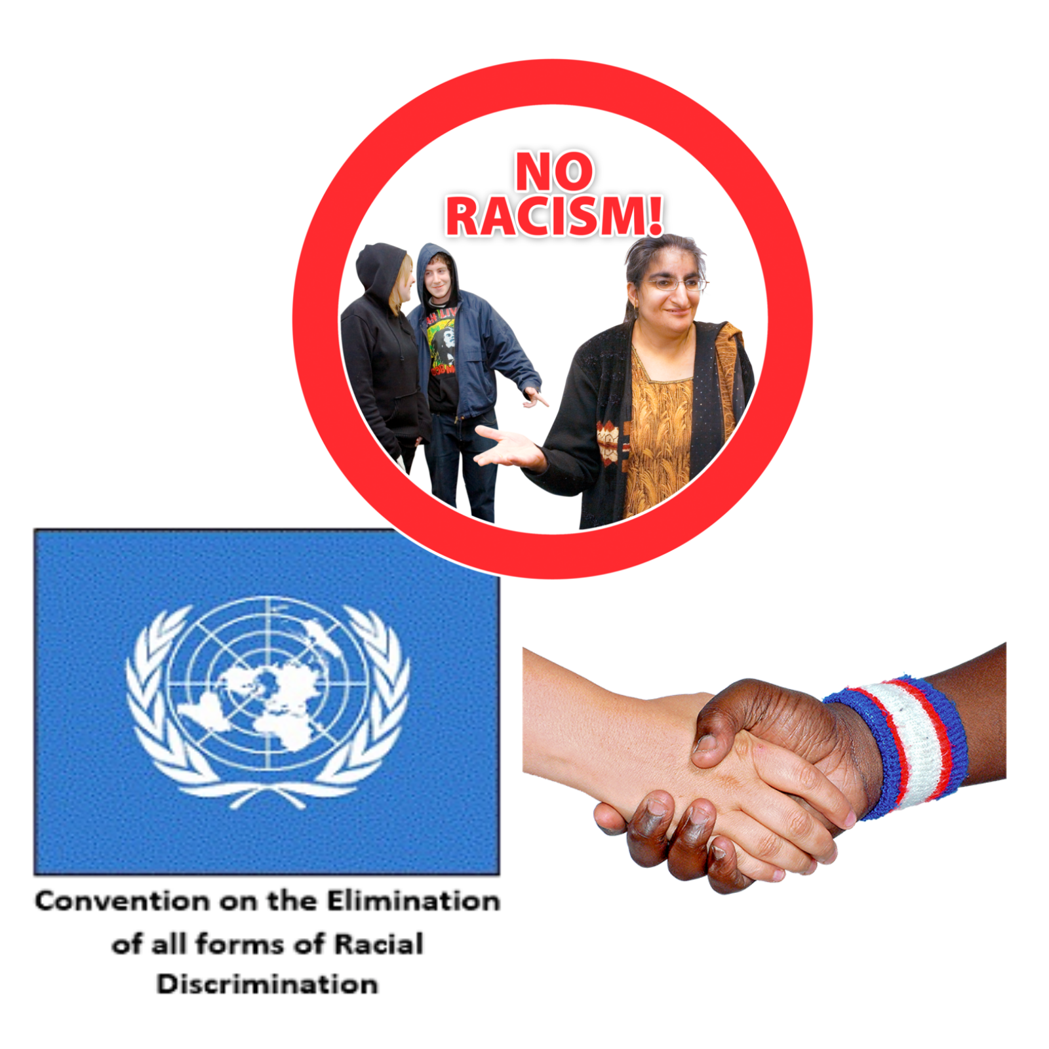 | Racism goes against human rights.  Scotland and the rest of the UK signed up to a human rights treaty to stop racism.  A human rights treaty is a promise that countries make to protect people’s rights.
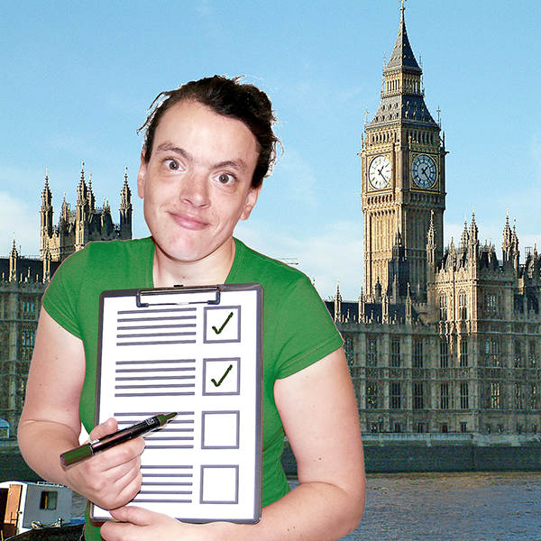 | The report will help the UN to make sure that the Scottish Government keeps its promises to stop racism.
We also wrote a report about people who had experienced racism.

To find out what people said, read Easy Read: Lived experiences of racism on our website.

What the report says
 | The Scottish Government has done some good things since the last time the UN checked.
For example, the Scottish Government made a plan to make human rights better.

This is called the Scottish National Action Plan for Human Rights.
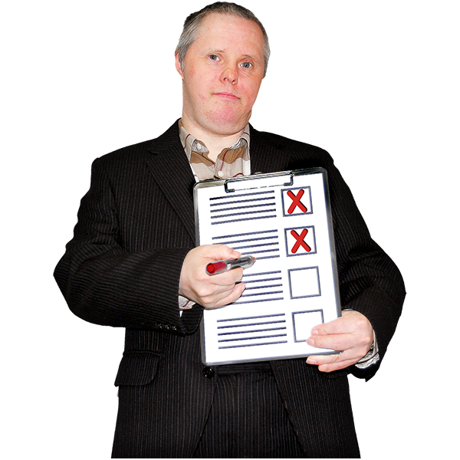 | But we think Scotland should do more to keep its promises.

Some of the big problems
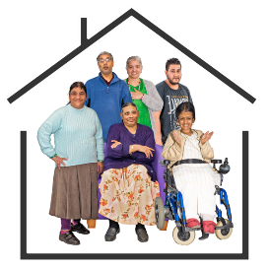 | Housing: People from minority ethnic communities are more likely to live in houses that cost too much money or do not meet their needs.
 | Poverty: People from minority ethnic communities are more likely to be poor, including children.
Benefits: Some people who come to the UK from other countries are not allowed to get the benefits that people born here can.

This rule makes people unsafe and poor.
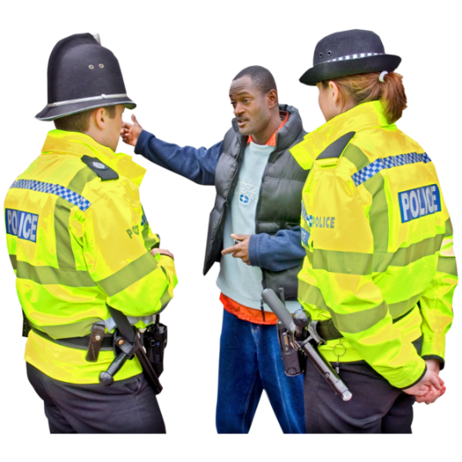 | Policing: Some people from minority ethnic communities do not trust the police to protect them.  Police Scotland have made a plan to get better, but it is too early to tell if it will work.
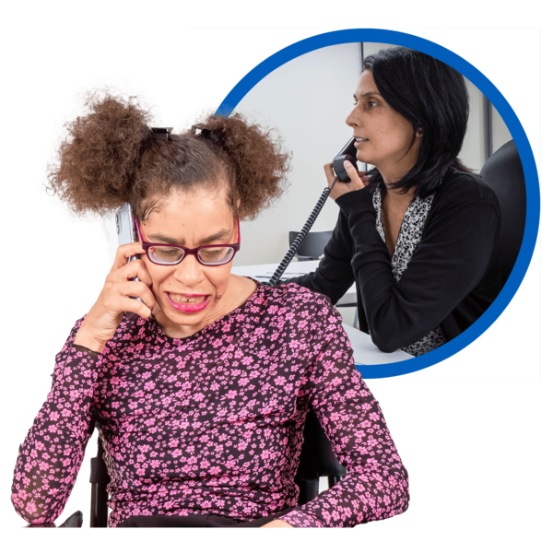 | Health: People from minority ethnic communities are more likely to be unwell.
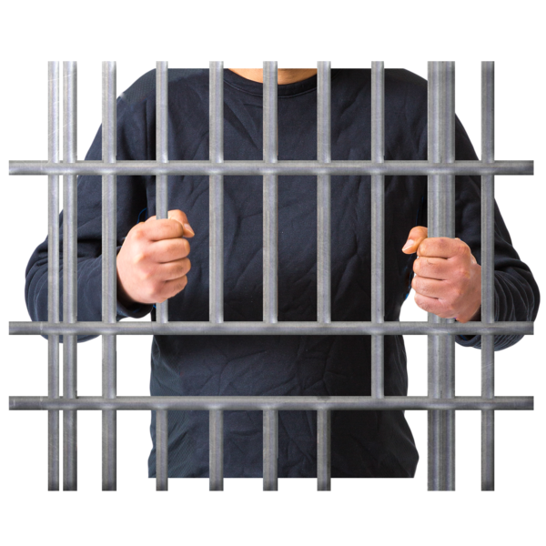 | Prisons: Some people from certain ethnic groups are more likely to get sent to prison.  It is hard to complain about racism in prison.
Immigration: People who move to the UK from another country need help from a lawyer to stay.

Getting a lawyer is hard and costs a lot of money.

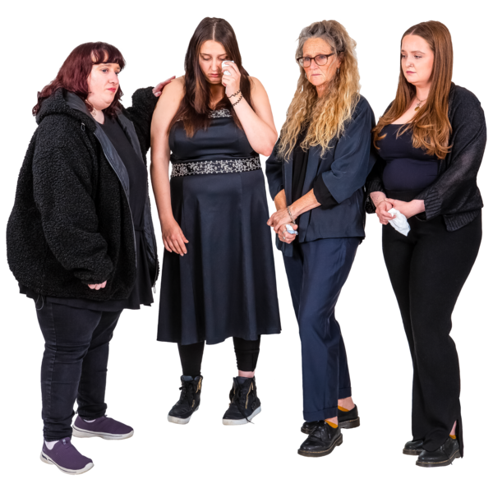 | Gypsy / Travellers in Scotland have been made to live in ways that go against their culture for a long time.  This has made people feel that the Scottish Government will not protect them.

