Real-life experiences of racism in Scotland
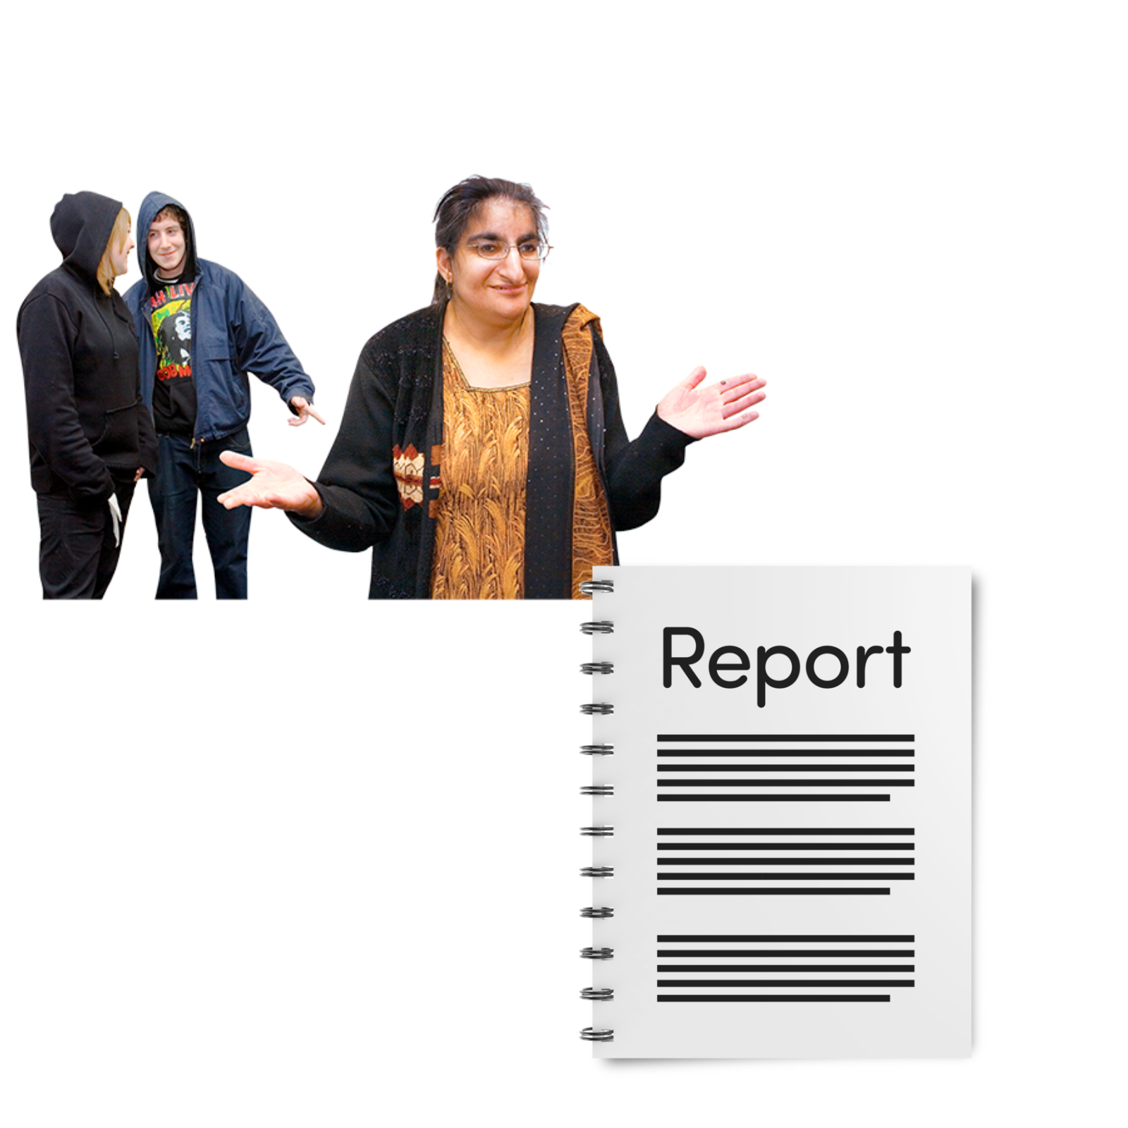

Easy Read

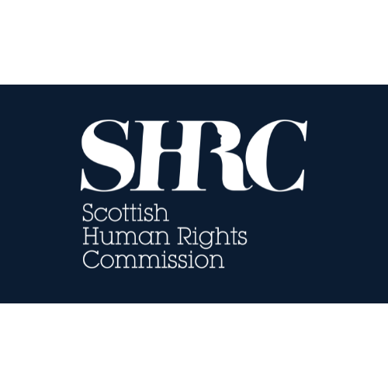 | Report by the Scottish Human Rights Commission with thanks to CEMVO and BEMIS

Contents
Who we are | Page 2
What this report is about | Page 3
What people at the CEMVO events told us | Page 4
What people at the BEMIS events told us | Page 7

Who we are
 | We are the Scottish Human Rights Commission. We are called SHRC for short.
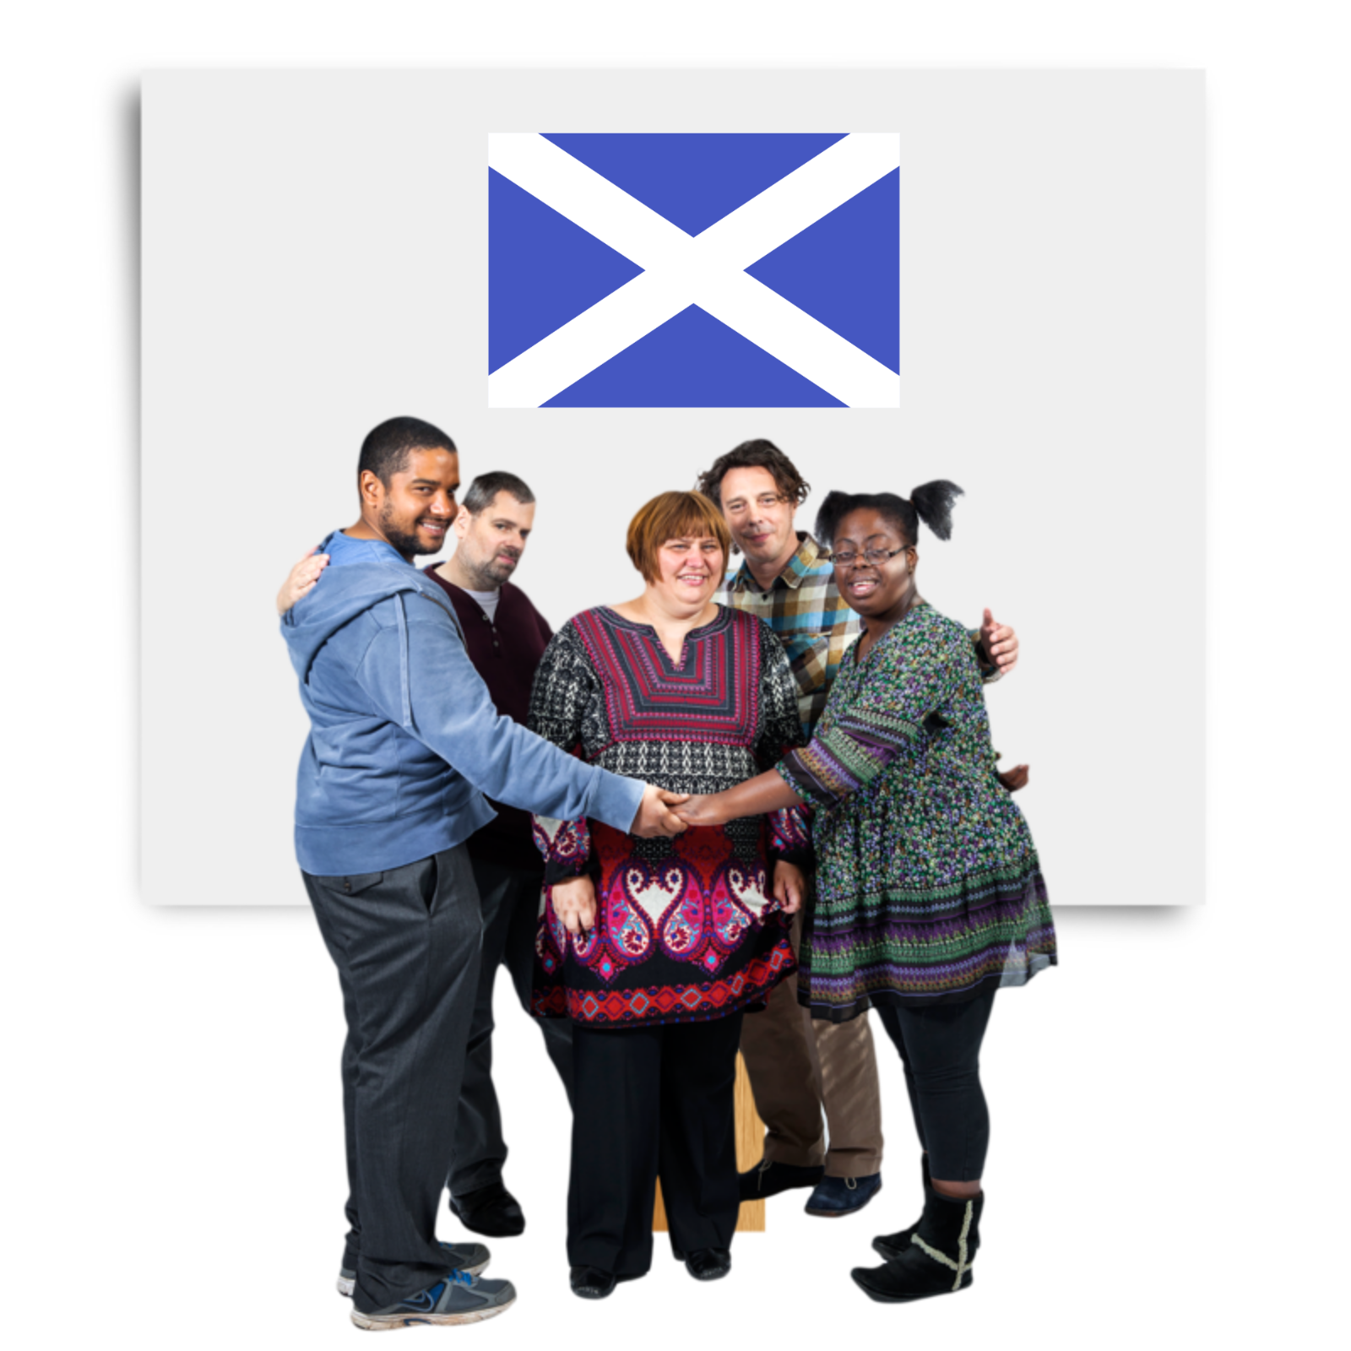 | Our job is to protect people’s human rights in Scotland.
 | Human rights are rights that every person has. For example, the right to be alive and the right to go to school.

What this report is about
This report is about people’s real-life experiences of racism in Scotland.

Racism is when people are treated differently because of the colour of their skin or where they are from.
To write this report, we went to events and talked to people who had experienced racism.
The events were set up by groups of experts called CEMVO and BEMIS.
We sent this report and another report about racism to the United Nations.

Read the other Easy Read report on our website: Report on Human Rights and Racism in Scotland

What people at the CEMVO events told us
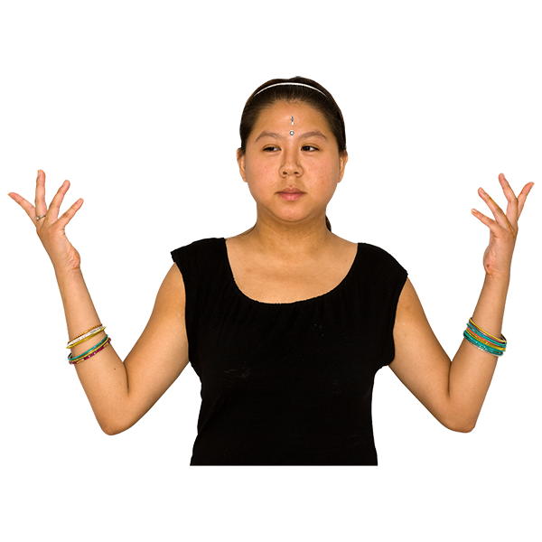 | People did not know what the Scottish Government was doing to stop hate crimes.  A hate crime is being harassed or attacked because people think you are different.
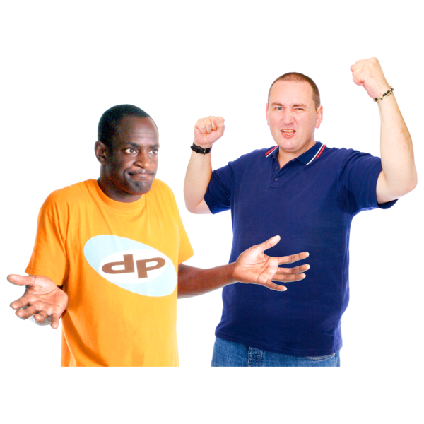 | People had experienced violence and harassment, but they did not know if it was a hate crime.
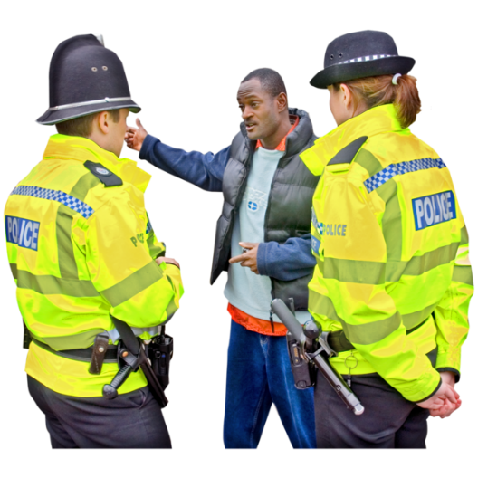 | People did not think the police would take hate crime seriously.
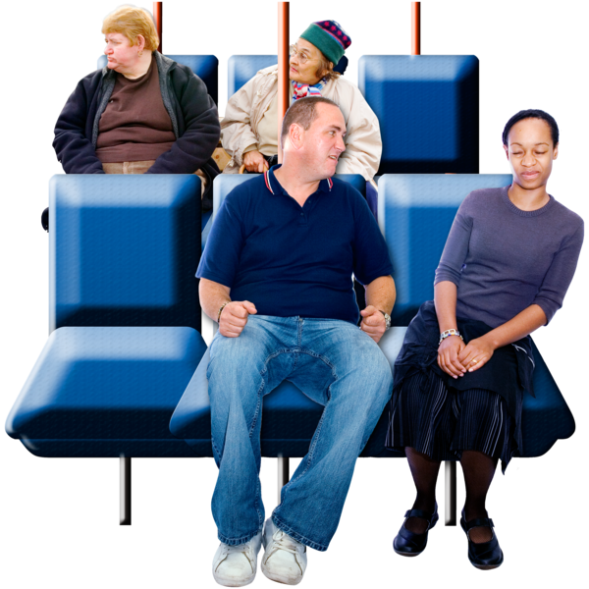 | People felt unsafe in some places, including at their jobs, in school and on public transport.
 | People agreed that school was important so that children could learn about other cultures and ways of life.
People also thought that racism happened a lot in school.

They thought some schools dealt with racism differently than others.
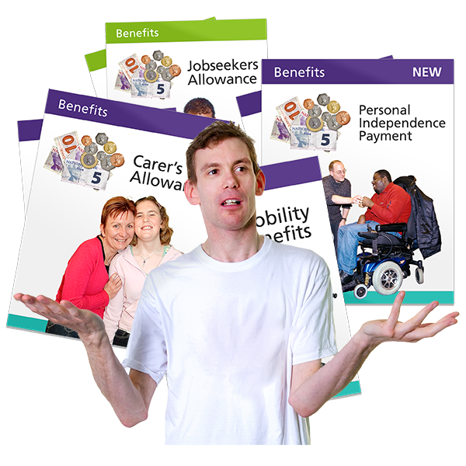 | Most people at the event had not applied for benefits in Scotland and had not heard of most of the available benefits.
 | People thought that the rules that mean migrants cannot get help from the government were unfair.
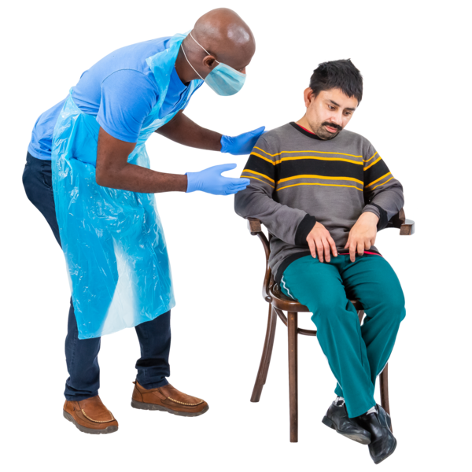 | Everyone thought that there were problems accessing healthcare in their communities.
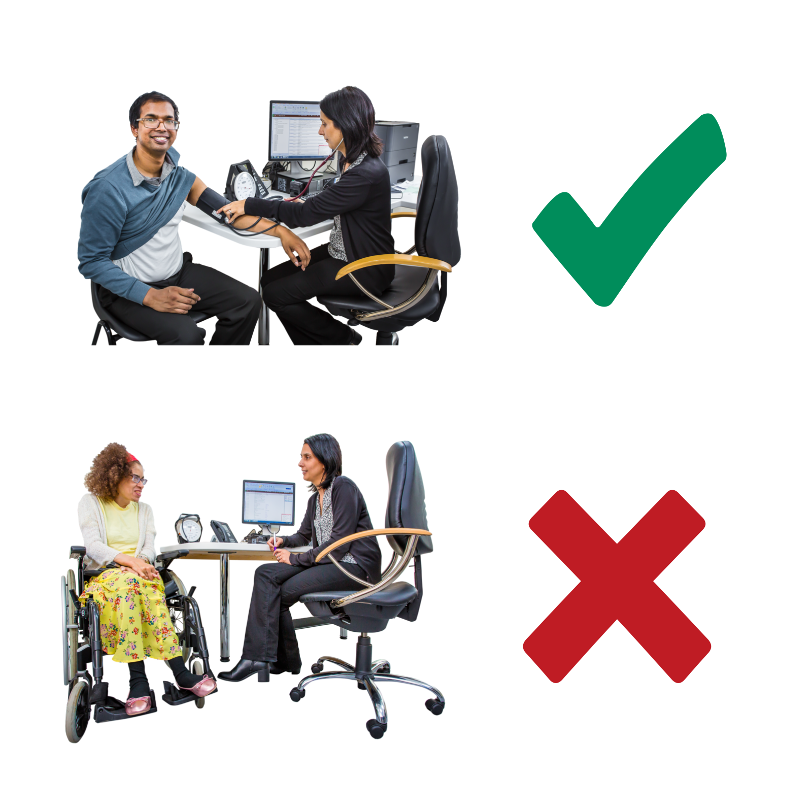 | Some people had very good experiences of the NHS.  Other people felt they were treated unfairly because of the colour of their skin or where they are from.
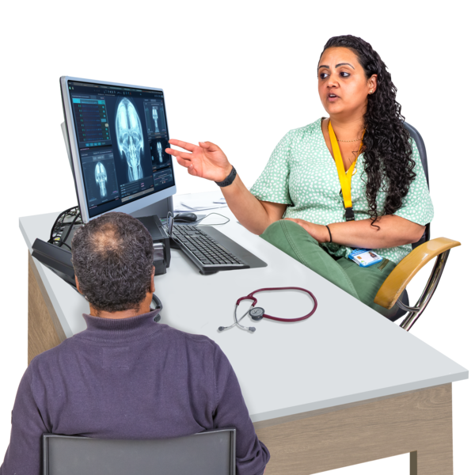 | People thought that people who work in the NHS did not always take them seriously.

What people at the BEMIS events told us
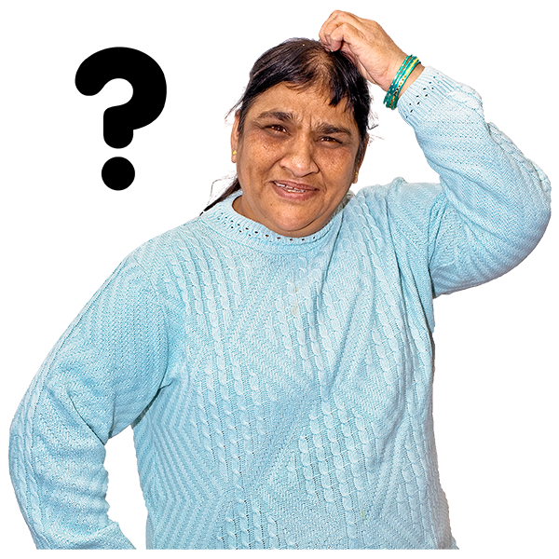 | People thought that it is too complicated to access services they need.
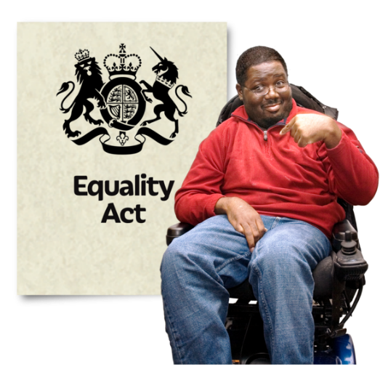 | People thought that the laws which should protect them from being treated unfairly are not working well enough.
 | People thought that Scottish Government’s plan to stop racism is not a big enough priority.
 | People thought that the things politicians and the news say make the public think bad things about people from different communities.
 | People were worried the police would not take them seriously if they reported a hate crime.
 | Many people sometimes felt unsafe in places like schools and on public transport.
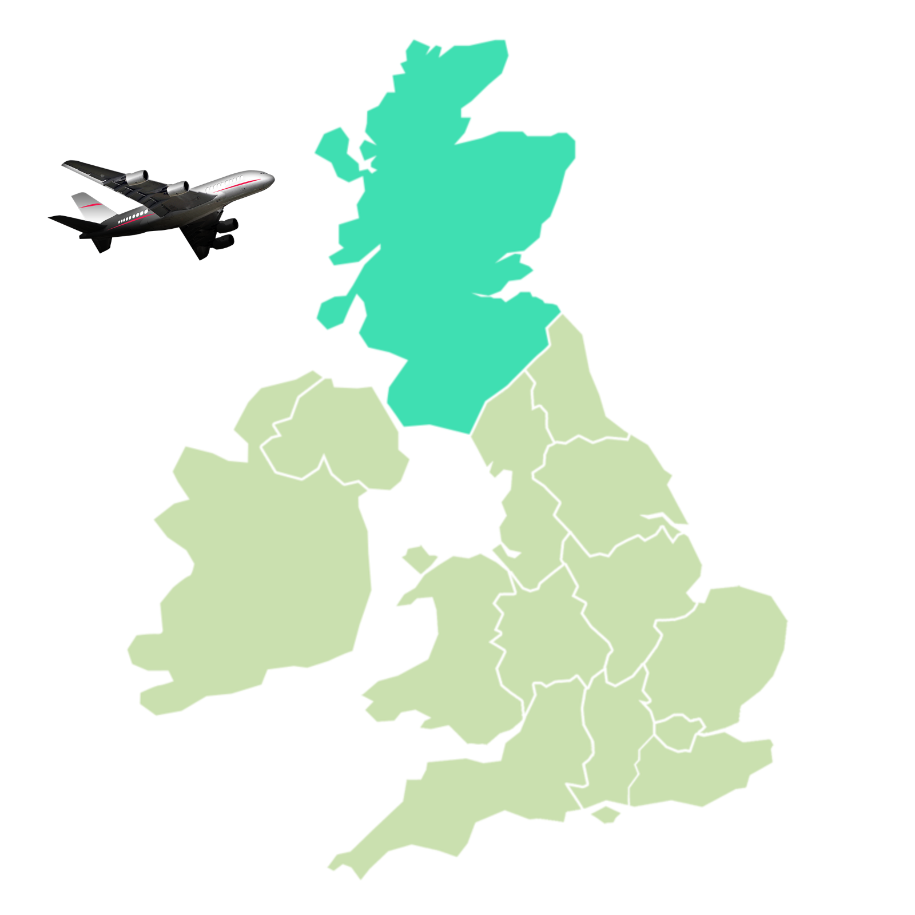 | People were very worried that the immigration system was not fair.  Immigration is when people move here from another country.
 | People thought that the UK immigration system is too hard, expensive, and treats people badly.
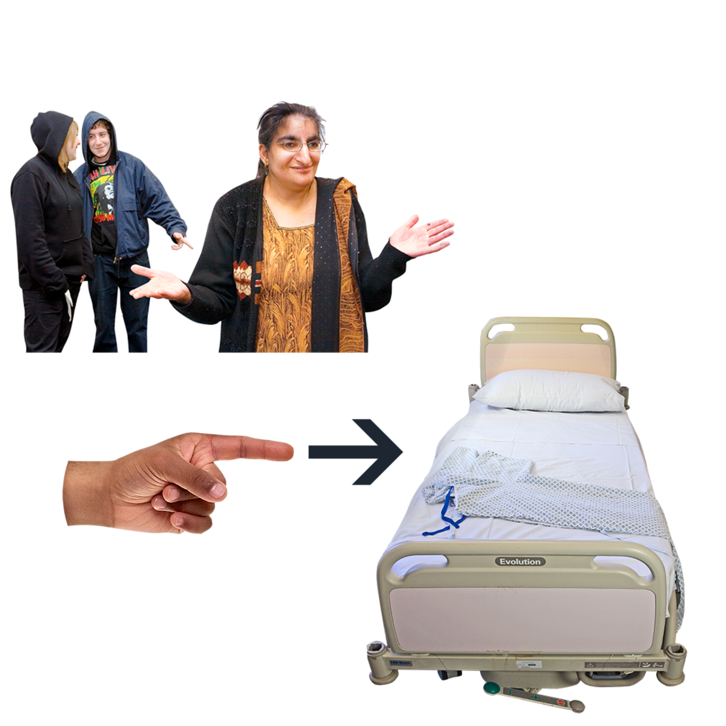 | People thought that racism leads to poorer health and wellbeing.

