# Human rights in Scottish prisons and mental health hospitals

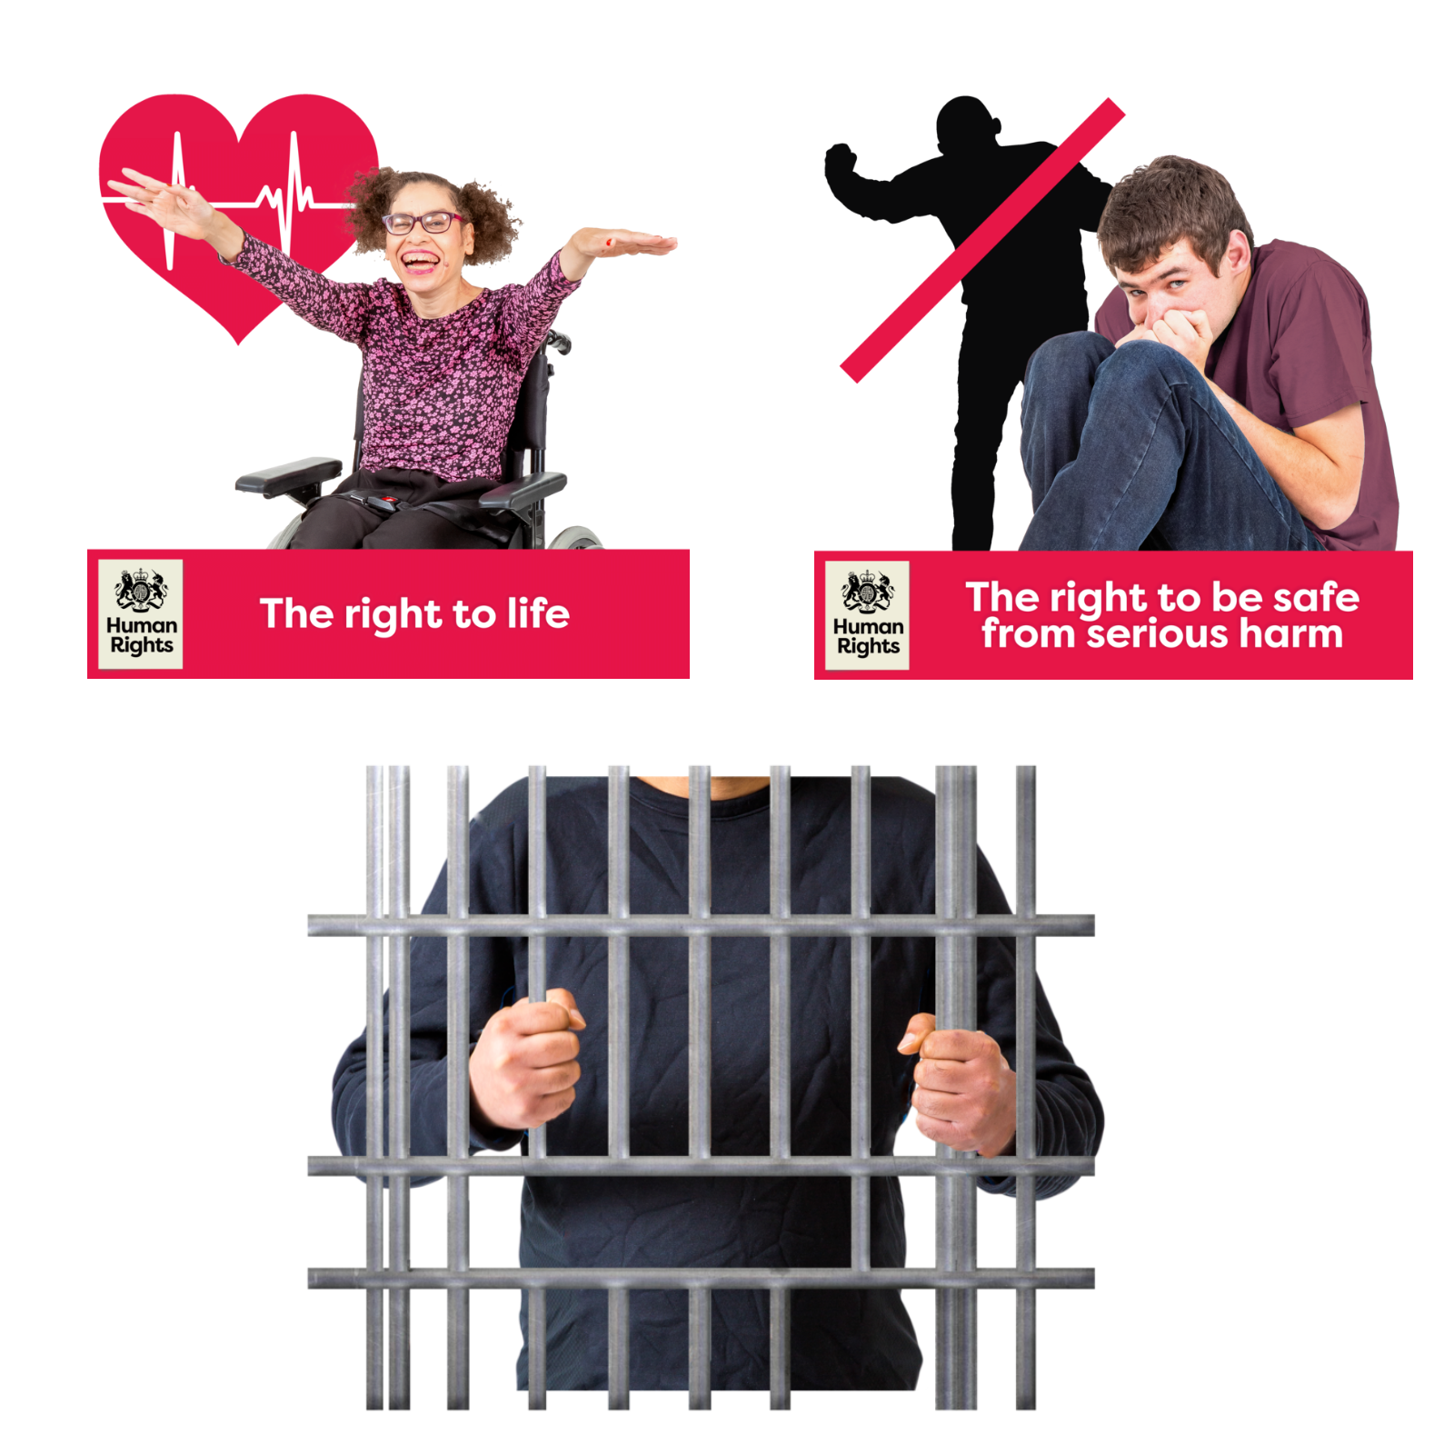

# Easy Read

 



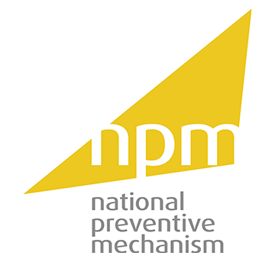

|  |
| --- |
| Report by the Scottish Human Rights Commission and the National Preventive Mechanism |

## Contents

| **Heading** | **Page number** |
| --- | --- |
| Who we are | Page 2 |
| What this report is about | Page 4 |
| Why we did the report | Page 5 |
| The recommendations we looked at | Page 6 |
| What the report says | Page 7 |

## Who we are

|  |  |
| --- | --- |
| Scottish Human Rights Commission logo | We are the Scottish Human Rights Commission. We are called SHRC for short. |
| People in a circle around a woman protecting her underneath a Scotland flag. | Our job is to protect people’s human rights in Scotland. |
| Woman pointing to herself | Human rights are rights that every person has. For example, the right to be alive and the right to go to school. |
| National Preventive Mechanism (NPM) logo | We wrote this report with the National Preventive Mechanism. This is called the NPM for short. |
| Person behind bars in prison. Above them is a human rights treaty. | The NPM’s job is to protect the human rights of people in prisons and other places that people are forced to stay. |

## What this report is about

|  |  |
| --- | --- |
| Man behind bars in prison and a report | The report measures progress on human rights in prisons. |
| Secure hospital and a report | The report also looks at human rights in the hospitals prisoners go to if they need help with their mental health. |
| Woman smiling next to a heart with a heartbeat frequency, text underneath reads "the right to life". Scared man hiding from the shadow of someone with their first raised. Underneath text reads "the right to be safe from serious harm" | The report looks at 2 human rights:   * The right to be alive * The right to be safe from serious harm |

## Why we did the report

|  |  |
| --- | --- |
| Woman frowning and looking worried, a thought bubble over her head with a prisoner in it. In the corner two people look at a big clock. | We have been worried about human rights for people in prisons for a long time. |
| Woman with her hand in the air surrounded by lightbulb ideas. Calendars above shows 2014 to 2024. | For more than 10 years, human rights groups have made **recommendations** of things that prisons could do to make human rights better. Recommendations means ideas for what needs to change. |
| Above her is a checklist with one ticked and one crossed. Woman with her hand raised in question. | We wanted to find out if the recommendations had been done and if human rights had got better for people in prison. |

## The recommendations we looked at

|  |  |
| --- | --- |
| Man has an idea, pointing finger up and smiling, a big lightbulb is next to him. | We looked at 29 ideas for changes in prisons and mental health hospitals for prisoners. |
| Crowd of lots of people with an X next to them. | 1 of the recommendations is to have less people in prisons to stop it from getting too crowded. |
| Booklet with a man's face on a grave. The title of the booklet is review. | Another recommendation is to do a better job at finding out what happened when people die in prison. |
| Brain | Another recommendation is to look after people in prison better when they need help with their mental health. |

## What the report says

|  |  |
| --- | --- |
| Rules No 5B | Most of the changes have not been done. Only 5 changes are on their way to being done. |
| Timer People 2 | We think the other changes are taking too long. |
| Checklist | We want the Scottish Government and the people in charge of prisons to make the rest of the recommended changes. |
| Inspectors Checking 8 | We will check again soon to see if the changes have been done. |