Scottish Human Rights Commission

The Istanbul Convention

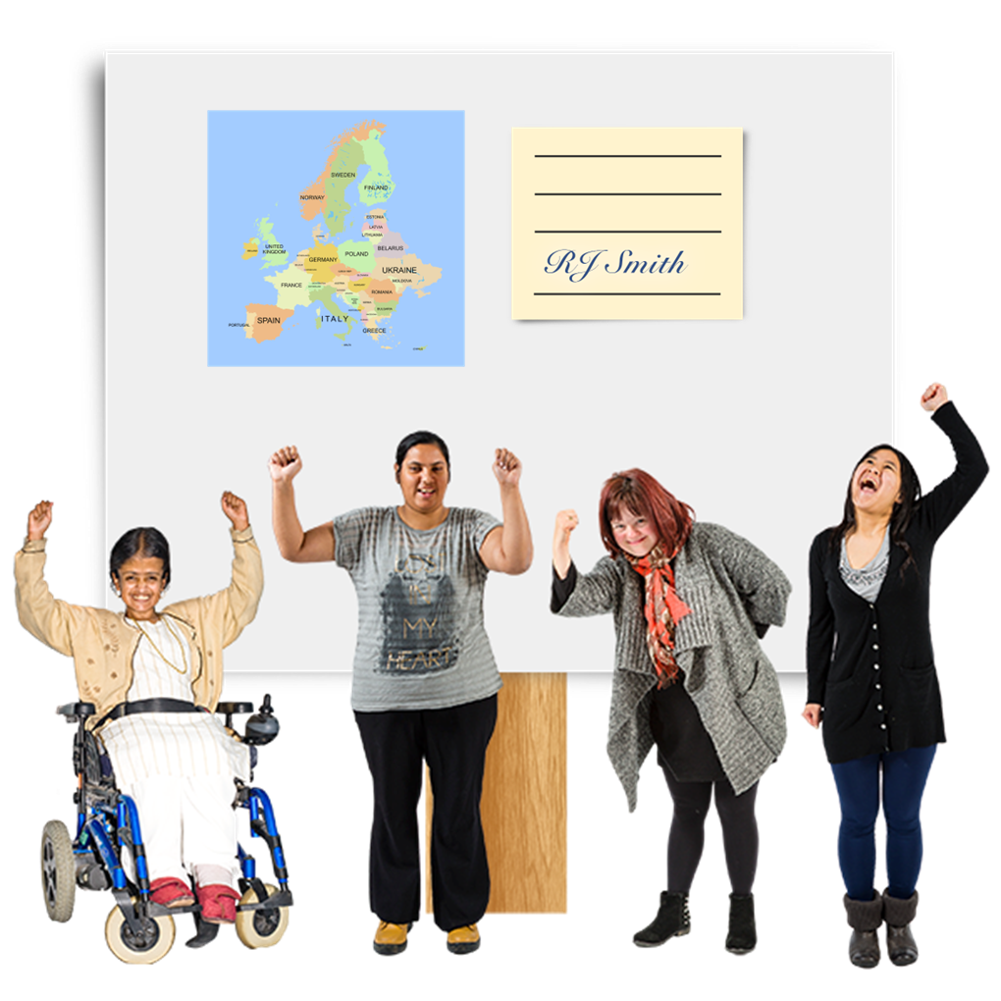

Easy Read

What is the Istanbul Convention?

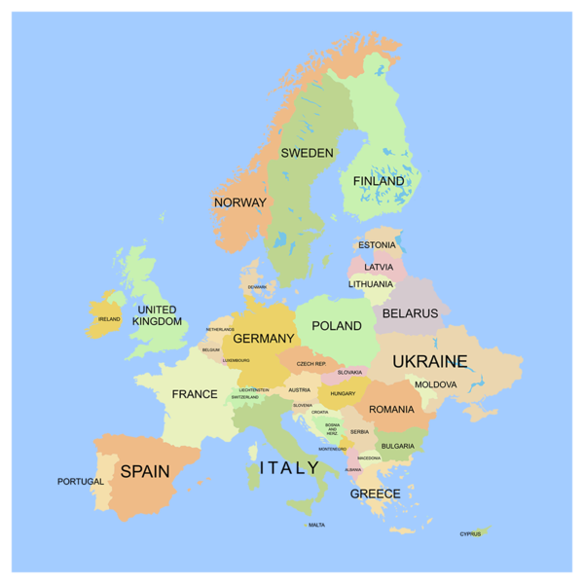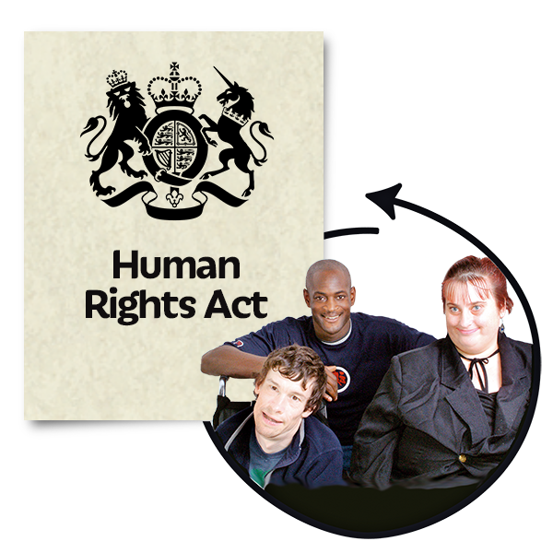 | The Istanbul Convention is a European human rights treaty about violence against women and girls.  Human rights are freedoms that are protected in law.  They make sure we are treated fairly and with dignity.  A treaty is a written agreement between countries that says how they will follow international law.
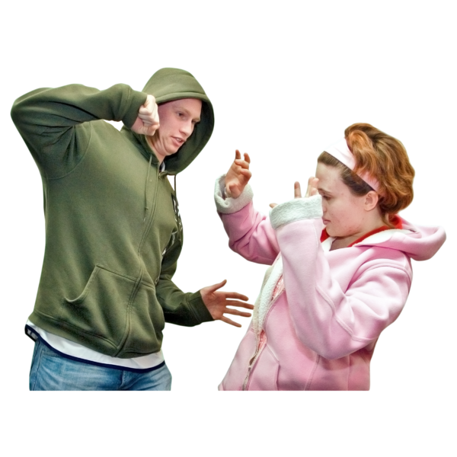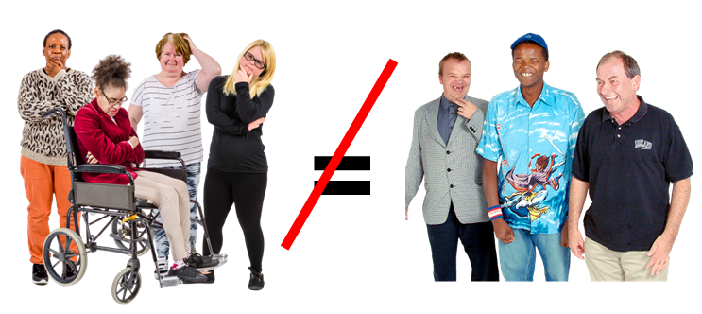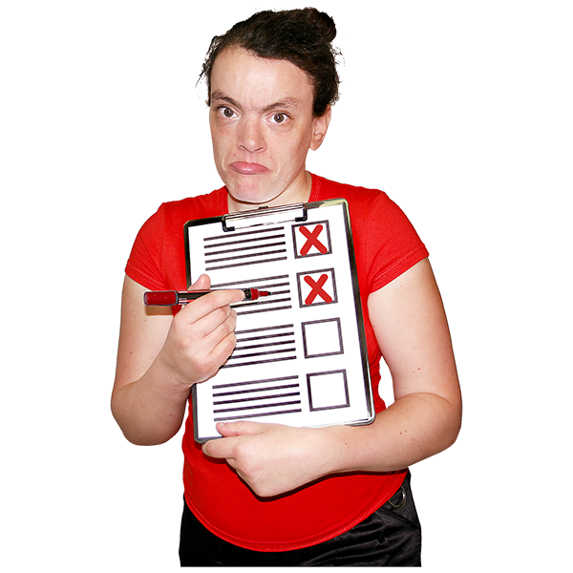 | The Istanbul Convention defines this violence as gender-based.  This means that women experience violence because they are women.  This violence happens because women and girls are not seen as equal with men and boys.  This violence and inequality shows that the human rights of women and girls are not being protected.
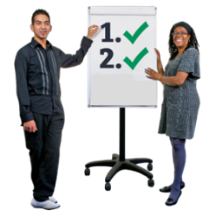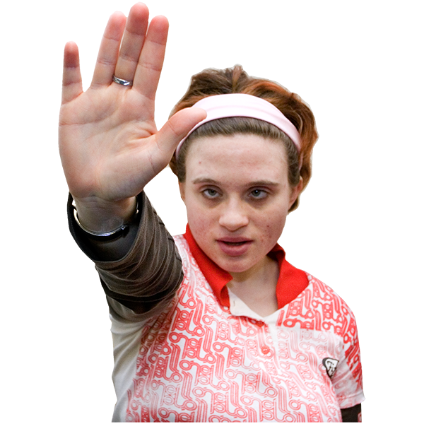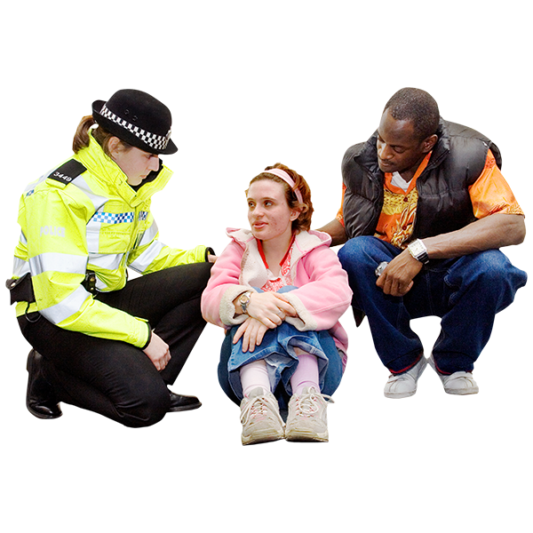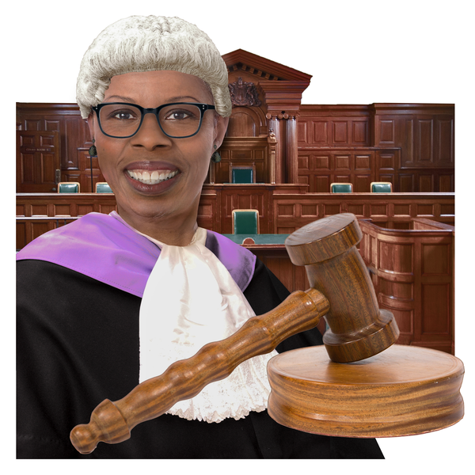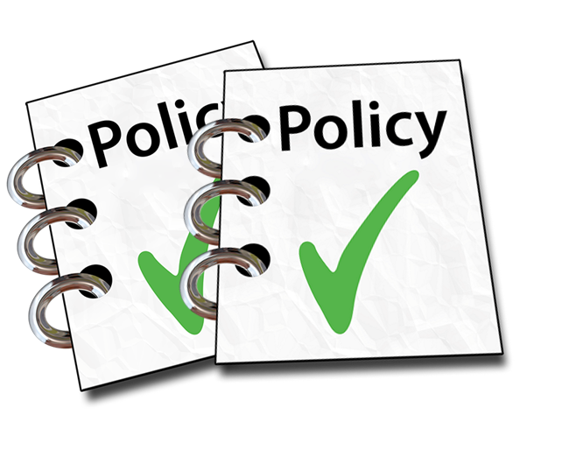 | By signing the convention, countries agree to:  - work to stop violence from happening  - make sure they respond properly when it does  This work is known as the 4 Ps:  - prevent – stop something from happening  - protect – keep people safe  - prosecute – to take someone to court if they have committed a crime  - and have policies – documents that:  - explain what they want to achieve  - show the work they are going to do
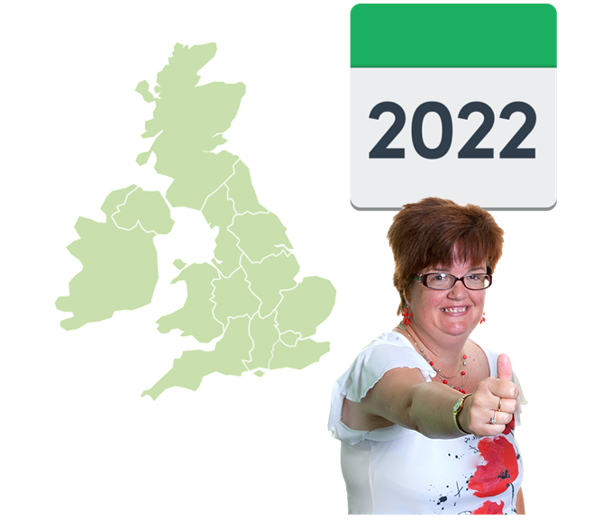 | Autism-Europe has made an Easy-Read version of the Convention.  The UK, including Scotland agreed to meet the standards in the Convention in 2022.  The Scottish Human Rights Commission checks how human rights are being protected in Scotland.
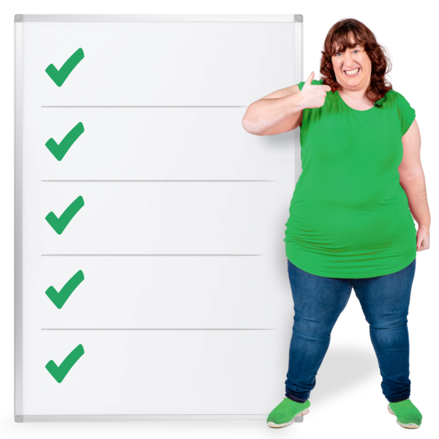 | A group of experts on violence against women, called GREVIO, has been set up to check how countries are meeting the standards.  The group makes recommendations so that countries work together to give advice and to move forward in their work.  A recommendation is what the group thinks should happen.
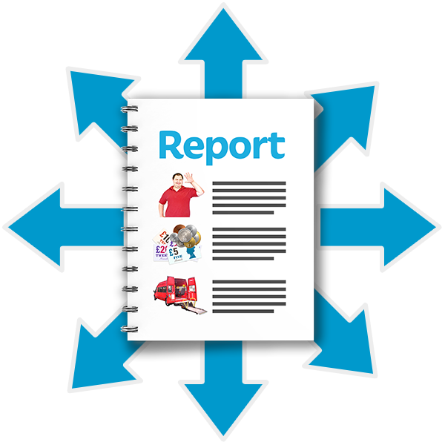 | We have sent a report to GREVIO to help them with their checks.  It is called a monitoring report.
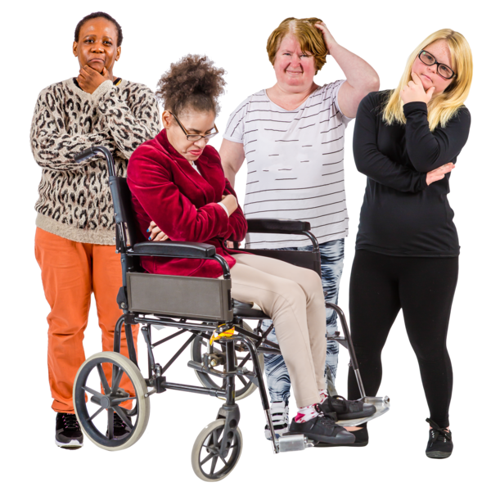 | The Scottish Government says that it wants to do many things to prevent, protect, prosecute and have policies about violence against women.  There is a big difference between this and the experiences of women and girls in Scotland who have had violence happen to them.
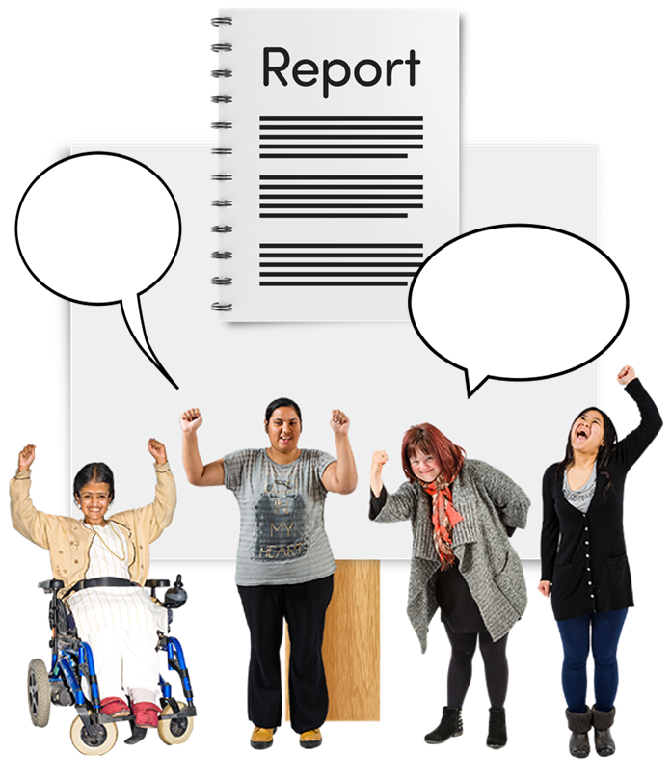 | We listened to women and girls who are part of survivor groups in Scotland.  A survivor is a person who has experienced gender-based violence.  They shared their experiences, which we  published in a report called ‘In Our Words’.
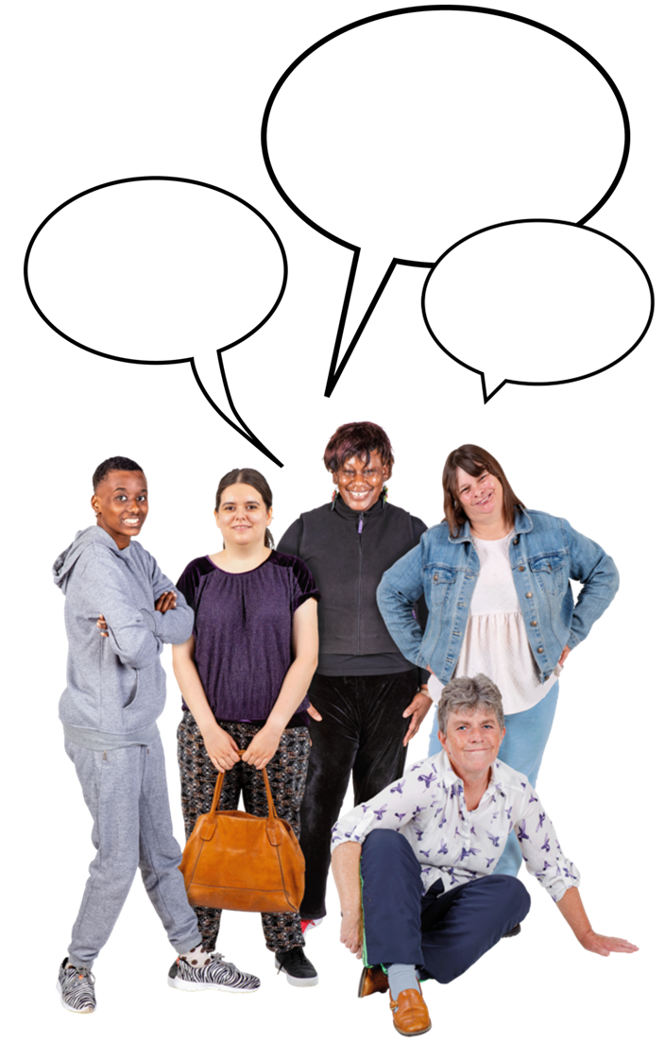 | The report uses the words of victim-survivors to show what they felt about reporting or getting support after experiencing violence.  Victim-survivors are people who have experienced a crime or action that has caused them harm.  They might prefer to call themselves a victim or a survivor of crime.

The most important things in the monitoring report
 | Scotland’s national policies for violence against women and girls are based on human rights including the Istanbul Convention.
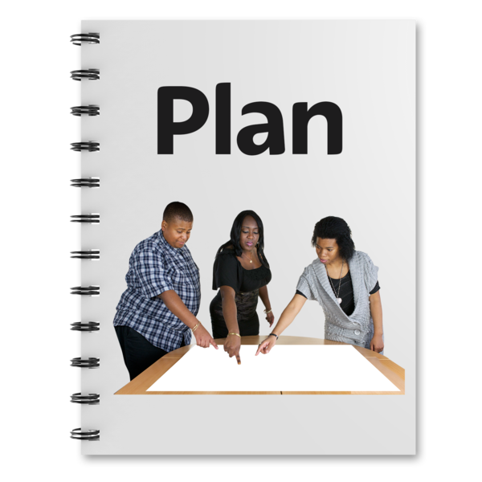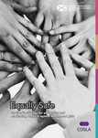 | The Scottish Government and local government have a national strategy called Equally Safe which describes how they will protect women and girls from violence.  A strategy is a big plan.
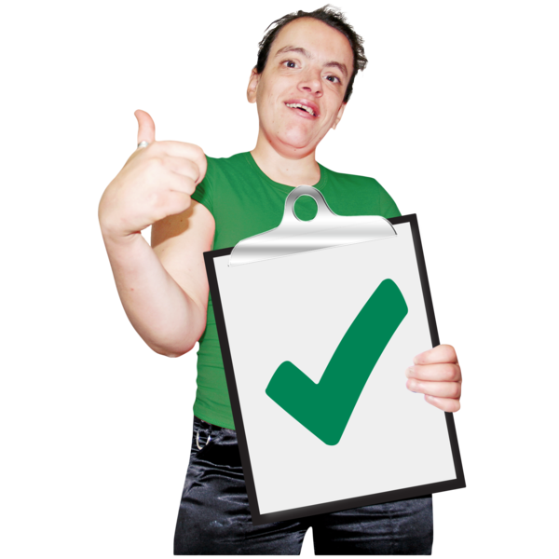 | We found that this strategy has helped people to understand what gender-based violence against women and girls is.
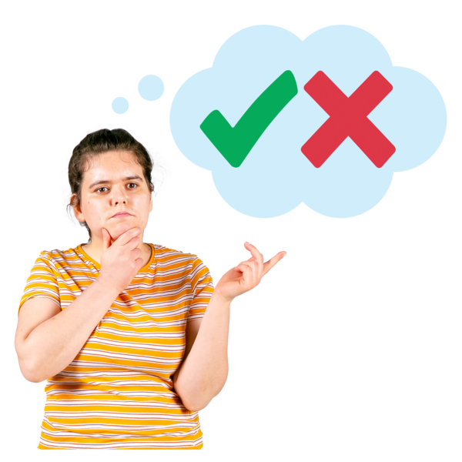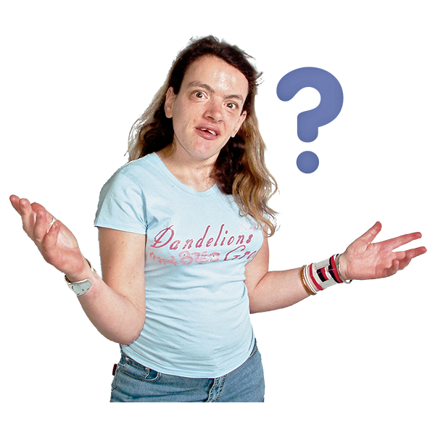 | There is a big difference between what Equally Safe says and what women and girls say about their actual experiences.  Equally Safe does not have a very clear way of checking how things have changed.  This makes it difficult to say if Equally Safe has made things better for people.
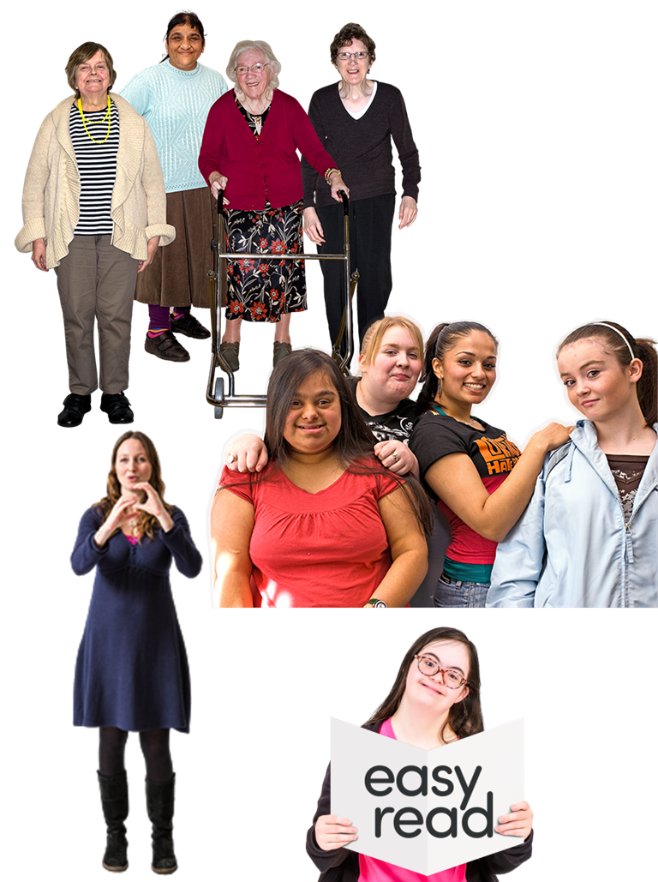 | There needs to be more understanding about how different groups of women and girls might need different types of support or information.
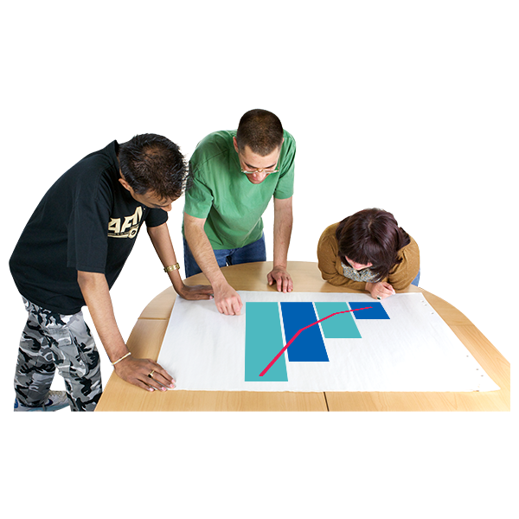 | We do not have enough data and evidence, especially about groups of women who are treated even more unequally.  Data is facts, figures and information.  Evidence is information that proves something is true.  Human rights can help us to know what data and evidence is needed.
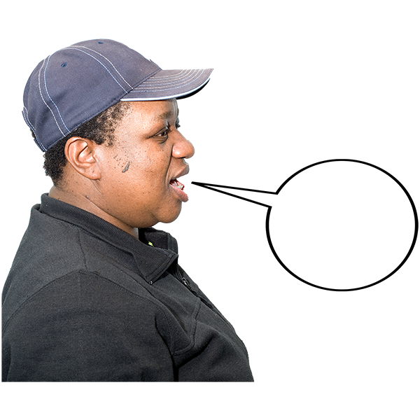 | Victim-survivors want to share their stories to make things better for other women and girls.  The organisations that work with victim-survivors are not usually given funding to do this work properly.
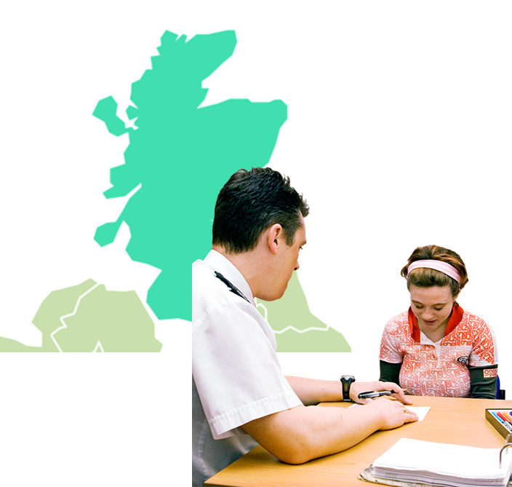 | Getting support after being the victim of violence is difficult for women because support services are not the same in all parts of Scotland.
Many support services for victim-survivors:

- do not have enough funding – money for the work they do

- funding amounts do not always stay the same or are enough for future services

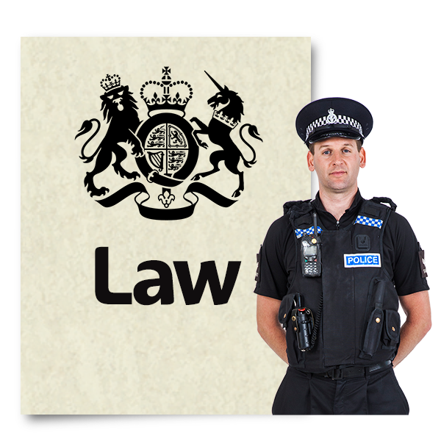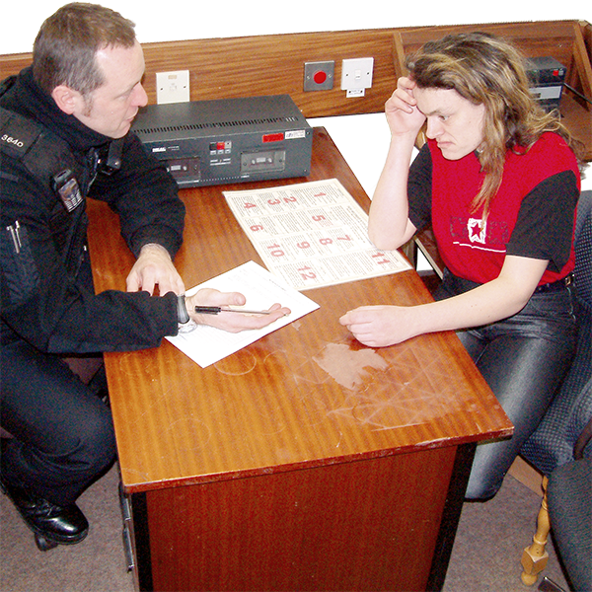 | Changes to criminal law are good but it is too early to say if they are working well.  Criminal law deals with cases where the law has been broken.  The police and victims of crime need to:  - work better together  - be better at sharing information
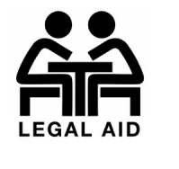 | It is expensive to go to court.  Legal aid is money provided by the government to cover legal costs for people who cannot afford them.
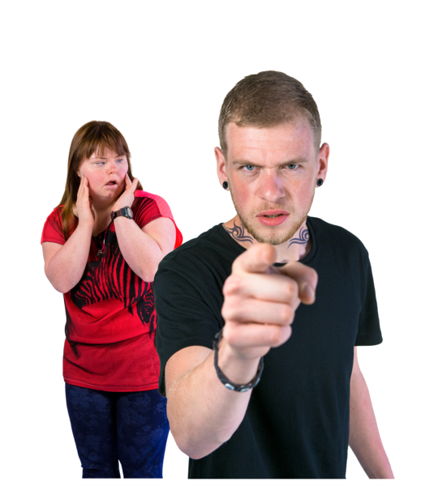 | It is difficult to get legal aid for:  - civil cases where women need protection from somebody accused of violence  - cases to agree parenting arrangements with a partner accused of violence
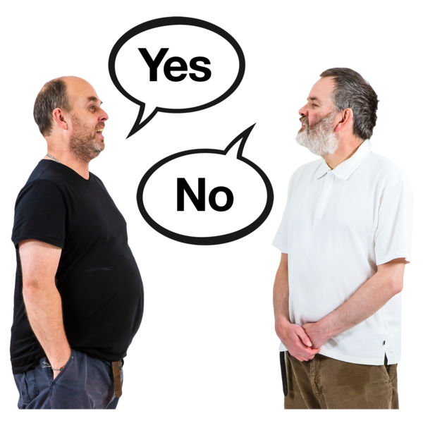 | Civil law is when 2 people or organisations disagree about something, but it is not a crime.
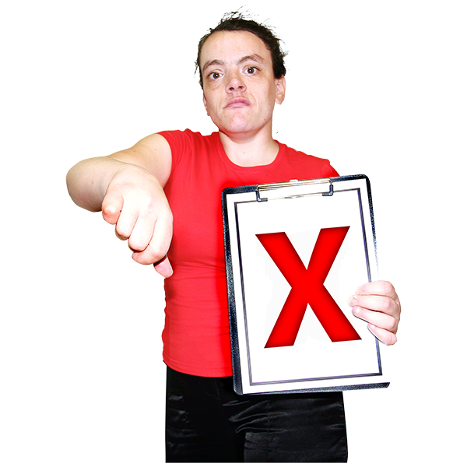 | Victim-survivors do not always have good experiences when they go through criminal court cases.
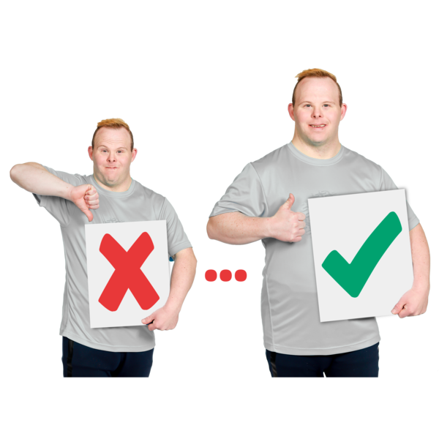 | The Scottish Government wants to make some changes to criminal court to make it less stressful and frightening for women and children.
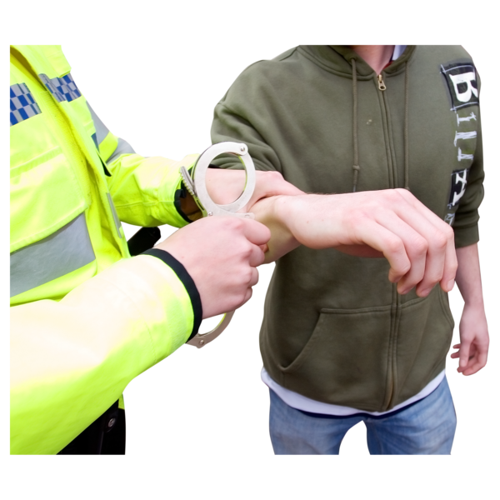 | Some people are worried that the human rights of people accused of crimes will not be properly protected.
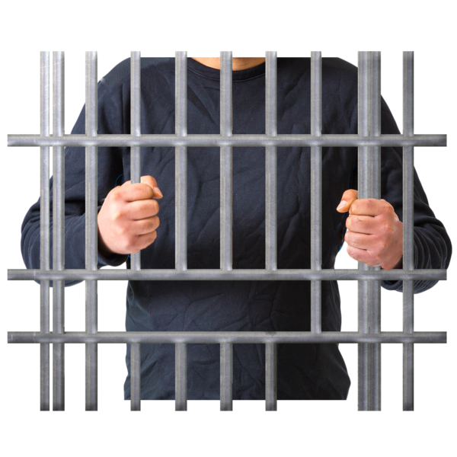 | We cannot tell if the penalties for people convicted of violence against women and girls are fair.  Victim-survivors do not feel that the penalties are fair.  Penalties are punishments for breaking the law – for example a prison sentence.
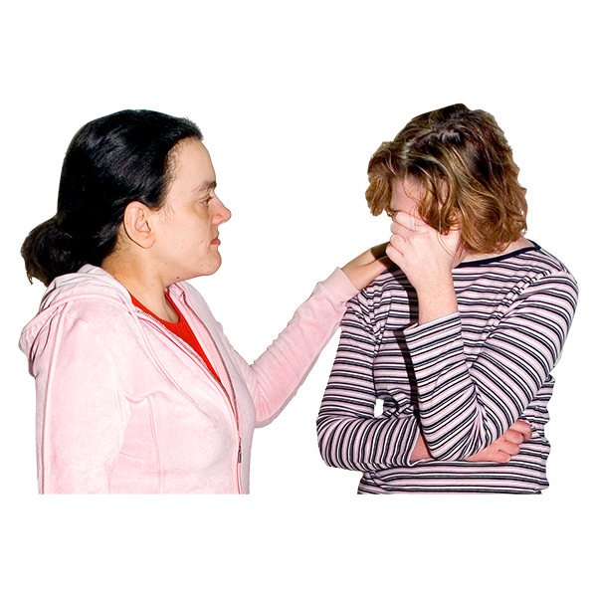 | When the Scottish legal system deals with children and young people who have carried out crimes, it needs to consider how harmful violence against women and girls is.
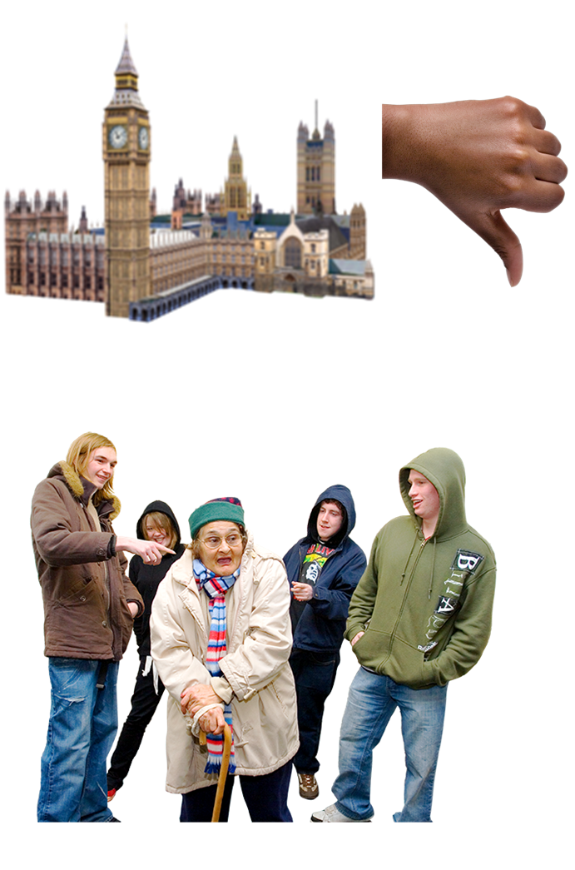 | The UK Government does not agree to parts of the Istanbul Convention that protect migrant women and girls.  This makes them much more unsafe.  A migrant is a person who moves from one place to another, to find work or better living conditions.  We think that the UK should agree to these parts of the Convention.
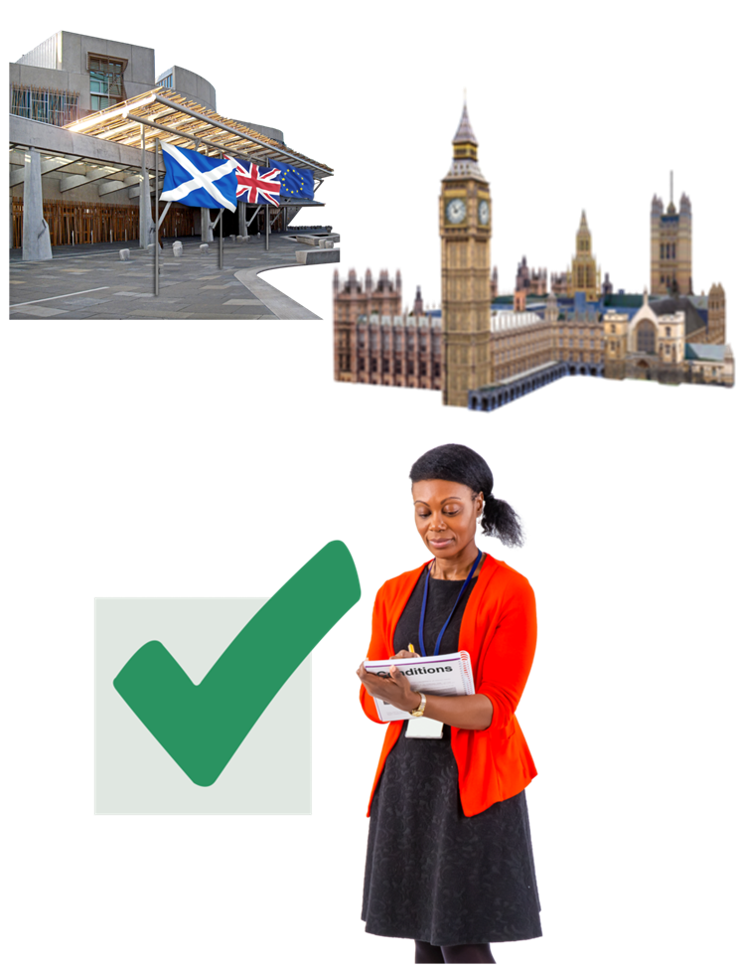 | The Scottish Government should do everything that it can to help migrant women who cannot get support from the UK Government.  The Scottish Government should work with the UK Government to make sure that migrant women can get support.
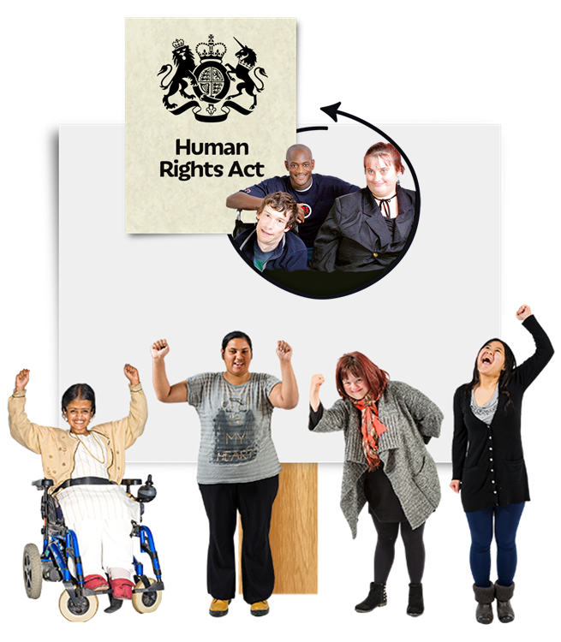 | The Scottish Government has plans for a new human rights law.  It must apply to victim-survivors of violence against women.

The most important things from the In Our Words report

Prevention
We worked with groups of women who have experienced gender-based violence.

We asked them what is needed to stop violence against women?

Many of them wanted to see:

- more education

- children to be taught about equality and healthy relationships, when they are very young

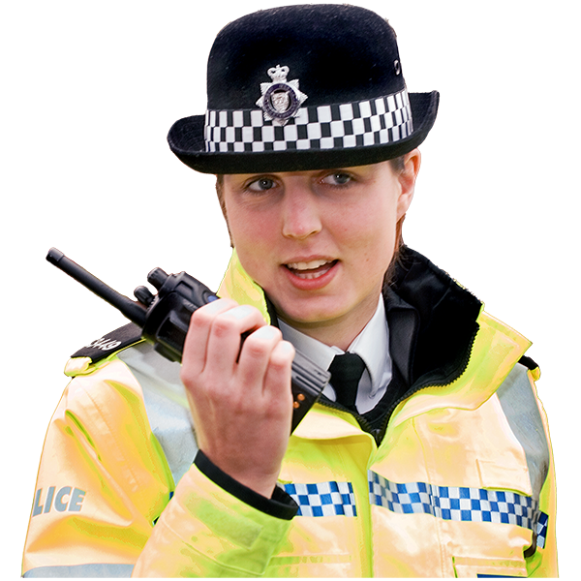 | - people to take violence against women seriously  - punishment for violent people  They thought the programmes that work with violent men have not changed how the men behave.
Some women had good support from the services that help women after they report violence or experience violence.

However this was not always the case.

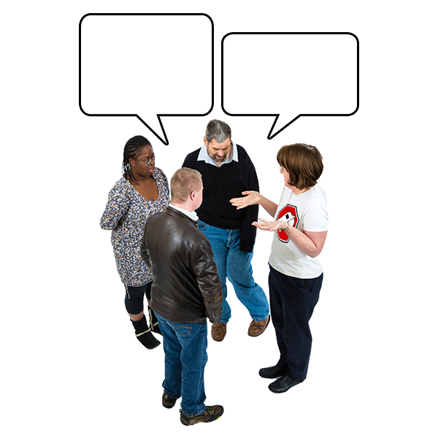 | Women wanted ways to share their stories and views with people making decisions so things could be better for other women.

Protection
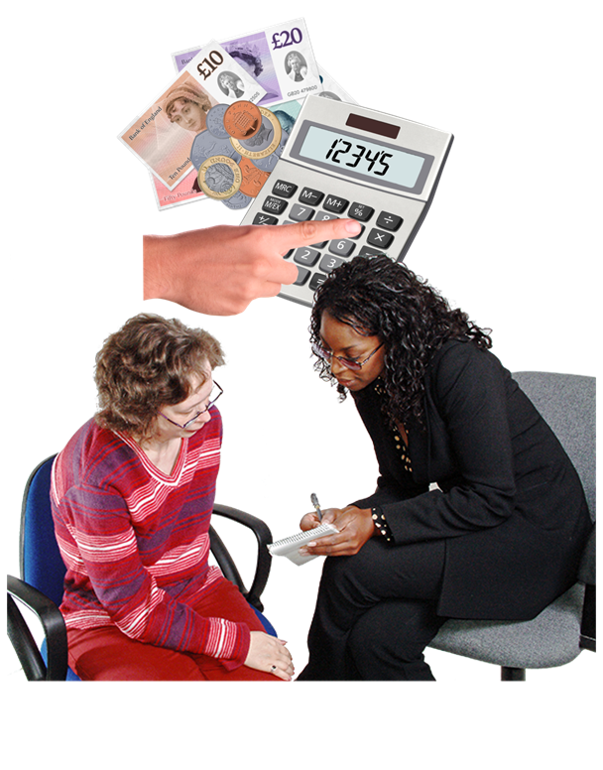 | We asked the women to describe good and bad support for women who need protection from violence.  The women who described positive support thought that there needed to be more money for the organisations who supported them.
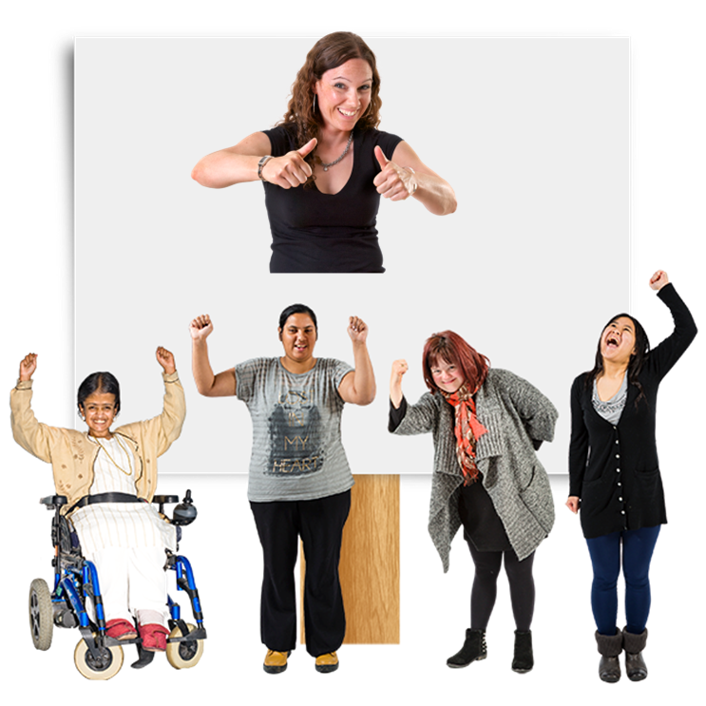 | Many women had waited a long time to get mental health support but it helped their recovery.  Recovery means:  - managing their symptoms  - getting control of their life  - learning new ways to live the life they want
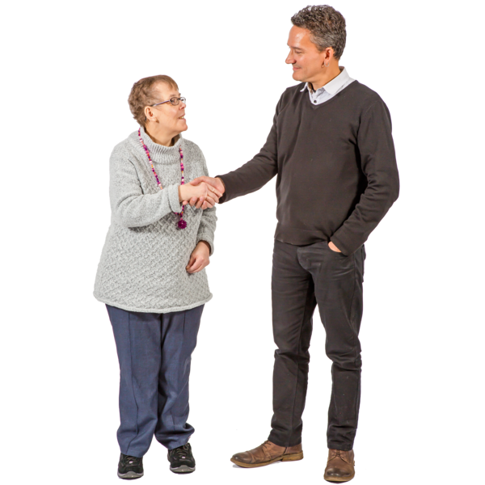 | Most women wanted to see more information and respectful communication.  Respect means treating people with kindness and showing that their thoughts and feelings are important.
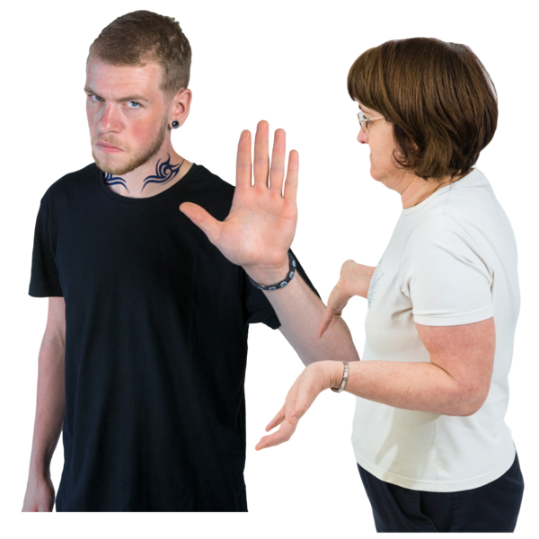 | Many women felt they were blamed for what had happened to them.  This made them feel less likely to report if they ever experienced violence again.
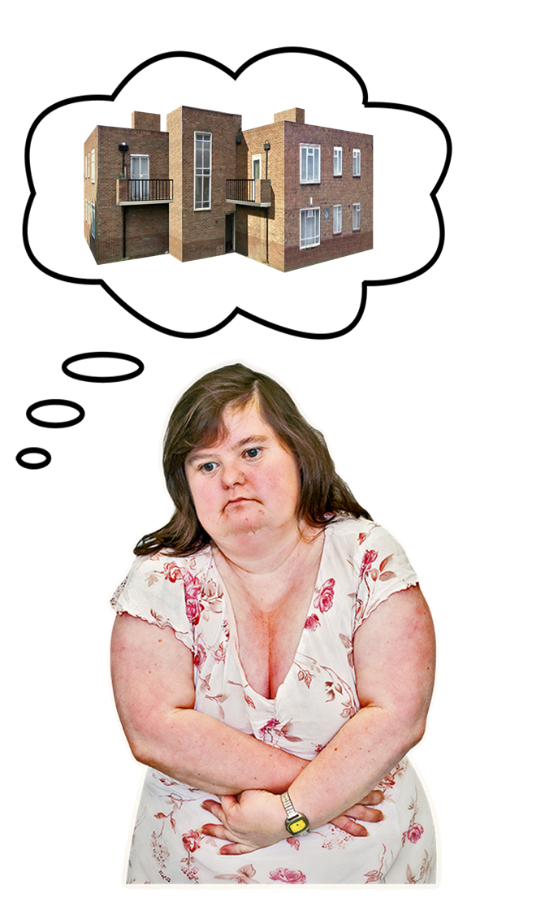 | Women with a learning disability were worried that if they asked for help, their children would be taken into care.  Taken into care means the children could be sent to live:  - with another relative  - with a foster carer  - in a children’s home

Prosecution
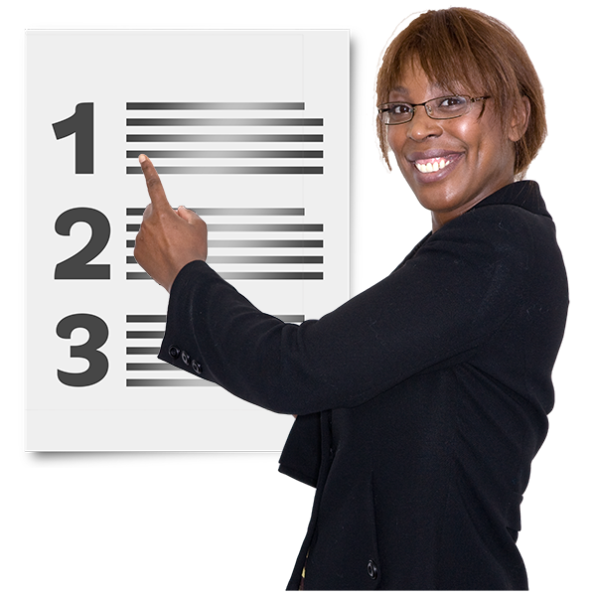 | We asked the women:  - what needs to happen for a successful prosecution  - what makes prosecution difficult
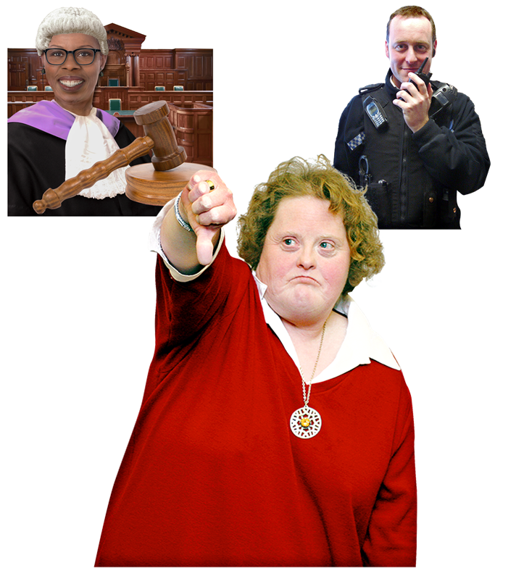 | Almost all the women had something bad to say about the criminal justice system – this means police and courts.
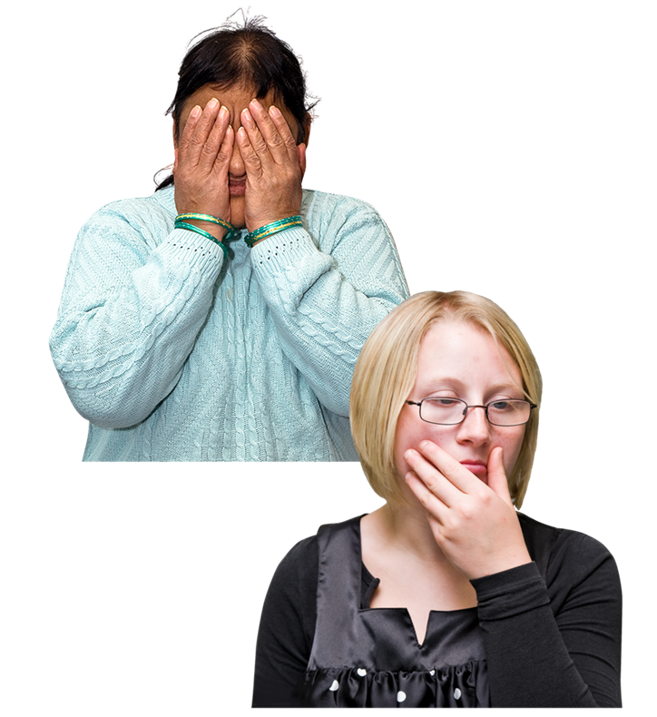 | They felt that they were not taken seriously or treated with respect.  Sometimes they felt that people treated them as evidence and not as people.
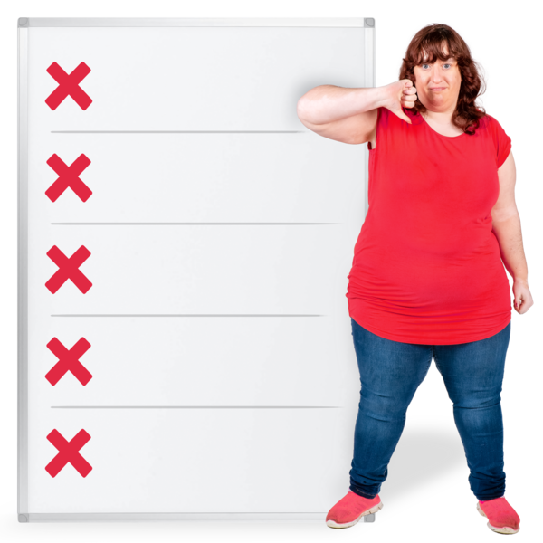 | Most of the women said:  - the impact of being treated like this was very harmful  - they did not think that people treated them this way on purpose  - the way the criminal justice system works is the problem most of the time  Many women described what happened to them in courts as being a story that was told about them that did not feel true.
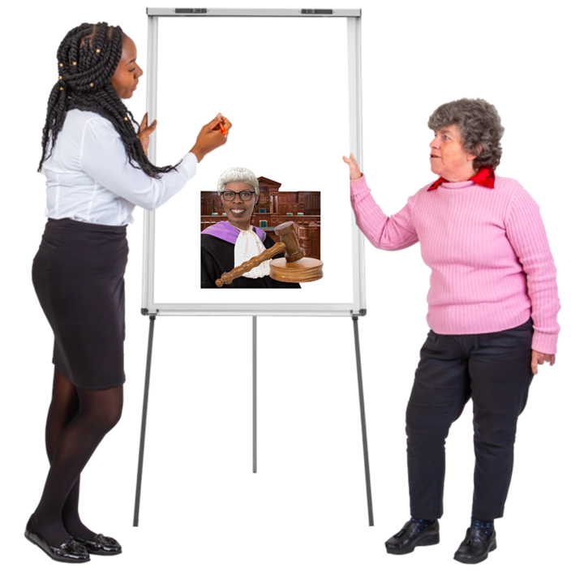 | We asked the woman how this could change and they suggested:  - more training for people who work in the police service and in court  - being told what was happening more often
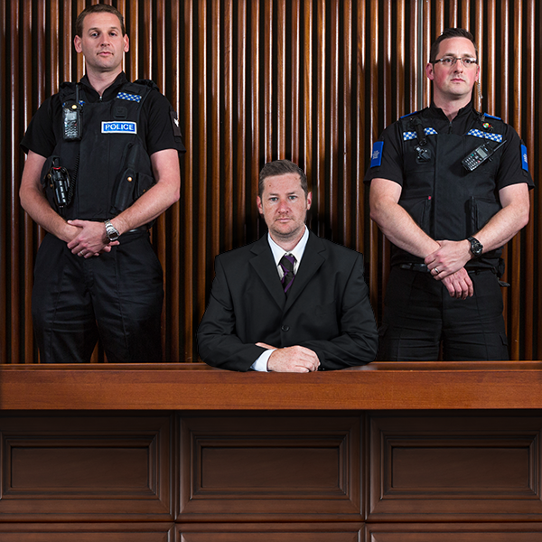 | Some women felt it was more difficult to get a fair sentence, even when somebody was found guilty.
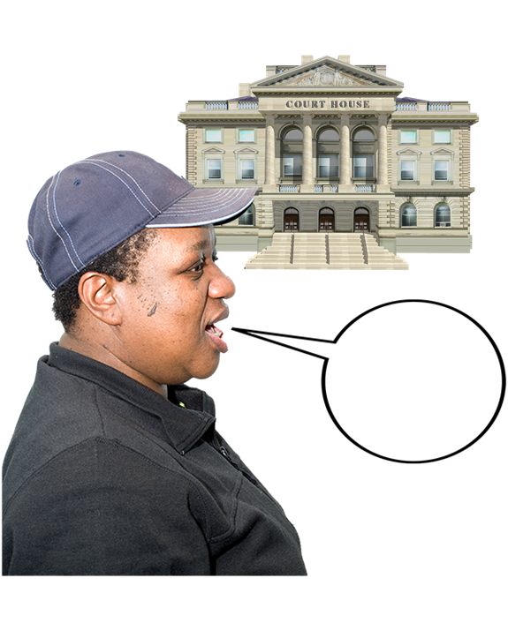 | Some of the women talked about having to go to court to discuss their children or to agree child contact with the person who used to be their partner.  Child contact is the arrangement made for a child to see the parent they do not live with.
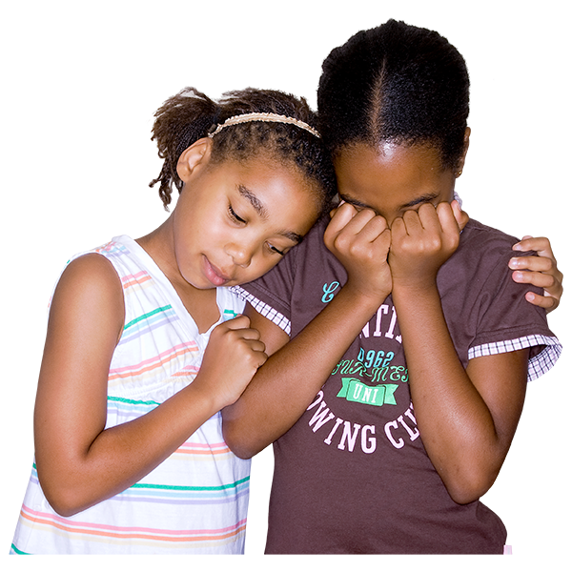 | This had been very difficult for them and for the children.  Some women thought that the safety of their children was at risk.

Policies
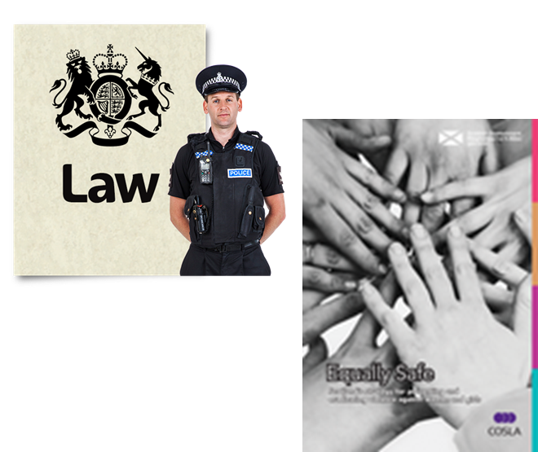 | We did not ask women to talk about what laws or policies they knew about.  Some of the women already knew some laws or policies like Equally Safe.
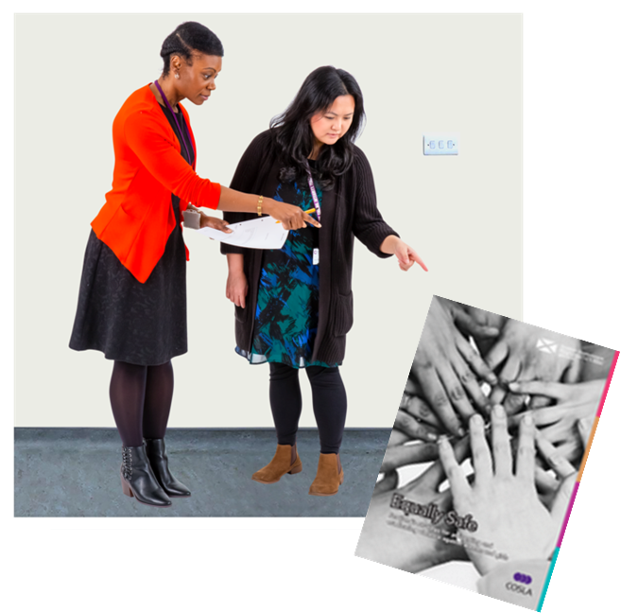 | The women who knew about Equally Safe were positive about it, but thought it needed to be checked more often, to see if it was working well.
Some women felt there were sometimes differences between what the Scottish Government wanted to do in one area of policy and what it did in another area.

Many women wanted more ways to take part in policy decisions.

