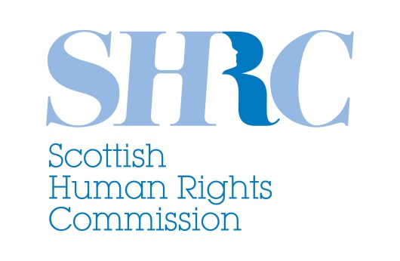

**STATEMENT**

**Response to the United Nations Human Rights Committee’s Seventh Periodic Review of the UK’s implementation of the International Covenant on Civil and Political Rights**

The Scottish Human Rights Commission strongly welcomes the [Concluding Observations](http://tbinternet.ohchr.org/_layouts/treatybodyexternal/Download.aspx?symbolno=CCPR%2fC%2fGBR%2fCO%2f7&Lang=en) of the United Nations Human Rights Committee’s Seventh Periodic Review of the UK’s implementation of the International Covenant on Civil and Political Rights (ICCPR).

As Scotland’s national human rights institution, the Commission has given [evidence to the Committee](http://www.scottishhumanrights.com/resources/policysubmissions/iccpr2015) over the past year on a range of issues affecting people’s rights in Scotland.

We are extremely pleased that the Human Rights Committee has taken this evidence on board and has adopted a robust series of recommendations to address several of the concerns we raised.

In its report, the Committee shares our concerns:

* that plans to repeal the Human Rights Act would weaken protection for civil and political rights;
* about the use of non-statutory stop and searches by Police Scotland;
* about the high number of suicides in Scotland;
* about the impact of cuts to legal aid in Scotland;
* that the age of criminal responsibility is set at 8 years of age in Scotland;
* that corporal punishment in the home is not prohibited in law.

The Commission particularly welcomes the series of recommendations made by the Committee to address these concerns. We are pleased that the Committee:

* calls on the UK to ensure that any new human rights legislation strengthens the status of international human rights in domestic law;
* calls for measures to ensure that stop and search takes place in a way that conforms with the ICCPR;
* calls for robust measures to prevent suicides, including in custody;
* calls for weaknesses in legal aid funding to be addressed;
* calls for the age of criminal responsibility to be raised in line with international standards;
* calls for legal and practical steps to be taken to end corporal punishment in the home.

The Commission is also pleased that SNAP - [Scotland’s National Action Plan for Human Rights](http://scottishhumanrights.com/actionplan) – has been welcomed by the Committee as a positive aspect of progress towards implementation of the ICCPR.

SNAP provides a roadmap towards the realisation of all international human rights in Scotland; the Commission will continue to facilitate its implementation and further development in collaboration with government, public bodies and civil society across Scotland.

In addition, the Commission now expects the Scottish and UK Governments and the Scottish Parliament to consider how best to respond to the Committee’s specific recommendations in relation to Scotland.

The Scottish Government has an opportunity to provide leadership on many of the issues identified, while the UK Government must take seriously the Committee’s concerns about replacing the Human Rights Act with legislation that weakens domestic protection for international human rights. The Scottish Parliament also has a remit to act in relation to a number of the issues raised and the Commission would expect the Parliament’s Justice Committee to consider the recommendations in detail.

As Scotland’s national human rights institution, the Commission will play an active role in sharing the Committee’s recommendations with Scottish civil society and the wider public. We will also continue to hold all concerned to account by monitoring and reporting on the implementation of the Committee’s recommendations.

Scottish Human Rights Commission

24 July 2015