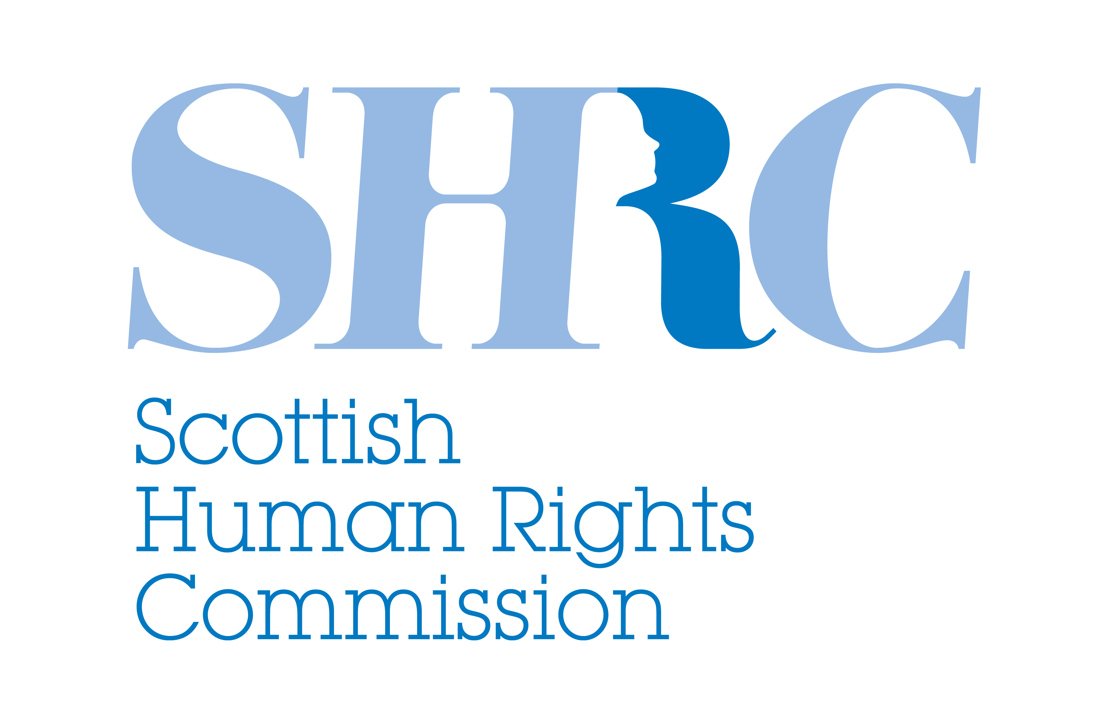
Protecting human rights in Scotland in a changing relationship with Europe
May 2016
The Scottish Human Rights Commission (the Commission) is pleased to publish a paper by Dr Tobias Lock from the University of Edinburgh on “The Human Rights Implications of the European Union (EU) referendum” to help inform the current debate around the UK’s membership of the EU.
Human rights protecting fairness, justice and dignity stand to be eroded in the United Kingdom’s potentially changing relationship with Europe. The Commission believes that in all circumstances the laws and institutions that protect our human rights should be strengthened not weakened and change must be progressive not regressive - enhancing human rights protections for all.
The result of the imminent referendum on whether the UK should remain a member or leave the EU will have an impact on some human rights safeguards for individuals living here in Scotland and in the UK. Meanwhile, irrespective of the result of the referendum, the Human Rights Act 1998 remains under direct threat with regressive proposals being considered to repeal and replace it with a weaker British Bill of Rights.
The human rights protections provided by our membership of the EU and our membership of the Council of Europe are distinct but complementary. The Council of Europe is an international organisation in Strasbourg comprising 47 European states, set up to promote democracy and protect human rights and the rule of law in Europe. The EU meanwhile is an economic and political partnership involving 28 European countries. The EU’s Charter of Fundamental Rights (Charter), and the Council of Europe’s European Convention on Human Rights (Convention) both contribute to the human rights framework that protects us all. Our relationship to each however is potentially shifting and with it the human rights protections that we currently all enjoy.
The UK was a founding member of the Council of Europe and led the way in drafting the Convention. However, our relationship with the Council of Europe will now be challenged by the proposed repeal and replacement of the Human Rights Act anticipated post EU referendum. The Human Rights Act provides a direct route for justice in domestic courts. It means our public bodies and those delivering public services must comply with the Convention. It also applies directly to the Scottish Government and Scottish Parliament, ensuring Convention rights are central to devolution and devolved legislation. The proposals to repeal the Human Rights Act and attempts to change our relationship to the Convention and the Council of Europe matter because they have a direct impact on legal protection and practical realisation of people’s rights in Scotland. Beyond this, the debate sends a damaging message across Europe and beyond, weakening the international system of human rights as a whole.
The debate over our relationship with the Council of Europe and the Convention will come to the fore in the coming months, but before that there is a decision to make about our relationship with the EU. Leaving the EU would mean that the Charter no longer directly applies to the UK or to Scotland. That would mean a reduction in human rights protections and procedural remedies in areas within the scope of EU law such as privacy, data protection and a fair hearing. It could also mean the loss of a backstop of protection against regression to our national laws in areas such as anti-discrimination, environmental protections and consumer rights. Furthermore, an EU exit may represent the loss of potential for the fuller protection of social rights, or principles, contained in the Charter such as workers’ rights, access to social security and healthcare.
At a time when pressing global, regional and national challenges such as conflict, immigration and asylum, climate justice, development, surveillance, terrorism and extremism threaten the realisation of human rights, it is essential that we retain a strong collective commitment to the human rights framework to govern our responses to these challenges.
In Scotland steps are being taken to advance in a journey towards the better protection and realisation of human rights. This is epitomised in Scotland’s National Action Plan for Human Rights (SNAP), which is a collaborative approach to making human rights a reality in schools, hospitals, care homes, workplaces and beyond. Around 50 organisations from across the public sector and civil society are working together to improve human rights in practice. The Scottish Government has committed to embed SNAP and the United Nations Sustainable Development Goals into the National Performance Framework. This measures the progress of the Scottish Government against a range of economic, social and environmental indicators and targets.
Significant positive human rights ambitions have been voiced by the Scottish Parliament and the Scottish Government. For example, the First Minister recognised in December 2015 that making international treaties, such as the International Convention on Economic and Social Rights, the Convention on the Rights of the Child, the Convention on the Rights of People with Disabilities and the Convention to Eliminate Discrimination against Women, enforceable in domestic law is an important part of the debate in ensuring people’s rights are at the heart of everything government does. She has subsequently gone further in committing to “a broad collaborative process, engaging with people across Scotland and learning from best global practice in participatory democracy, to advise on the guaranteed protections we should seek to enshrine in law.”
Whatever the outcome of the referendum - to stay in the EU or to leave - the Commission wants to see progress made on these ambitions. This means strong and progressive human rights laws and institutions which can best uphold human rights for all. It means retaining the full range of human rights protections we currently have through the Charter and Convention and ensuring they are applied and enforced in practice. Furthermore, it means taking forward the commitment to build on these laws, going further to protect people’s rights in areas such as health, housing and education by incorporating international treaty standards into our domestic laws and implementing them in practice.
The Commission encourages the widespread and meaningful participation of people from across Scotland in identifying and considering opportunities to advance human rights in Scotland’s future. We would like to thank Dr Tobias Lock for his work in producing his paper as an important contribution to this agenda.

