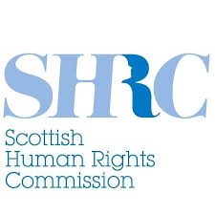
Scottish Human Rights Commission
Annual Report 2022 to 2023

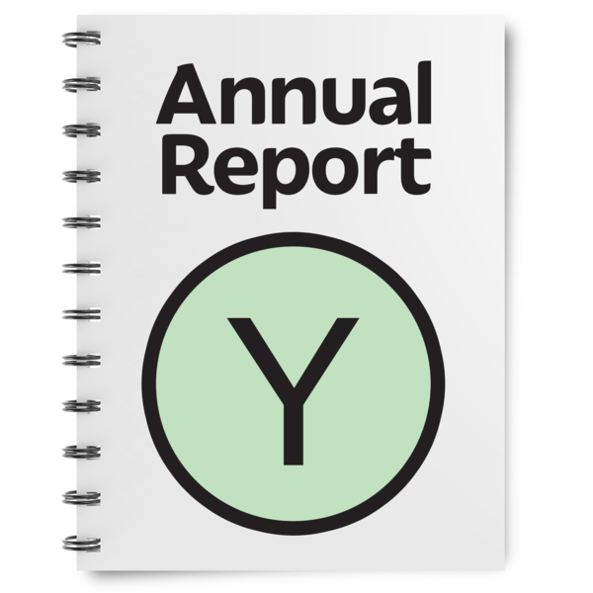

Copyright images © Photosymbols. Prepared by Disability Equality Scotland

About the Commission
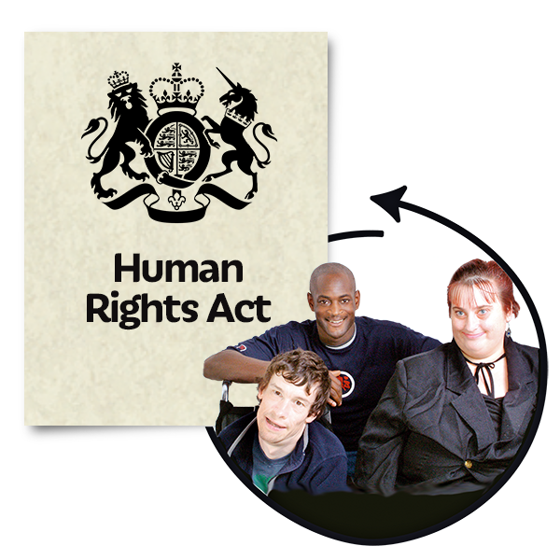 | Human rights are freedoms that are protected in law.  They make sure we are treated:  - fairly  - with dignity  Dignity means being treated in a way that is as thoughtful as possible.  The Scottish Human Rights Commission works in Scotland to:  - look after people’s rights  - check that the Scottish Government and its organisations are looking after people’s rights
The Scottish Human Rights Commission reports to:

- the Scottish Parliament

- the United Nations

The United Nations is an organisation that works with countries to keep peace and security across the world.
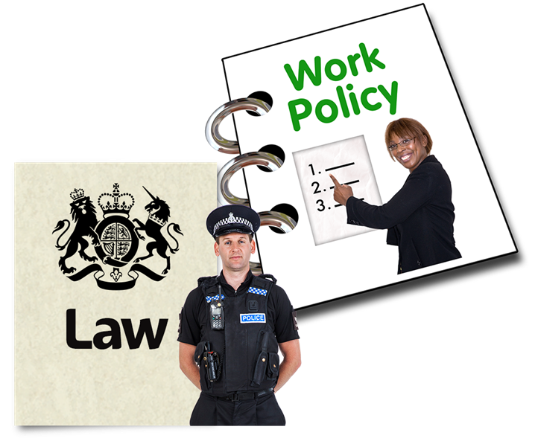 | The Scottish Human Rights Commission has powers to:  - help change laws, policies and the way people work  - tell more people about human rights using education, training and research  - take part in some civil court cases  Civil court is when 2 people or organisations go to court to sort a disagreement, but it is not a crime.  - have inquiries into the policies and practices of Scottish public authorities  An inquiry is a review into what went well and what could have been done better.

PANEL Principles
The Commission uses the PANEL principles in all its work:

Principles are the standards for our work – what we believe in and how we want to work.
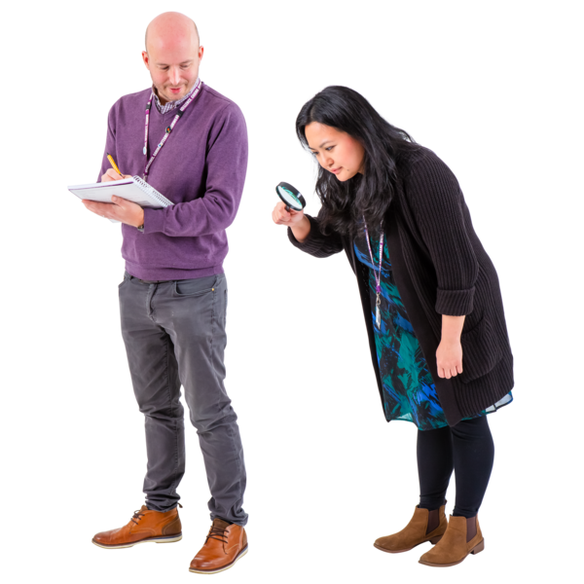  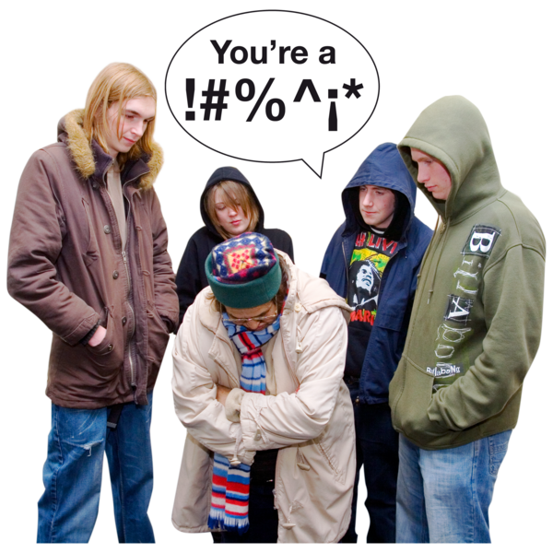 | P: Participation  People should take part in decisions that affect their rights.  A: Accountability  Human rights should be checked to see that they are being protected.  If they are not being protected, this should be changed.  N: Non-discrimination and equality  We must stop all forms of discrimination.  Discrimination means treating someone unfairly.
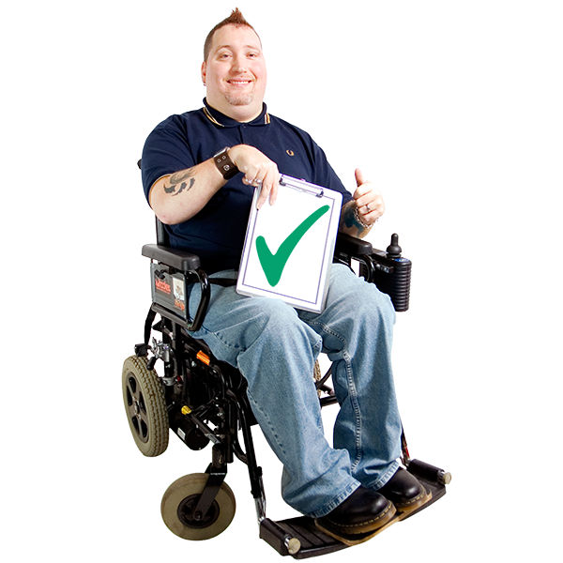  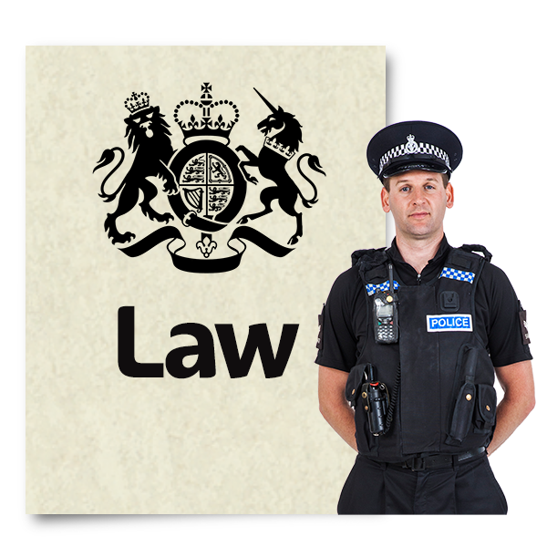 | E: Empowerment  Everyone should understand their rights and be able to take part in decisions that affect their lives.  L: Legality  The way people approach human rights should follow Scottish, UK and international laws.

How the Commission plans its work
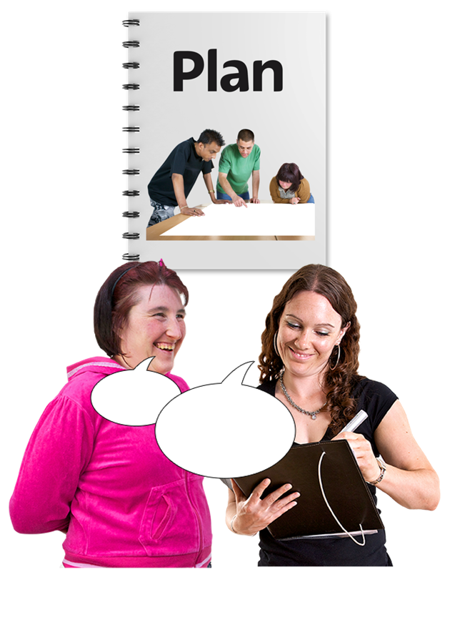 | The Commission’s fourth Strategic Plan was published in March 2020 after we had asked a lot of people and organisations what they think.  A strategic plan is a document that gives details of:  - what we want to work towards in the future  - how we will do this  The plan has 4 priorities for 2020 to 2024:
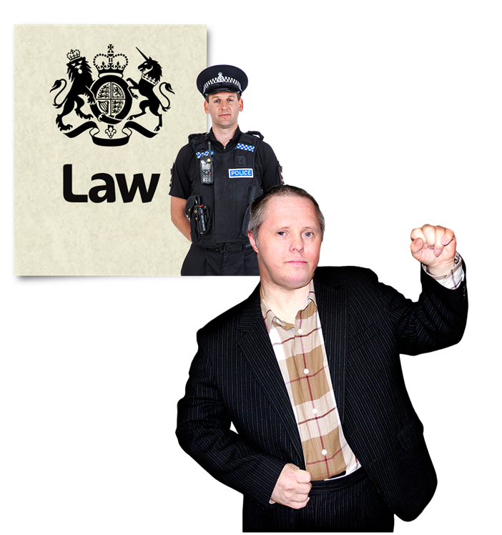  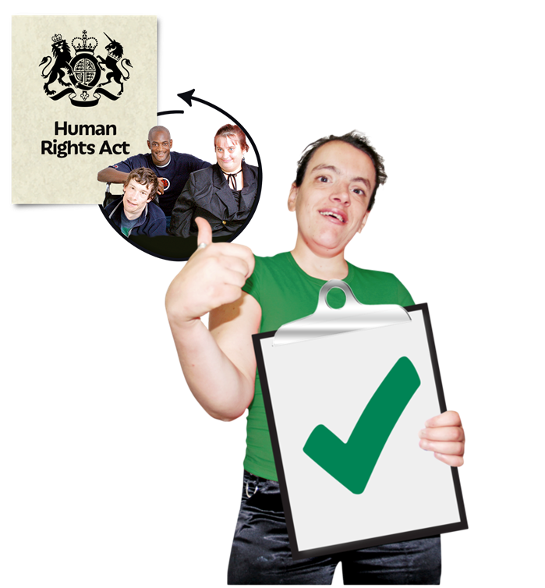 | Priority 1: Making sure more people understand their rights, and they are protected by making the law stronger.  Priority 2: Making sure more organisations follow human rights laws.
Priority 3: Making sure more people understand and protect human rights.

Priority 4: Making sure we share what we know about human rights and learn from others around the world.

In 2022 to 2023 the Commission also made a new plan called Purpose, People, Performance.

This includes new projects including:

- access to justice for human rights problems

Access to justice means being treated fairly by the law, and having access to police, courts and organisations that give legal advice and support

- human rights of people in prisons in Scotland, with a focus on mental health support

- human rights of people with learning disabilities and autism who stay in hospitals and other places

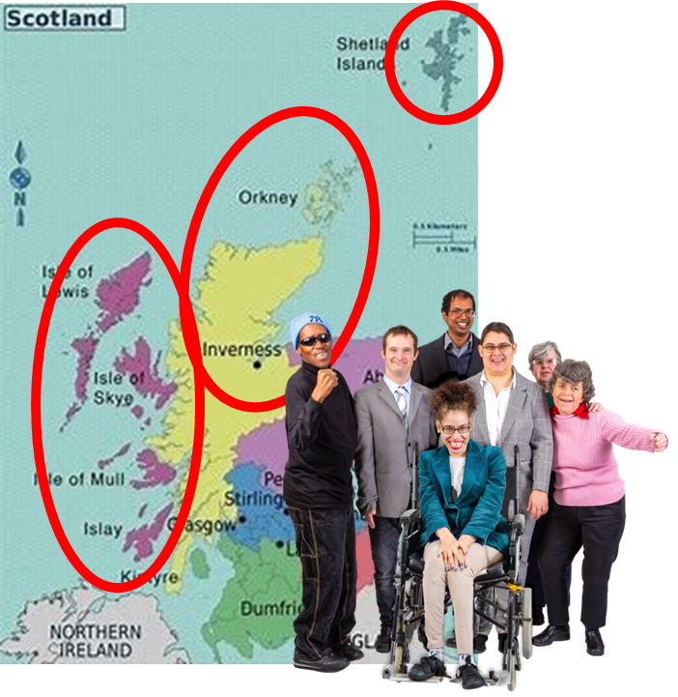 | - the rights of people in the Highlands and Islands
In 2022 to 2023 the Commission had:

- a new Executive Director called Jan Savage

- 1 Chair who works full time

- 3 Commissioners who work part time

- 21 members of staff

Our work in 2022 to 2023
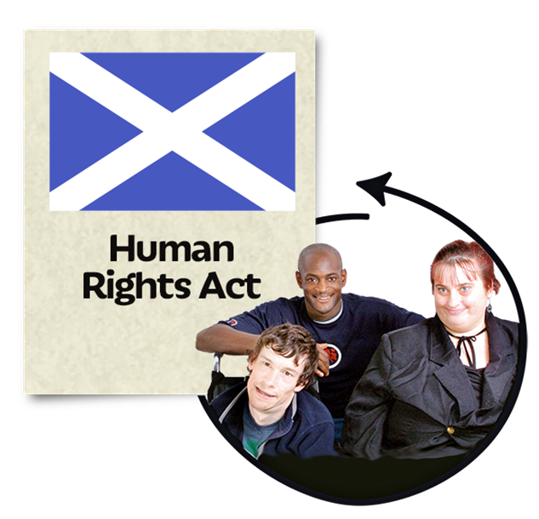 | This is a summary of our Annual Report from April 2022 to March 2023.  The Scottish Government has promised to introduce a new Human Rights Bill for Scotland, to make sure everyone gets important rights like good housing, healthcare and education.  We did lot of work to support the Human Rights Bill, offering advice on how to make sure the new laws protect human rights as strongly as possible.
 | We spoke out when the UK Government said it wanted to remove the Human Rights Act and were pleased when it decided not to do this.
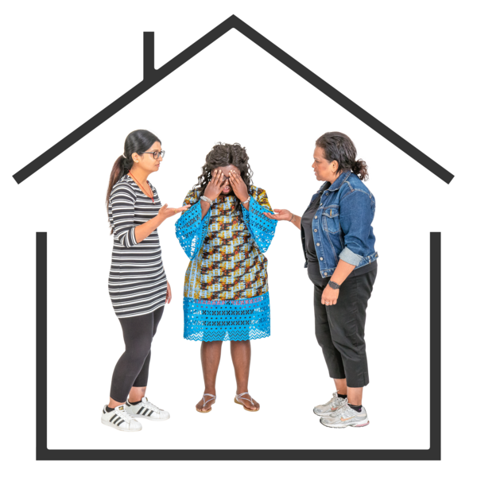 | We told the UK Government we did not like the Illegal Migration Bill which would make it harder for refugees to come to the UK.  We think this is against international human rights law.  Refugees are people who have left their country to escape from war or violence to find safety in another country.
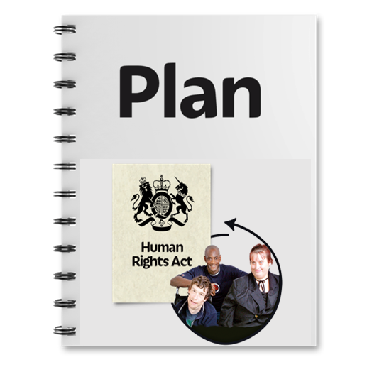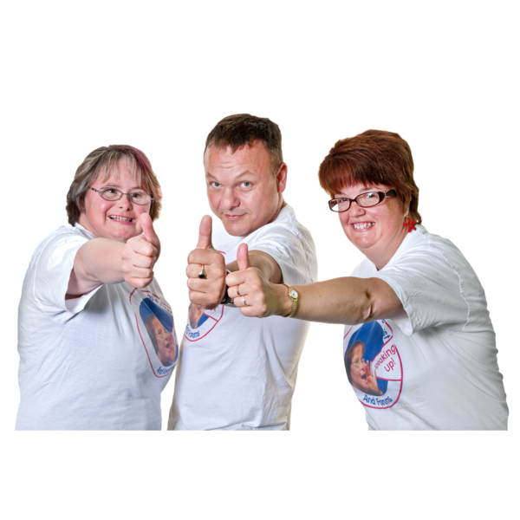 | In March 2023 we helped to launch Scotland’s second National Action Plan for Human Rights, called SNAP2.  It asks organisations like the Scottish Government to make sure everyone can live a life with dignity, including a good standard of living, employment and education.
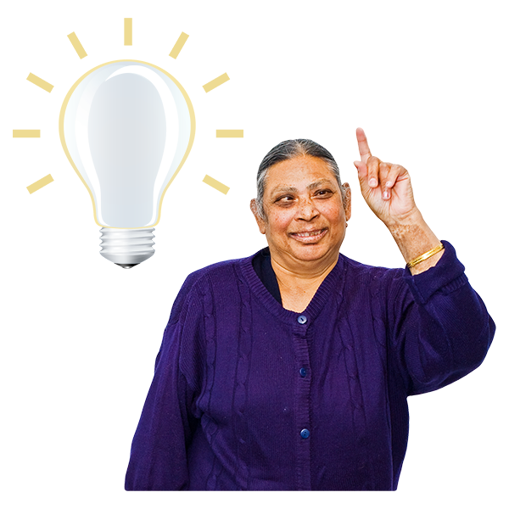 | There are 54 ideas in SNAP2.  The Commission will work to make sure they actually happen.
This year we went to the United Nations to report on Scotland’s human rights performance.

We talked about the rising cost of living.

This is making it harder for people in Scotland to have enough money to heat their homes or buy food.

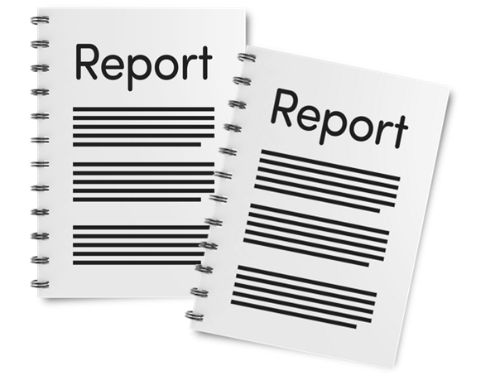 | We also delivered 2 reports to the United Nations on the rights of people with disabilities.  We wrote one and the other was written by the Scottish Independent Living Coalition (SILC).
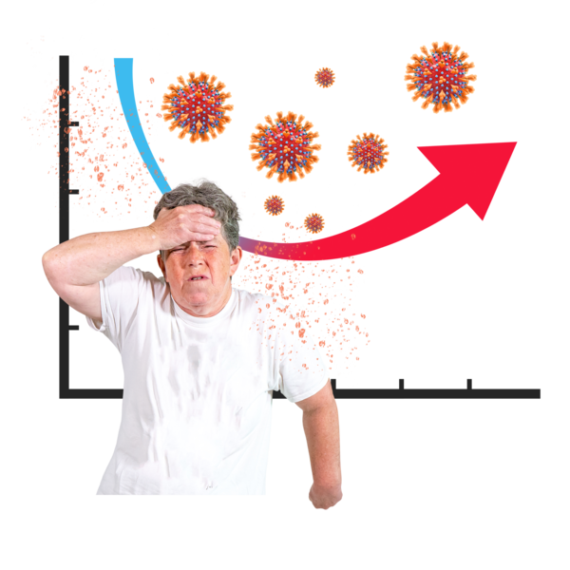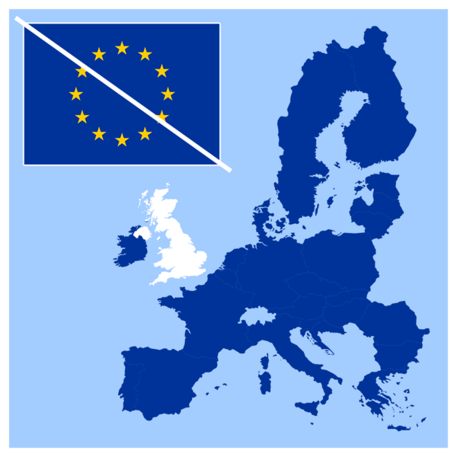 | Our report showed the effect of:  - the cost of living  - COVID-19  - leaving the EU
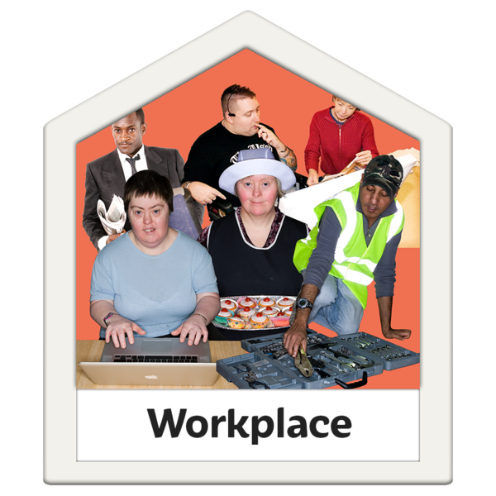 | Our report called for more protection of disabled people’s rights to:  - employment  - independent living  - a fair standard of living
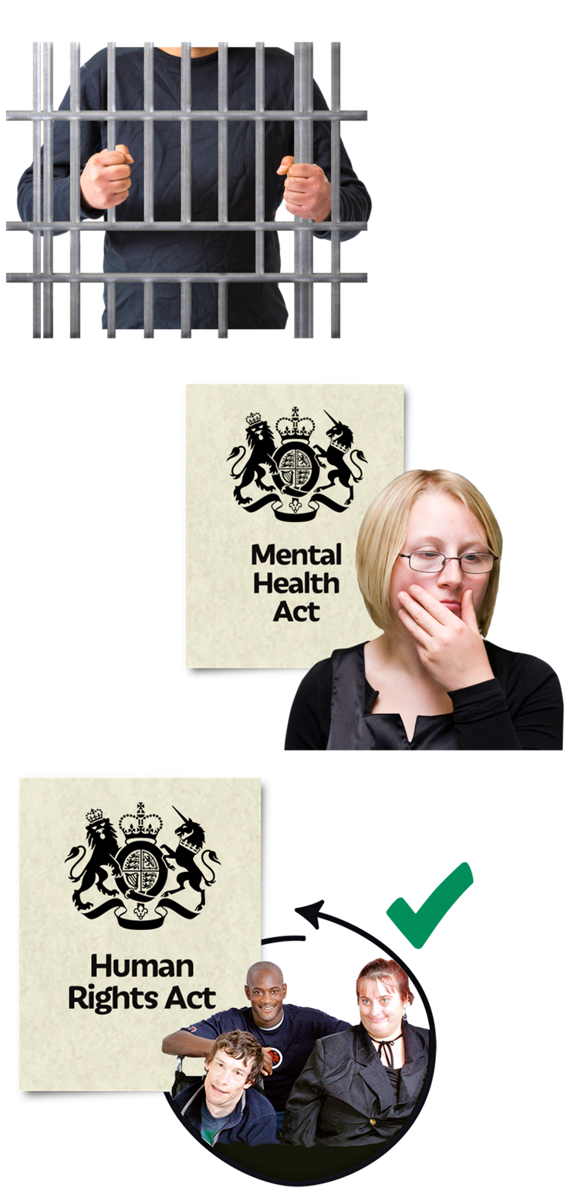 | The Commission did other activities in 2022 and 2023 including:  - work to improve human rights in prisons  - giving advice to organisations trying to improve the human rights of people experiencing mental ill health as part of the Scottish Mental Health Law Review  When the Review’s findings were published, we were pleased to see it focused on human rights.
 | - giving advice on many policies the Scottish Government is thinking about bringing into law
- going to the Scottish Parliament to talk about how law makers should put human rights first when making decisions about how money will be spent

The Commission believes this will help to build a fairer, more equal Scotland for everyone.
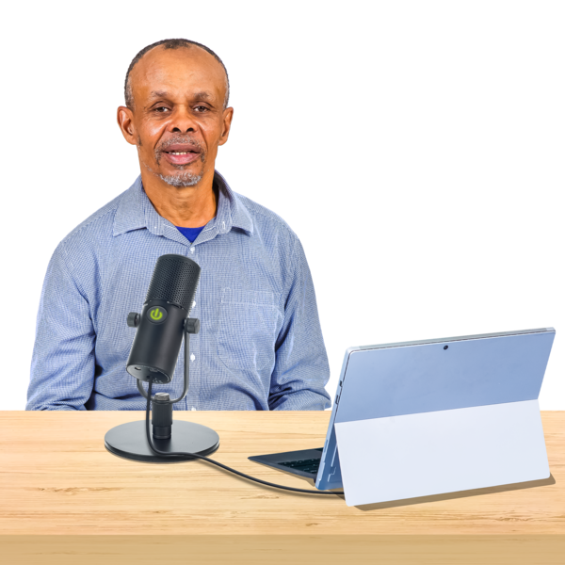 | - speaking to newspapers, radio and TV programmes to tell more people about how important human rights are in Scotland

Find out more
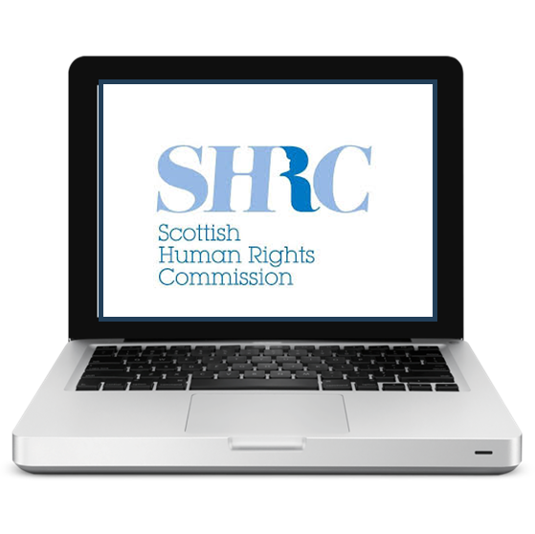 | You can find out more:  - on our website  www.scottishhumanrights.com  - email: hello@scottishhumanrights.com
- on X @ScotHumanRights

X used to be called Twitter.

- or find us on Instagram, Facebook, LinkedIn and YouTube

Copyright images © Photosymbols. Prepared by Disability Equality Scotland

