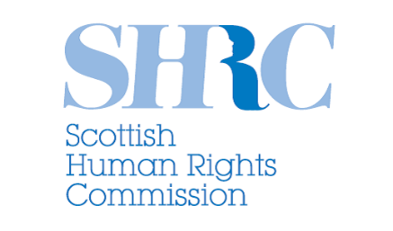 | Scottish Human Rights Commission
 | Strategic Plan Survey
 | The Commission is developing its Strategic Plan for 2024 – 2028
 | We’re asking for information to create this plan
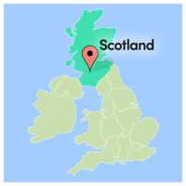 | To help us set our priorities and improve how we work we want to hear from people and organisations from across Scotland
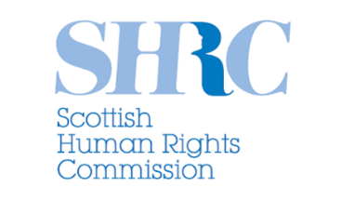 | This document is to give you more details about the Commission before you complete the survey
 | What is the Scottish Human Rights Commission?
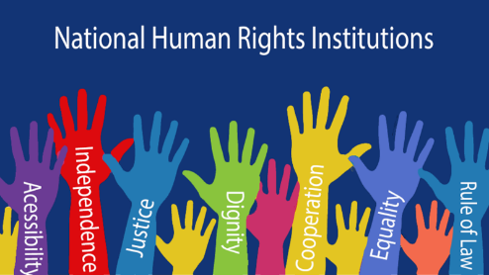 | The Scottish Human Rights Commission is Scotland’s National Human Rights Institution
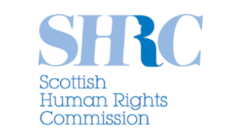 | The Scottish Human Rights Commission is an independent public body
 | This means we do not work for the government or any other organisation
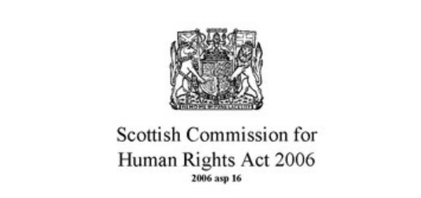 | The Scottish Commission for Human Rights Act 2006 is a law that says what the Commission should do
 | This means we can
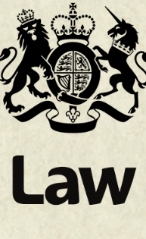 | Recommend changes to law policy and practice
 | Promote awareness of rights through education, training and publishing research
 | Protect rights through inquiries into the policies and practices of Scottish public authorities

