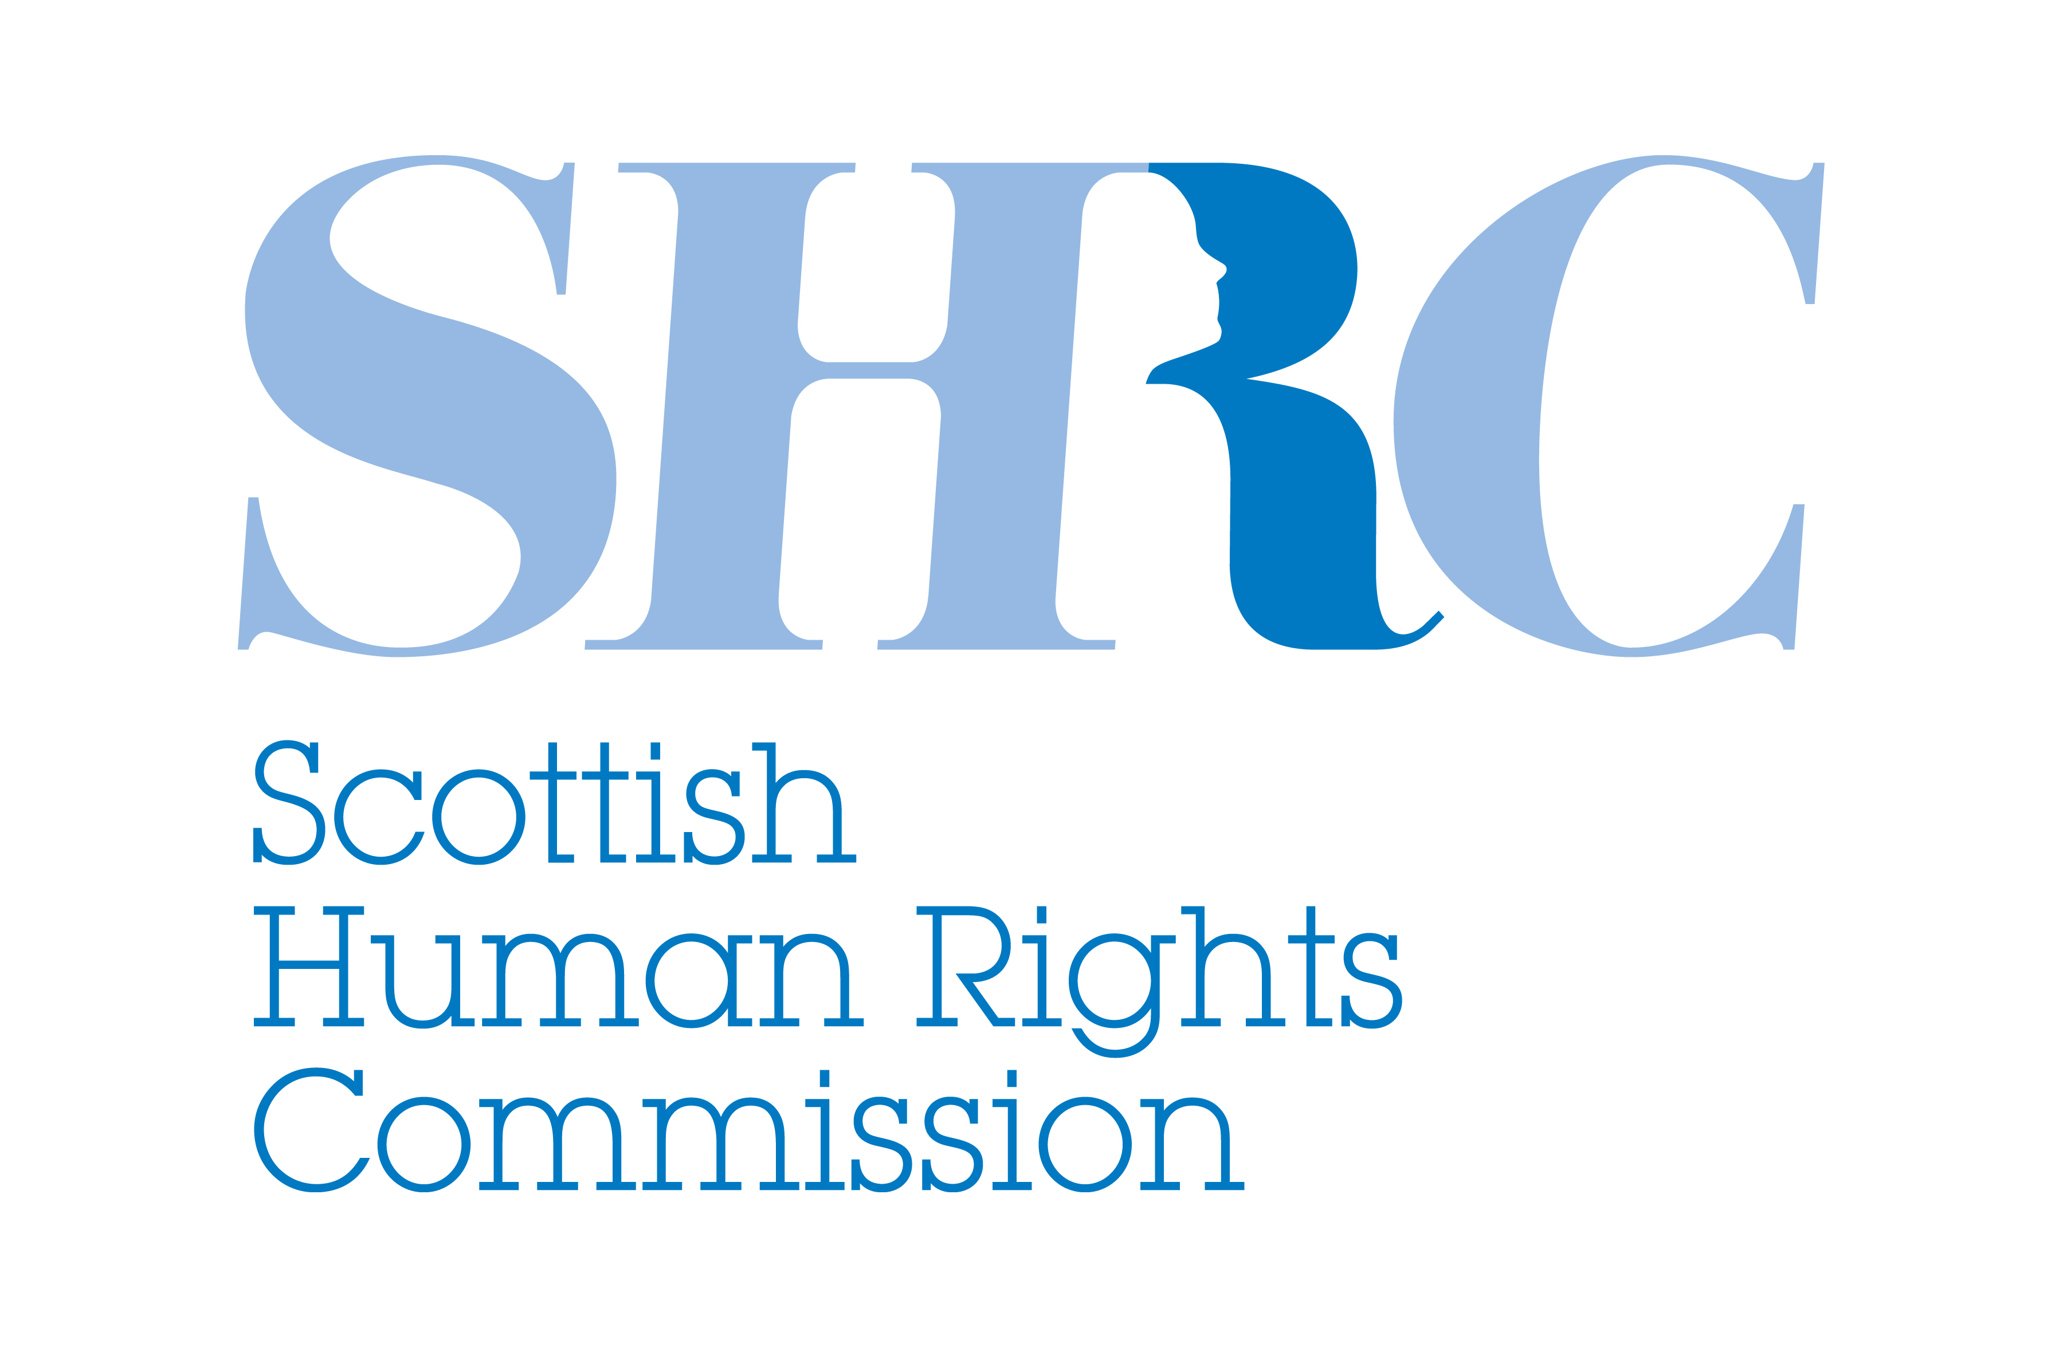

Changing the UK’s Human Rights Laws

Frequently Asked Questions

May 2015

What’s happening to the Human Rights Act and why does it matter?

The UK Government has announced in its first Queen’s Speech that it will “bring forward proposals for a British Bill of Rights”. Although the details are unclear, it seems likely that, among other things, the Bill will be intended to replace the Human Rights Act and “break the formal link between British courts and the European Court of Human Rights” (Conservative Manifesto, 2015).

The details of proposed changes will need to be analysed further but are set against the backdrop of regressive debates. The proposals matter because they have a direct impact on legal protection and practical realisation of people’s rights in Scotland. Any regressive moves would also send a damaging message across Europe and beyond, weakening the international system of human rights as a whole.

What does the Scottish Human Rights Commission think about the proposals?

The Commission is opposed to any changes that are regressive when it comes to protecting human rights. Our human rights laws must go forwards not back, building on the progressive approach to realising human rights embodied in Scotland’s National Action Plan on Human Rights.

The Commission has expressed long-standing concerns about the regressive nature of many elements of proposals to repeal the Human Rights Act and replace it with a British or UK Bill of Rights. Many of the plans that have been mooted in recent months and years would undermine the basic principle that each of us has the same rights simply because we are human. They would not lead to positive, tangible improvements in how we all experience our rights in everyday life. They would limit government accountability for the exercise of power and undermine efforts to build a culture where we all understand human rights and put them into practice. And they would set a poor example to other countries, undermining the UK’s international reputation and standing.

The Commission also believes that any proposed changes to human rights laws, which are of constitutional and social importance, should be considered as part of a broad and participative public process and cannot be rushed. Debates about human rights are not only about matters of law. They are about social values, democratic renewal and, ultimately, the recognition and protection of the human dignity of all.

What difference has the Human Rights Act made to people in Scotland?
The Human Rights Act introduced many of the human rights in the European Convention on Human Rights directly into Scotland’s own laws. These fifteen well-established fundamental rights and freedoms - like the right to life, free speech and protection from inhuman and degrading treatment in care or custody - are minimum standards across Europe, agreed by the UK and other countries in the post-war era as the basic protections needed in modern democracies.
The Human Rights Act provides a direct route to justice in domestic courts, rather than the European Court of Human Rights, for individuals whose human rights have been breached. This is one important element of making rights a reality in people’s lives. The Human Rights Act also places duties on public bodies in respect of human rights. Section 6 of the Act makes it unlawful for public bodies to act incompatibly with the rights contained in the European Convention on Human Rights. This gives rise to a compliance duty that has led to positive changes in policies, practices and culture without the need for individuals to take legal action including, for example, in hospitals and other health and social care settings.
What would the difference be between the Human Rights Act and a British or UK Bill of Rights?

In the absence of detailed legislative proposals, it is not possible to be sure. However, some of the proposals for a Bill of Rights that have been mooted in recent months and years include reducing the scope of human rights laws so that they only apply to “the most serious” cases or to particular areas of law. This begs several questions such as who would be accountable for deciding which cases were ‘serious’? What impact would this have on people’s rights in areas of everyday life like health and social care, education and the workplace? Other proposals suggest restricting the eligibility of rights on the basis of nationality or citizenship, which would clearly undermine the very concept of human rights belonging to each of us as human beings.

What is the impact of these proposals on our relationship with the European Convention on Human Rights?

Any proposal to enable the UK to pick and choose which judgments to accept from the European Court of Human Rights would be highly regressive. It would undermine the rule of law and accountability within the UK. It would also undermine the system of protection for human rights throughout Europe.

What would repeal of the Human Rights Act mean for Scotland?

The Human Rights Act is embedded into the Scotland Act. This means that the Scottish Government and Scottish Parliament are prevented from acting inconsistently with the European Convention on Human Rights. Repealing the Human Rights Act would therefore undermine the current devolution settlement.

There would also be direct and adverse consequences for people in Scotland in reserved policy areas like immigration, defence, some aspects of social security, employment and privacy. This would directly affect people in all sorts of ways – disabled people looking to challenge policies like the bedroom tax; the families of Scottish soldiers killed or injured in combat due to inadequate protective equipment; people and communities affected by immigration detention practices; employees seeking to challenge unfair employment practices; people concerned about the excessive collection of personal data.

In devolved areas like health and social care, education and justice, Scotland could maintain or enhance existing protections for human rights by passing its own legislation keeping the protections of the Human Rights Act, and improving upon them. However, there is no room for complacency; Scotland could not mitigate against the adverse consequences in people’s lives in reserved policy areas.

Is there a difference between Scotland and the rest of the UK when it comes to views on human rights?

While the Commission cannot comment in relation to the rest of the UK, it is clear from our work as Scotland’s National Human Rights Institution, that there is little appetite in Scotland for going backwards when it comes to protecting human rights. In fact, there is widespread support across Scotland’s political culture and civil society for a progressive agenda of realising all international human rights, founded on the legislative bedrock of the Human Rights Act and realised in practice through initiatives like Scotland’s National Action Plan for Human Rights.

Could the Scottish Government or Scottish Parliament block repeal of the Human Rights Act?

When the Scotland Act was passed, the Human Rights Act was considered so important that it was protected from modification by the Scottish Parliament. It was also used to define the Parliament’s powers to legislate.

The UK Parliament retained the power to legislate on devolved matters in Scotland, but there is a constitutional agreement that it will only do so with the consent of the Scottish Parliament – the “Sewel convention”. This convention will apply if the repeal of the Human Rights Act affects devolved matters. This will be clearer once draft legislation can be analysed. The Commission would urge the Scottish Parliament to withhold that consent to any moves to repeal the Human Rights Act and replace it with a regressive Bill of Rights. Although the Sewel convention is not legally enforceable, it should be respected.

What could the Scottish Government or Scottish Parliament do if the Human Rights Act is repealed?

If the Human Rights Act is repealed and/or replaced with a new Bill of Rights that offers less protection for people’s rights in Scotland, the Scottish Parliament could introduce new laws which maintain or enhance the current levels of protection offered by the Human Rights Act in devolved areas. The Commission’s view is that any such legislation should include the full incorporation of international human rights obligations into Scotland’s domestic law. This would continue Scotland’s progressive approach to realising human rights and build on Scotland’s National Action Plan for Human Rights.

However, this would almost certainly still leave a gap in protection for people’s rights in reserved policy areas.

What is the Scottish Human Rights Commission’s plan of action?

The Commisson will continue to monitor the situation and respond to detailed legislative proposals in due course.

The Commission’s position is that any change to the UK’s human rights laws must pass a very simple test: do the changes take us forwards or back? The Commission will consider any detailed proposals during the parliamentary process and assess whether they meet our progressive test as follows:

- Rights for all - Will the proposed change uphold the basic universal principle that each of us has the same human rights simply because we are human?

- Improving Lives - Will the proposed change lead to positive, tangible improvements in how we all experience our rights in everyday life?

- Ensuring accountability - Will the proposed change ensure that people in power, such as government and public bodies, are held to account?

- Building a better culture - Will the proposed change support or hinder efforts to build a culture where we all understand human rights and can put them into practice?

- Showing international leadership - Will the proposed change uphold international standards and provide a strong example to other countries?

For further detail on the Commission’s position please see the links below:

- UK General Election Briefing: Human rights for all – forwards or back? (March 2015)

- Submissions to the UK Government’s Commission on a British Bill of Rights in 2011 and 2012

- Submission to Smith Commission on further devolved powers for Scotland (2014)

- Parliamentary Briefing: Human Rights and the Rule of Law (2014)

