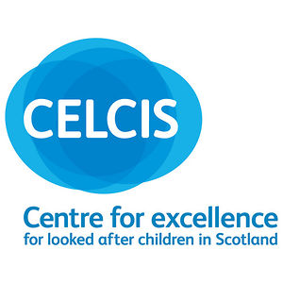

RESPONSE FORM

Action Plan on Justice for Victims of Historic Abuse of Children in Care.

We invite you to consider specific actions which can be taken to deliver the outcomes of the Action Plan on Justice for Victims of Historic Abuse of Children in Care. Views are sought from all individuals and organisations that are affected by historic abuse of children in care.

The Scottish Human Rights Commission (SHRC) and The Centre for Excellence in Looked After Children (CELCIS) will be collecting and analysing all responses received before the 22 January 2014.

Unless respondents consent to their views being made public, all responses will remain confidential. Contact details for the respondent will not appear online.

Please tick this box if you are content for your response to appear online.

Please tick this box if you are content for your response to appear online but not your name or organisation’s name to appear.

Please tick this box if you are content for us to link to your website.

Name:
………………………………………………………………………………………………

Organisation: (where appropriate)
………………………………………………………………………………………………

Website:
………………………………………………………………………………………………

Email address: ………………………………………………………………………………………………

Contact telephone number:
………………………………………………………………………………………………

Completed forms should be emailed to: actionplan@scottishhumanrights.com or sent by post to: Lauren Bruce, Scottish Human Rights Commission, 4 Melville Street, Edinburgh, EH3 7NS.

- What concrete steps do you consider most effective and achievable under Outcome 1?

Outcome 1: Acknowledgement of historic abuse of children in care and effective apologies are achieved.

- What concrete steps do you consider most effective and achievable under Outcome 2?

Outcome 2: Accountability for historic abuse of children in care will be upheld, including access to justice, effective remedies and reparation

3. Please provide details of any work you have been involved with which has not previously been shared that you consider to be relevant to addressing the outcomes in the Action Plan.

Thank you for contributing to the development of the Action Plan on Justice for Victims of Historic Abuse of Children in Care.

Contact point: www.shrcinteraction.org/ Tel: 0141 444 8551

